Complex example II –Pareto_ERP Microsoft Dynamics NAV 2018w1
Created by : Jaromír Skorkovský
Date : 30.10.2019
For : MPH_AOMA and AOPR and BPH_EPS1
Database : MS Dynamics NAV 2018w1
Keys : Ctrl-N=New, F4=Look-up, Ctrl-F7-entries, F7-statistics, F9-post
Shorthands : G/L General Ledger, TO-Transfer Order
Tutor-TU
- Reason-> With the help of self-evaluation questionnaire controlled by setting limits to divide portfolio and contacts into groups A, B, and C in the sense that 20% of customers do 80% turnover (A), other customers are in the so-called middle zone (B) and are potential candidates for group (A) and the last group (C) has little turnover, but it can improve in the future. Please see the diagram that depicts the whole process of this complex example (last page)

- Open by use of searching window Questionnaire setup:

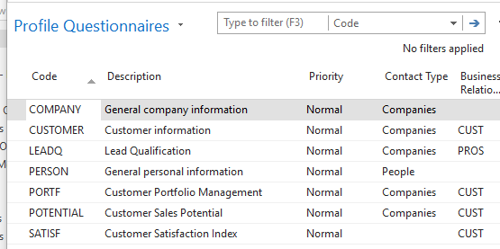
- Use icon New and enter Code = Pareto and Contact Type=Companies and Business Relation Code =CUST (Customers)
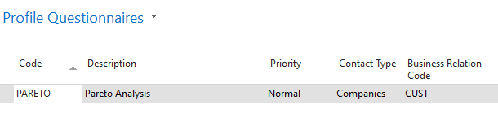

- Use icon Edit Questionnaire setup
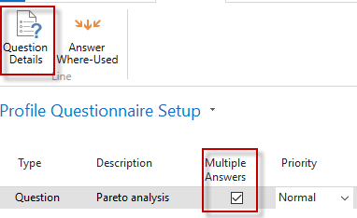
- Check Multiple answers and go to Question Details and enter data as is is shown on the lower window:
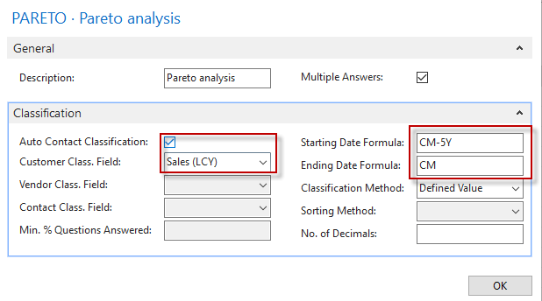
- Enter the data into the form as shown in the picture below
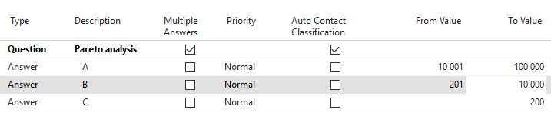
- Use icon Update Classification, and you will get :
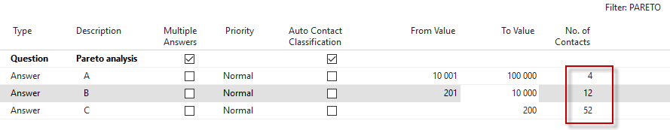
- From Flow field (Calculated field) No. of Contact go directly to the Contact card, and you will see assigned group (A, B or C) in the contact profile (click on Contact number->Advanced->List of profiles->icon Edit)
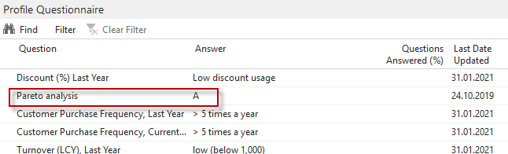
- Open by use of searching window Segments:
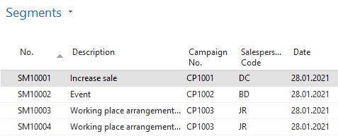
- Use icon New to create a new segment to the organization for contacts marked by A
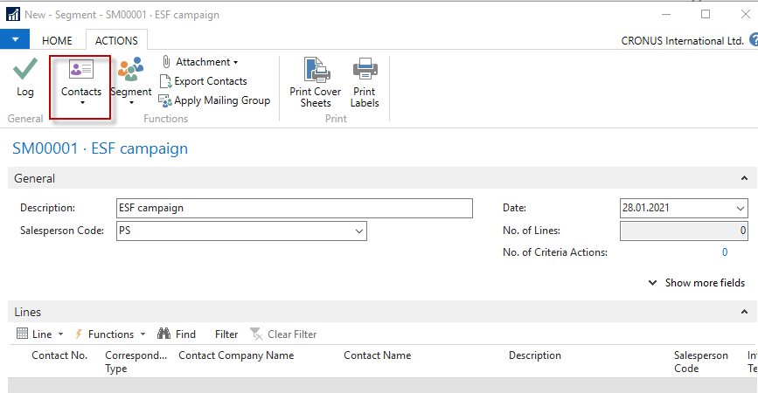
In the upper window, you see in BAR icon Contact, which must be used to get next picture (after choosing Contact Profile Answer area (tab) and entering a value into filed Profile Questionnaire code =Pareto and Answer =20000, which after use of mouse refers to code A

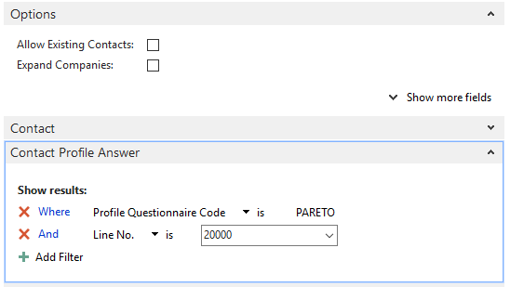
You will get 4 members from A group:
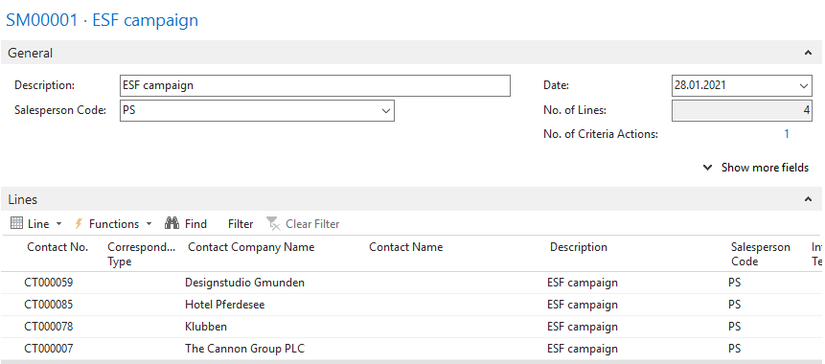
- Go to Campaign (Searching window) and create a new campaign like the one below (use icon NEW)
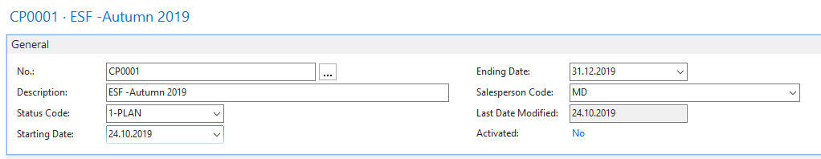
Mind you that we have changed the ending date more to the future to respect the actual working date of this database.
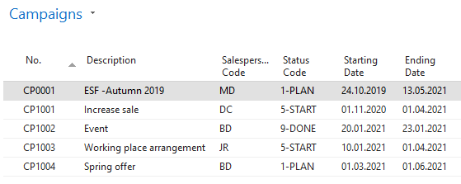
- Add code of created campaign CP0001 to Segment SM00001 and check the Campaign target field and confirm by OK button.
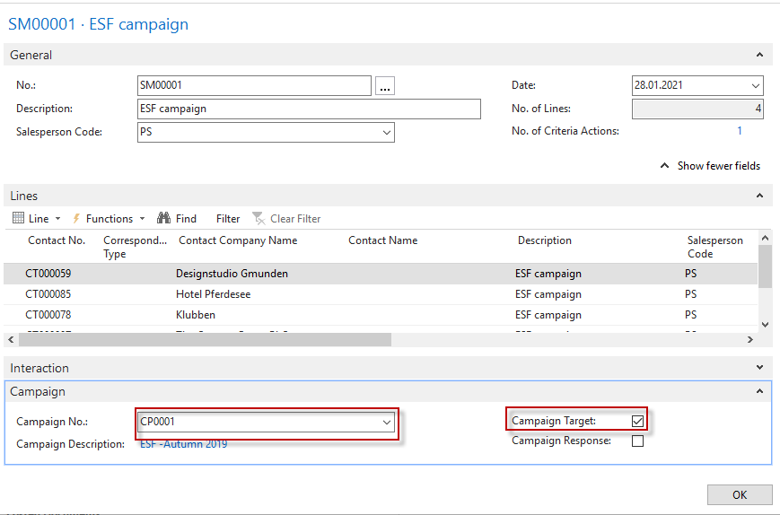
- Go to items and find item 1964-W. Add a new line with just created campaign.
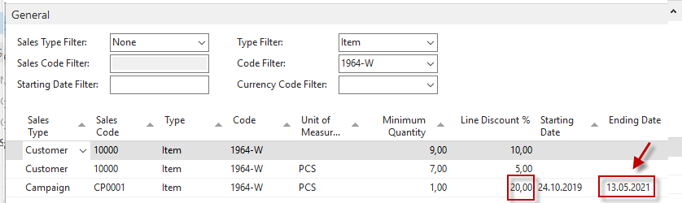
Then You must activate Campaign in question- so go back to campaigns and use Activate Sales Prices/Line Discounts icon
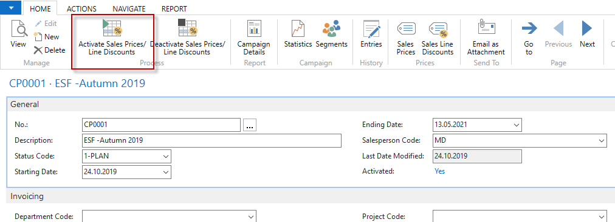
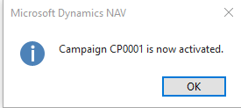
- Create a new Sales Order for Customer 10000 and item 1964-W-See sales line only:
- It can be seen that all customers who have a Pareto rating A assigned to their contact card will receive a 20% discount on selected goods in the campaign associated with their segment.

