**Simple scenario Accounting Schedules MS NAV 2019/20**

Created by : Jaromír Skorkovský, Department of corporate economy

Date : 6.11.2019

Reason : Orientation in the MS Dynamics NAV 2018w1. Material helping to understand basic Accounting schedule principles and one basic type of financial budget

For : MPH_AOMA, MPH_AOPR, winter term 2019

Used database : MS Dynamics NAV 2018w1 – RTS

Used abbreviations : Q=question, G/L=General Ledger, Simple Scenario = SS,

PWP=Power-Point

Accompanying material: PWP-Accounting Schedules

1. A useful tool to create new financial reports used for financial analysis without programming. This tool complements standard mighty reporting system (hundreds of reports)

1. Basic financial reporting is provided by running user-defined reports called Account Schedules. It is, besides hundreds of predefined and existing reports, a basic tool to access data of vital importance. All these reports use as resource data. General Ledger Entries created automatically by posting various documents (e.g., Sales and Purchase orders) by key F9. You can also calculate different parameters, such as IRR, ROI, and many more.

1. Go to menu **Financial Management ->General Ledger ->Reporting & Analysis ->Analysis & Reporting**. There you can see **Account Schedules.**

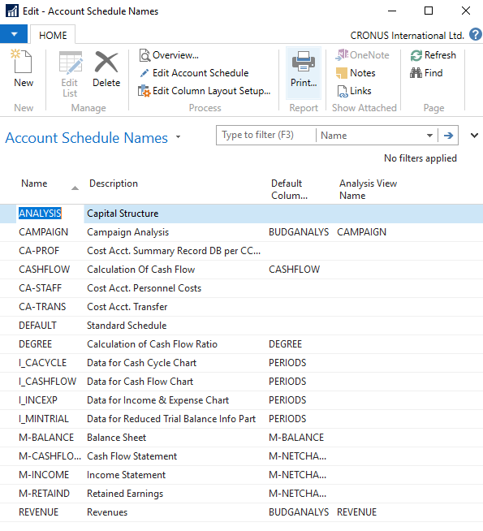

1. In this form, go to the field **Name** in the header and find **Analysis.** There you see a template of the report created by somebody who already created this Accounting schedule in the demo database. To see data, go to the icon **Edit Account Schedule** and push this icon. There you see all chosen **G/L accounts** used in this report. The tutor will explain the structure. Then you push the icon **Overview** to see data. The structure of the Account schedule uses data taken from **G/L entries** based on the initial setup of matrix lines and columns:

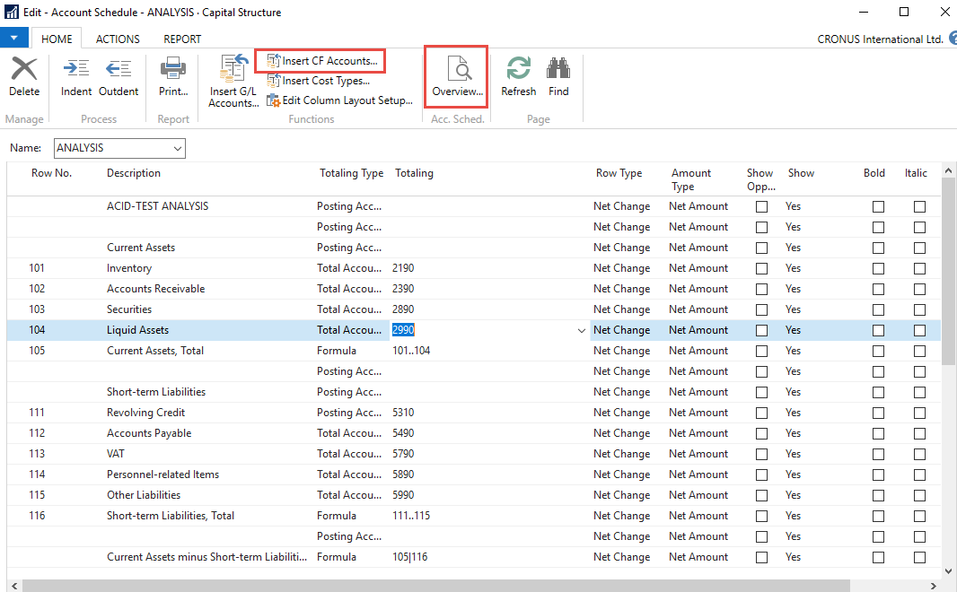

As you can see in the above form in the Row No, we do have variables (entered when created manually). In our case, we do have 101,102 and so on. In the totaling column, we can see accounts. IWhen a totaling type=Formula, then you can enter arithmetic operations (+,-,x,..,|). The alphanumeric character “|” which you can enter by key combination right Alt+W represents substruction.

And to see real data, you can also change periods by related fields (by date, dimension filters such as Department, a project of G/L budget filter). Dates window from to may be different on Autumn 2019 courses.

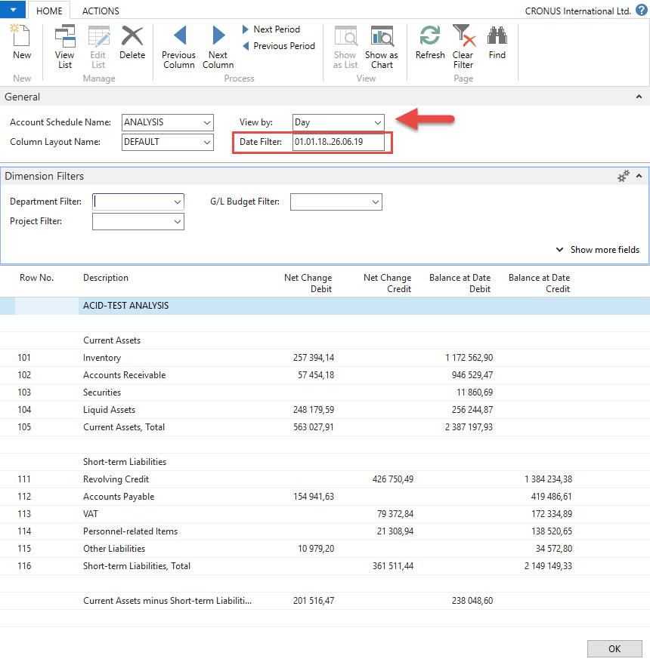

1. If you change Default Column layout Name to BUDGANAL (Budget Analysis), you close and open it again by Overview, and you will get the different data overview. You have to have some data in a budget matrix.

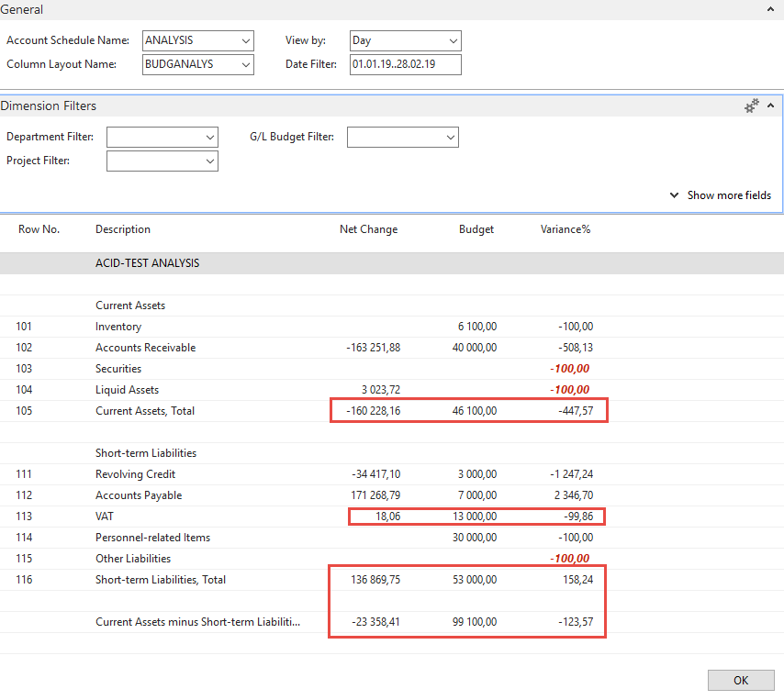

1. Let´s create your analysis! Go to the Name field and in the list enter new analysis name (e.g., TEST), as you can see below.

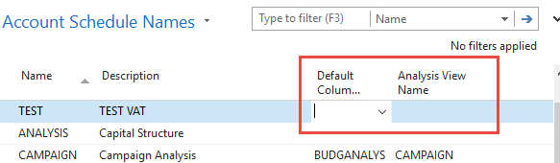

Enter default column layout = **DEFAULT**. By use of mouse or **F4** to see and chose this possibility.

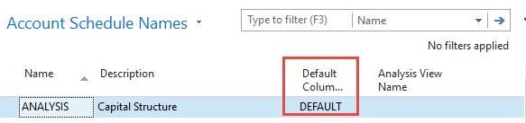

1. With the help of **F4** from the field **Default** column layout (see above) and by use of Advanced you will get this form after the creation of new line by **Ctrl-N** or icon=**NEW**:

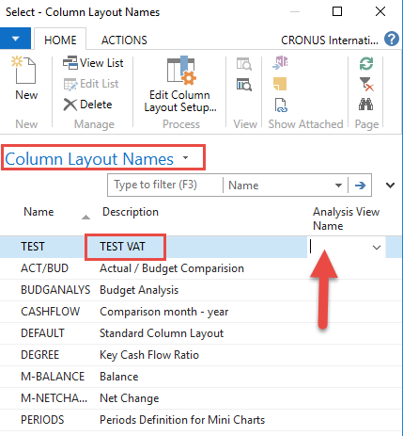

Next, you have to Create **Analysis View Name**. Use the **F4** and **Advanced** button and the **New** icon. Enter **VAT** accounts From-To (5600-5790), which are **G/L** account used for **VAT** posting, dimensions (Area and Department), and use icon **Update**. It will create a subset of data used in our Accounting schedule. The last entry numbers are visible in the form below. The first picture is before Update and the second one after.

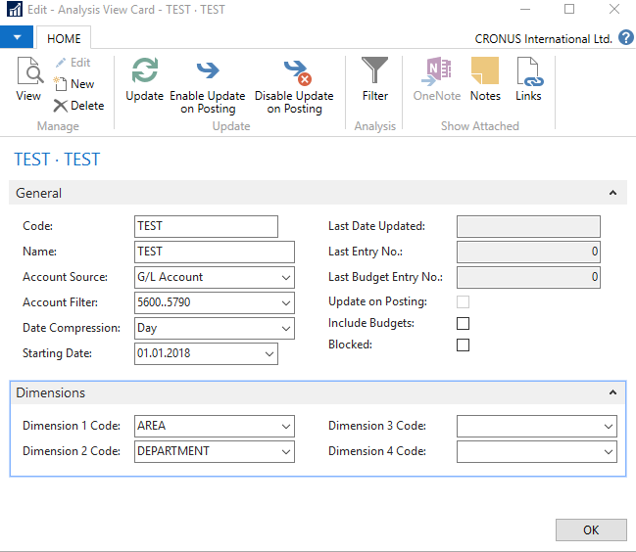

After the update you will get :

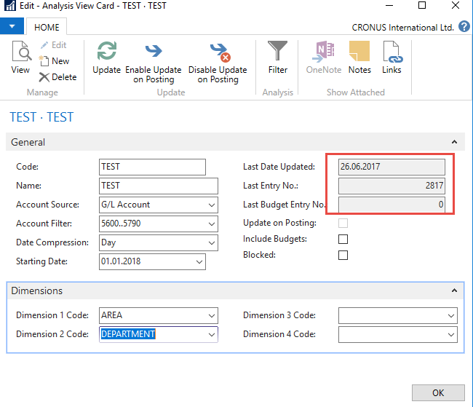

Finally, you will get this and use the layout of column=DEFAULT as we did before.

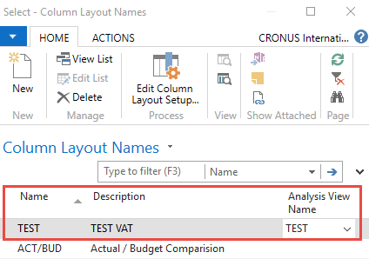

Go to Account Schedule Names, choose the TEST, and **Edit Account Schedule** icon. Then use icon create and enter two VAT account for purchase and two for sales and formulas as shown in the next form (use G/L account icon) and modify the first column manually to chosen variable names IN 10, IN 25….). These are, in fact, variables used in the calculation.

To enter new lines with description, use right-click and New line!

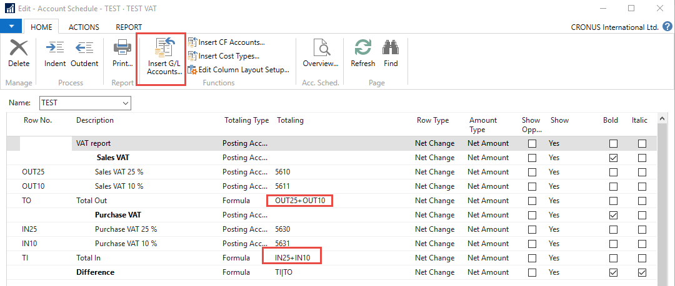

And you will get (after using icon **Overview**)

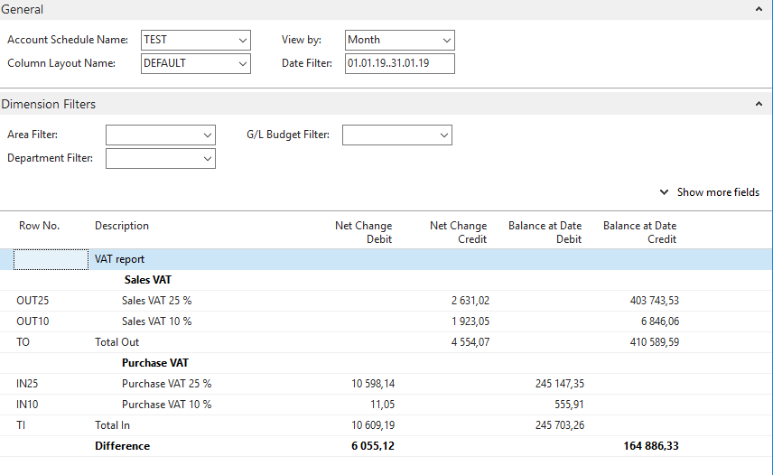

**Next example related to budget creation with Dimension use, G/L entries creation and accounting schedule to see how actual and budgeted amount fit together**

1. Create a new **G/L account** by use of icon new from **Chart of account** window and the indent chart of the account by the icon with this name. The number of the G/L account will be **8350** and the name Artificial Intelligence Consultation. General Posting Type=Purchase, General Business Posting Group=National, General Production Posting Group=Services

Before adding new G/L account



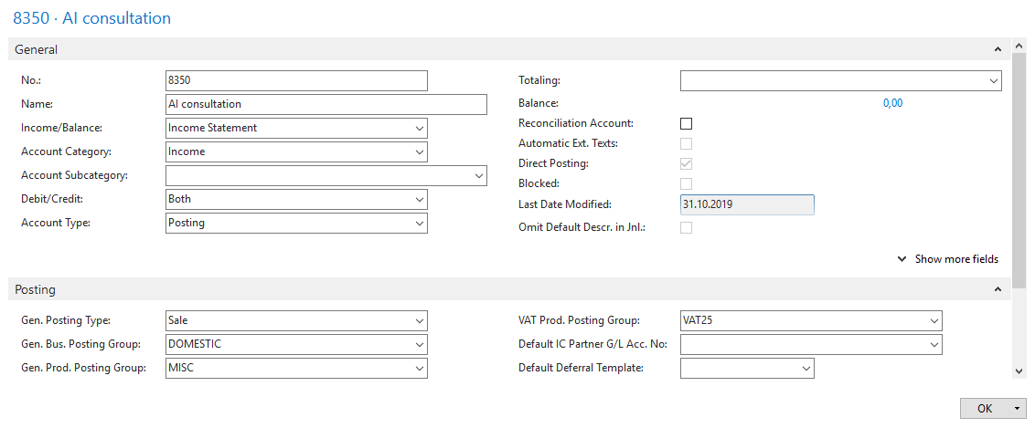

You must indent created Account by the icon above chart of account

After adding an indenting a new **G/L** account

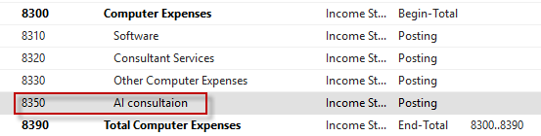

Create a new budget **2020**

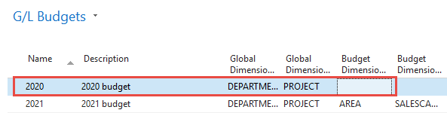

Now, you must enter data into the budget of 2020. So open budget and before check that the working date is 26.2.2020. Use icon **Edit Budget**. In Filters below the main matrix remove data From-To, if any. To enter data, use the **tree-dots** button and afterward icon New.

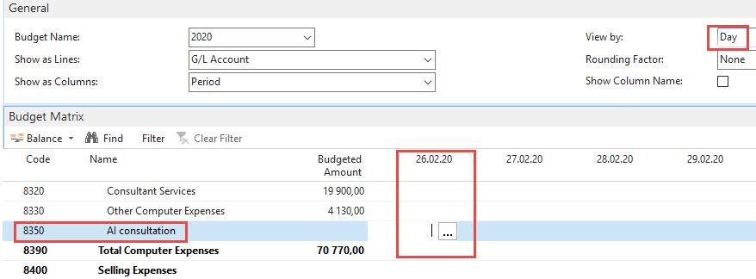.

The tutor will explain how to enter budget entries by use **tree-dots** button and how to assign to created budget entry a dimension value (s). Primarily use View by =Day. Finally, you will get for View by=Week this form.

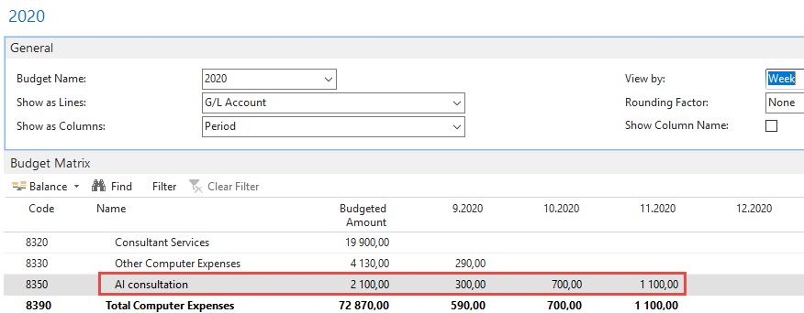

1. The next step will be the Purchase of services, meaning two lines in Purchase Order and every line assigned to different dimension values (Department=SALES and Department=ADM). You can use the **Purchase Invoice** instead of **Purchase Order**. The vendor will be 10000. Be careful about the working date (remember it). It is crucial for the following steps. Mind you, that type of the Purchase line will be **G/L account** (the one which we just created). For Sales dimension value this will be 1 hour and 180 GBP per hour. The second line for Dimension value ADM will be 1 hour and 60 GBP. To assign dimension values, use icon **Line** and, therefore, icon Dimension and icon New to add Dimension Department. Post Purchase invoice (purchase order)t by **F9.** Below you can see firstly two purchase lines and then How to assign one of the two values to them. In our case, this will be Department=SALES. Mind you, that the date of document creation is 26.2.2020.

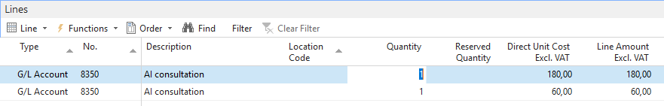

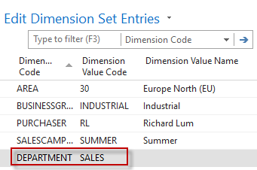

1. Change the working date to 6.3.2020 and create a new purchase order with two lines as we have done previously. For ADM dimension the value will be 500 GBP, and for SALES dimension the value will be 200 GDP

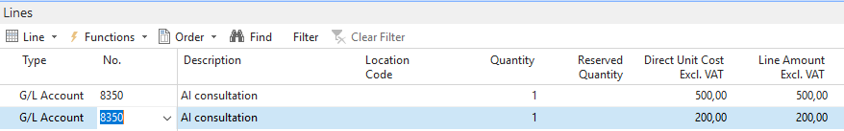

After posting the purchase invoice, you can see General Ledger Entries. In NAV 2018w1, we will use different dates (26.2.2020, 6.3.2020).

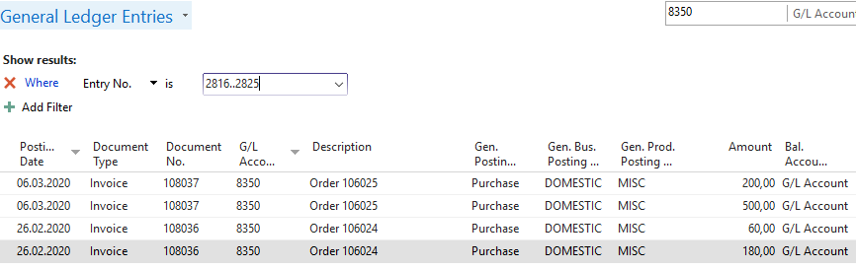

1. We have to create a new **Account schedule** to see the differences between budgeted and actual (real posted amounts). Go to Account schedule area and use NEW:

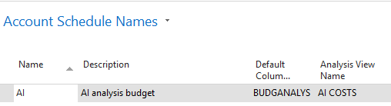

We enter New name=AI and already predefined Default Column=BUDGETANALYS. Then we enter brand new name for **Analysis View Name**, and the card will be as follows. Parallelly follow the creation of this card and its update done by a tutor.

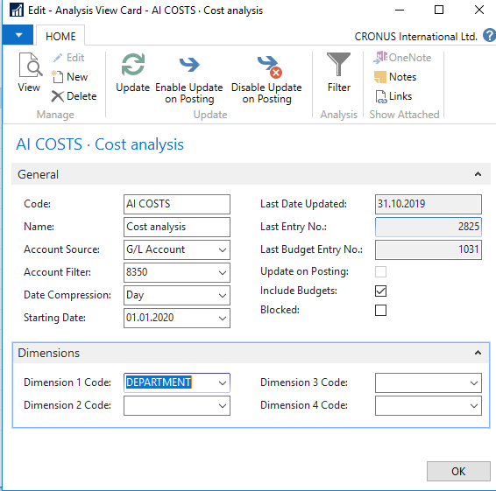

Now we have to add a new line into our new **Accounting schedule AI** by use of **Edit** icon and **Insert G/L accounts.**

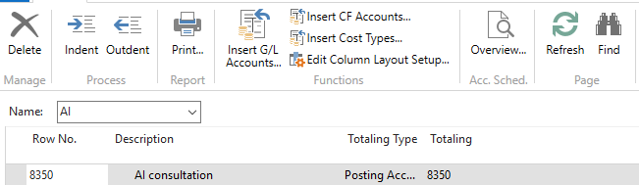

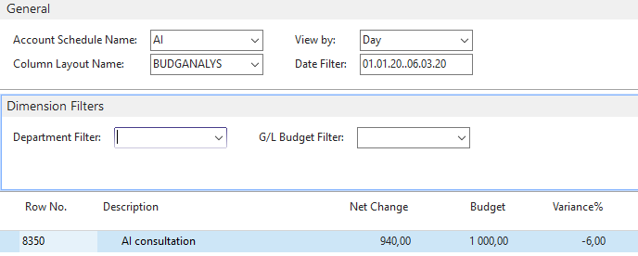

And then enter filter fro chosen dimension Deparment values (ADM od SALES)

