Simple scenario Purchase Order MS Dynamics NAV 2016w1_2018w1
Created by : Jaromír Skorkovský
Date : 25.9.2019

Reason : Orientation in the MS Dynamics NAV 2018. Material helping to understand basic purchase principles
For : MPH_AOMA, MPH_AOPR,
BPH_PIS1 and MPH_RIOP for summer term 2019 (if required)
Used database : MS Dynamics NAV 2018 W1 (British one) – RTS (role tailored client)
MS Dynamics NAV 2018 Czech – RTS
Used abbreviations : Q=question, G/L=General Ledger, Simple Scenario = SS,
PWP=Power-Point. PO-Purchase Order
Accompanying material: Introduction MS Dynamics Purchase NAV RTC 20181003

This material is very useful for better understanding of Purchase Order creation.

- Go to menu Departments (down the menu) - >Purchase - > Order Processing (main part of the screen) ->List->Vendors. You will see the list of all Vendors used in our ERP system

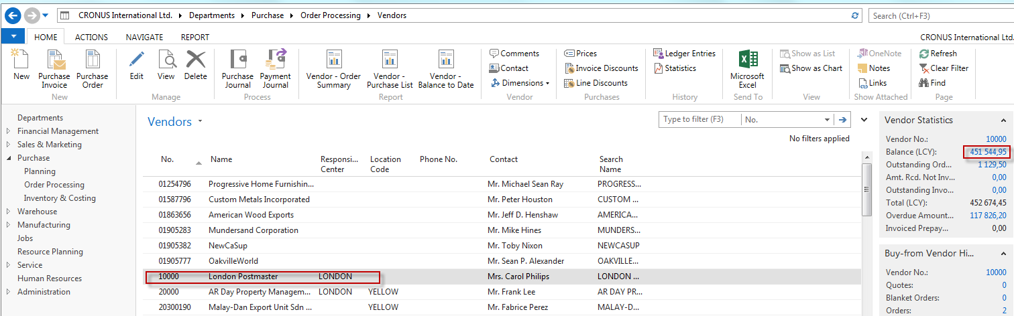

- You can move up and down cursor by arrows or even mouse clicks. To go to the first Vendor record, you can use Ctrl-Home and vice- versa to the end of the list by Ctrl-End. These rules are valid for all kinds of the list in the ERP system

- You see on the left-hand side Vendor statistics (Balance and other fields)

- Click on figure Balance, and you will see all document already issued by all users

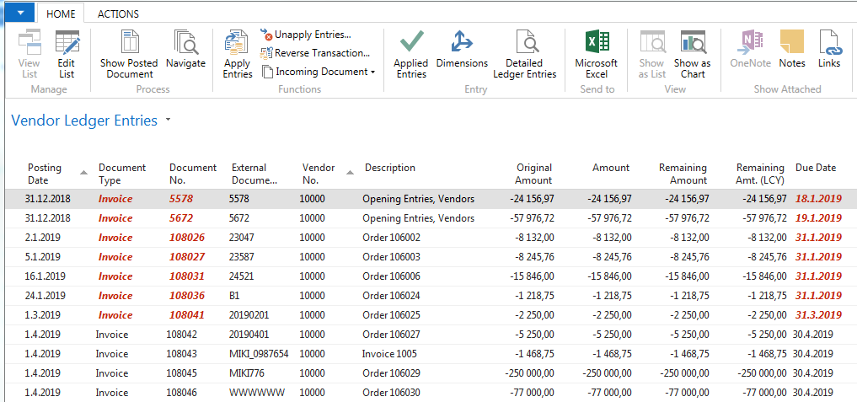

- Go back to list by key ESC.
- Open one chosen Vendor card by icon Edit (or View)

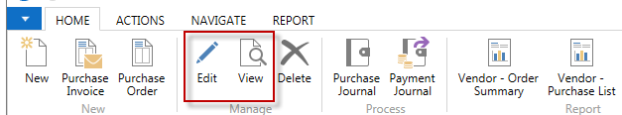

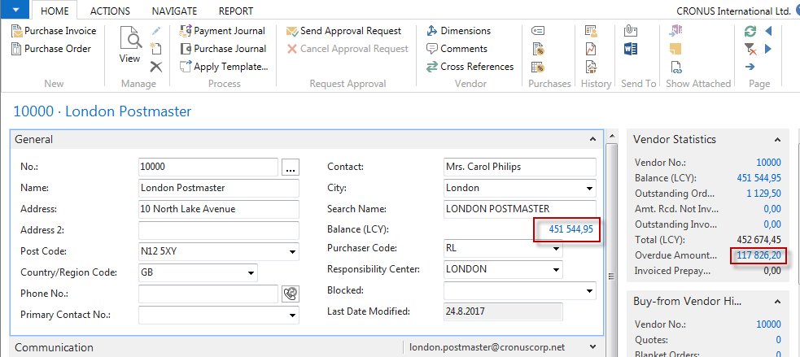
Investigate some other most essential Tabs of Vendor Card such as Payment Terms Code, Currency code, and language.
- Go back by ESC and go to the searching window (upper right corner) and write there Item and “jump” to list of items.
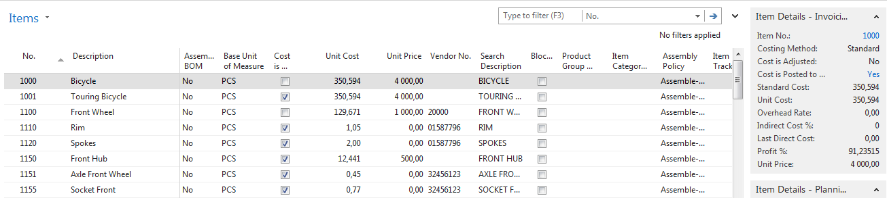

- By use of the filter, the engine goes to the Item 1932 – Berlin chair. How to do so? In the upper part of the list, you have filter pane where you can choose what kind of filter you would like to use. In our case we know, that item number is 1932, but we do not know if there is any other character of the number after 1932, so you put there * to saying to filter engine, that it could be any character or number after it. Character * represents a wildcard.

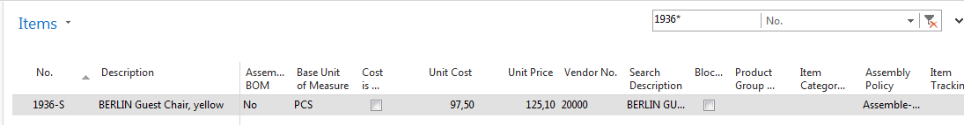
- Open this item card in the same way as you already did in the Vendor list area. (Icons Edit or View)

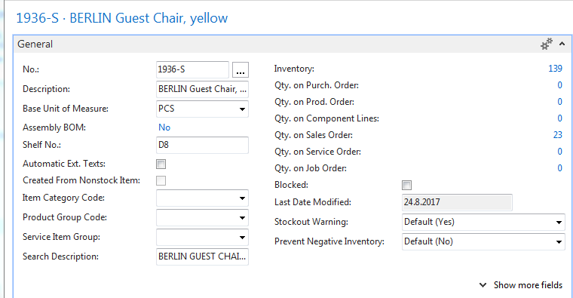

Here you see how much do we have in this very moment in our stock (Inventory field) and how many of this item is in our case (database) already ordered (but not delivered so far).

See next Invoicing Tab, where you can see the cost of the item and its Unit price as well.

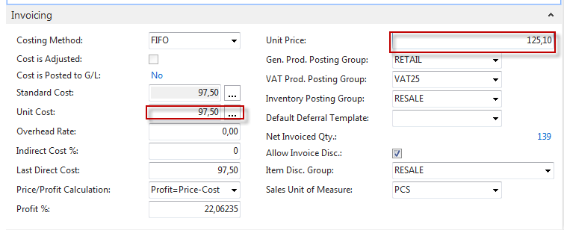
After investigating all procedures, press ESC and got to clause 10.
- Go to menu Departments (down the menu) ->Purchase ->Order Processing->List->Purchase Orders and you will see a list of existing Purchase orders which were issued previously but not posted (ordered items but not delivered so far). Click on Icon NE (upper left corner). By use of mouse of key F4 enter your chosen Vendor number to the header of our new Purchase Order and confirm your choice by key ENTER. You will get the header of our newly created document:

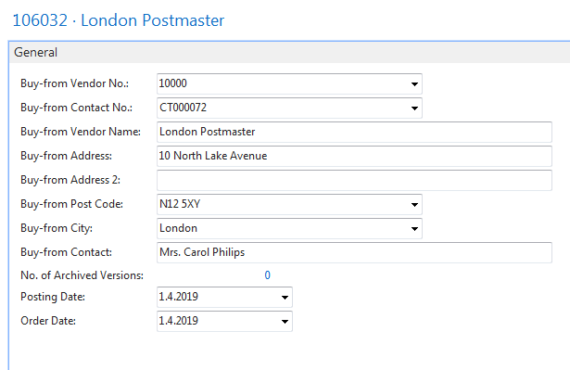

- Below Purchase Order header you could see so far empty PO line, where you have to specify what do you want to order (Type=Item, Number is 1936-S, stock location= Blue and quantity= 10)

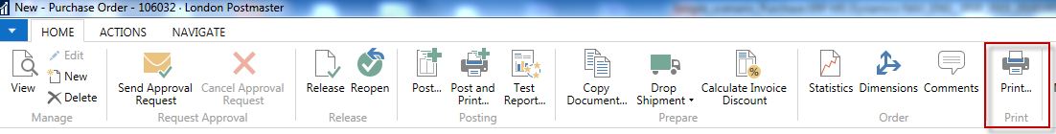

By use of the icon on the picture in above preview your document

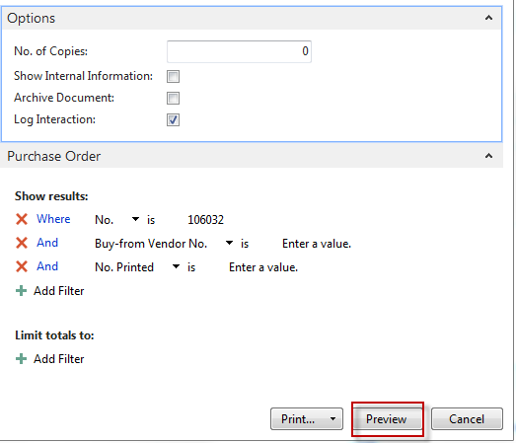

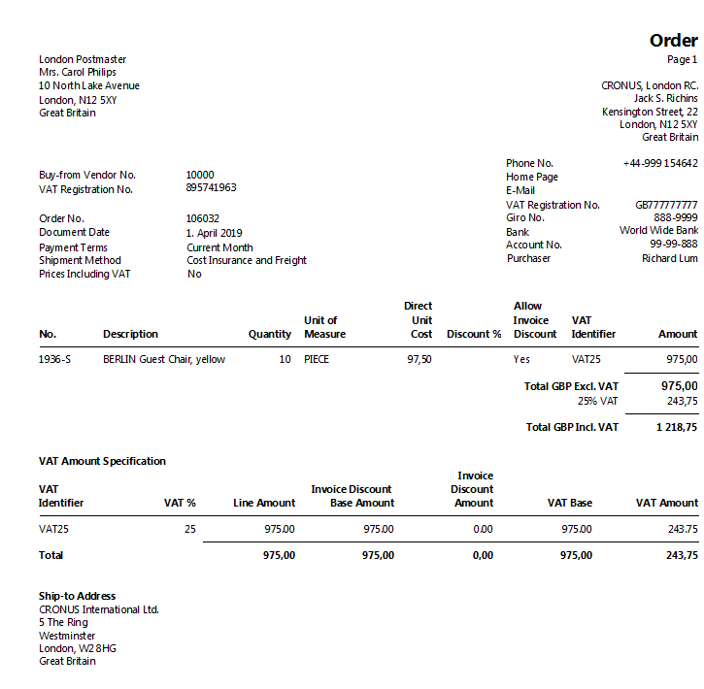

- The vendor will get this document by post or e-mail. After the expected delivery time, you will get ten chairs and two documents (Delivery list and Purchase Invoice) issued by your Vendor. Enter any alphanumeric string (e.g., ABC123) to the header of PO to the field Vendor invoice number (marked by orange *¨)
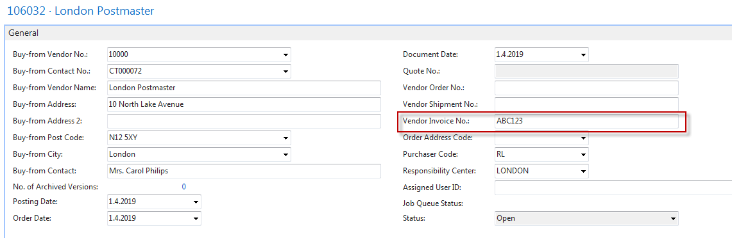

- Next significant action is Posting this document to the system. Use either icon Post or Key F9. The result will be visible in stock (one item ledger entry with ten chairs), Vendor entry (new invoice (our payables) and in G/L.

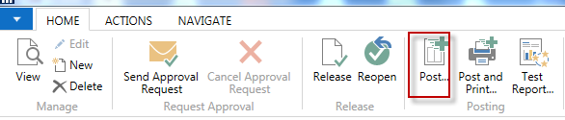
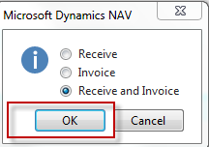

- Item ledger entry (go to the searching window, write down Item, go to the list of items, find item 1936-S (the same procedure used in clause 8) and see entries by Ctrl-F7 or icon Entries :
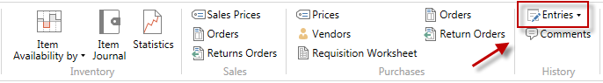

Item ledger entries:

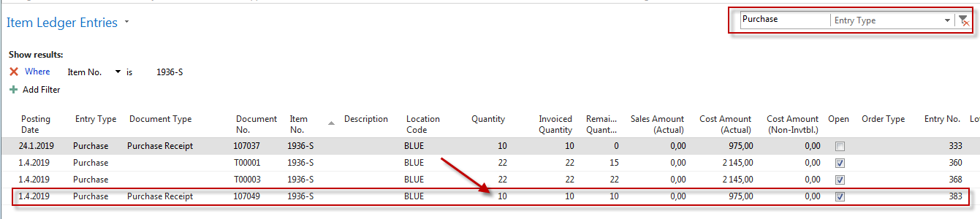
- Go to menu Departments (down the menu) - >Purchase ->Order Processing (main part of the screen) ->List->Vendors. You will see the list of all Vendors used in our ERP system

- Find Vendor 10000 and make key combination Ctrl-F7 to get Vendor ledger entries
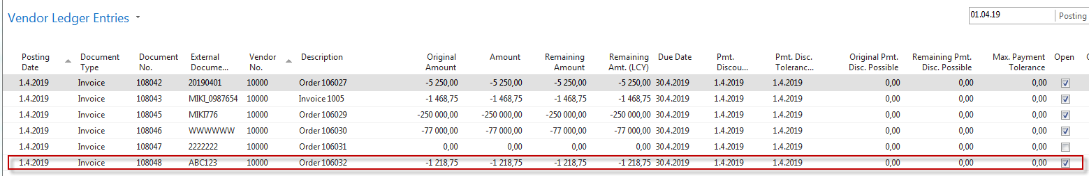
- From there, we can show you how the Navigate function works. So you find icon Navigate an click on it
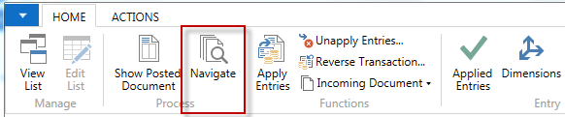
moreover, you will get a picture from where you can see all likely impacts of posting PO.

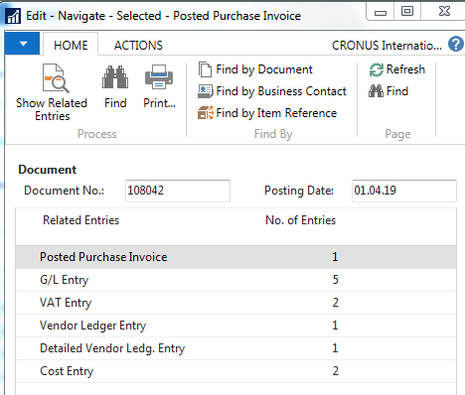

- To see document use icon Show related entries. To see G/L transactions (Entries) use the same icon.
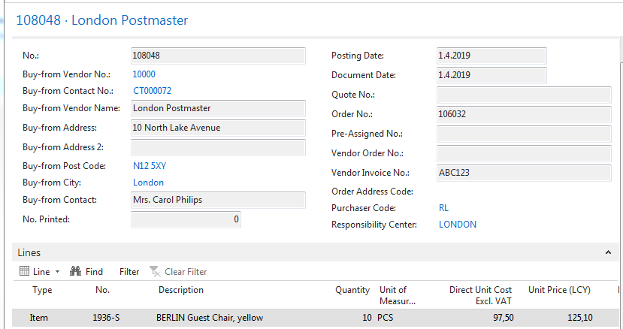
Moreover, General Ledger entries

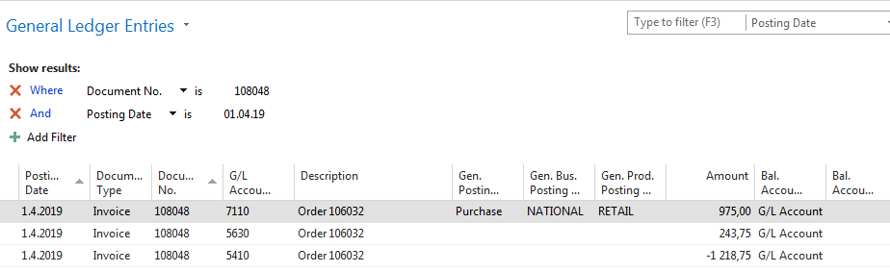

NAV syntax of amount: if positive sign then Debit side or Debtor side if negative, then Credit side or Creditors

