Simple scenario (Item Transfer ) ERP Microsoft Dynamics NAV 2018w1
Created by : Jaromír Skorkovský
Date : 9.10.2019
For : MPH_AOMA and AOPR and BPH_EPS1
Database : MS Dynamics NAV 2016 W1
Keys : Ctrl-N=New, F4=Look-up, Ctrl-F7-entries, F7-statistics, F9-post
Shorthands : G/L General Ledger, TO-Transfer Order
Tutor-TU

Go to Menu Warehouse-> (working space)->Administration-> Setup> Locations
Select Locations = White and at the top of the window select Manage and View icon
Open card Location=White and see all the tabs of this card.
See icon Bins. Open it, and you will see:
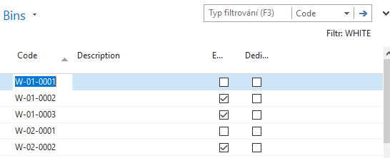

See bin contents by use of icon Contents
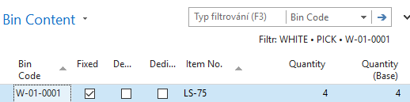
The bin is the smallest possible storage location. Limits, Empty and Assigned -> TU, Zones will show you again
Go back by ESC key (clik several times)
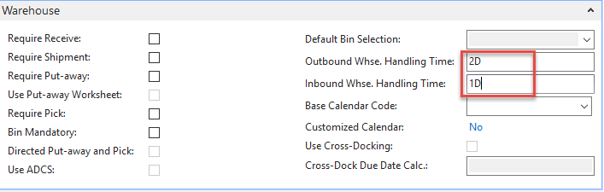
Select Locations=Blue and Edit-> see Warehouse tab and Inbound and Outbound times

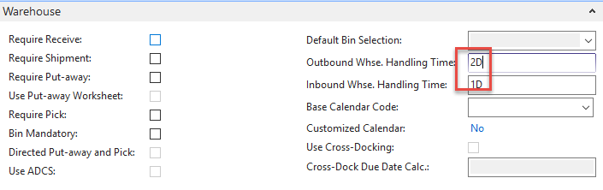
Do the same action for chosen inventory Location=Red. Inbound handling time =1D Outbound handling time =2D.If in your current database you may have different values,so you must rewrite it.
Menu Warehouse-> Administration-> Inventory-> Transfer Routes
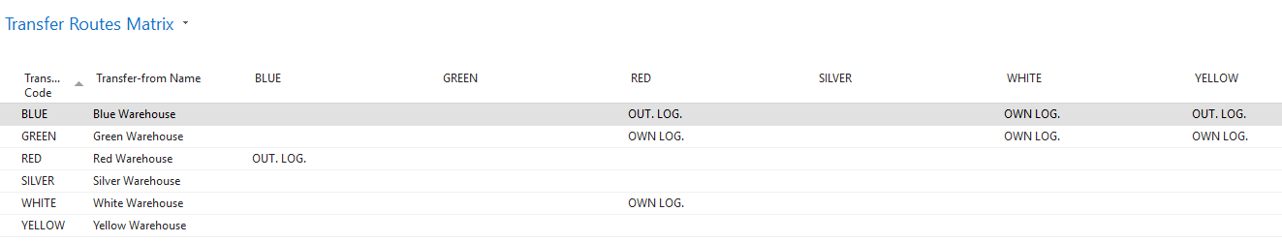
You wil get this matrix window

Go to searching windows and find Shipping agents area
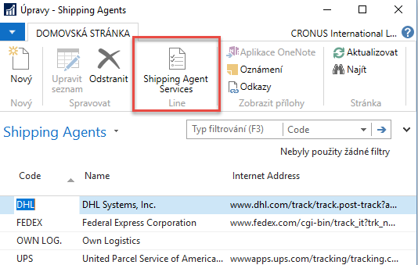
Use icon Shipping Agent Services
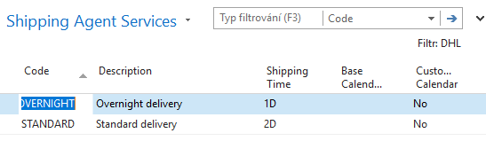
Go to the searching window and enter string Transfer Orders or use Menu Warehouse-> Orders & Contacts-> Lists->Transfer Orders
For an explanation of principles, see PWP Presentation about Transfers
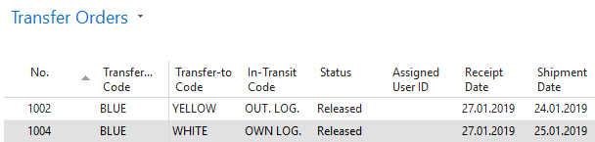
Ctrl-N Create a new Transfer Order - confirm with key Enter from the screen below

Add by F4 values of Location From and To. In our case, it will be Blue and Red
In transit, the chosen lorry comes from the Transfer Routes matrix.
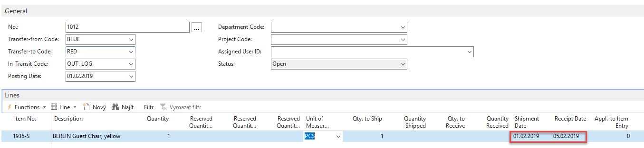
Enter Item-1936-S (Berlin chair) and one pcs.

On the tab Transfer From you will see
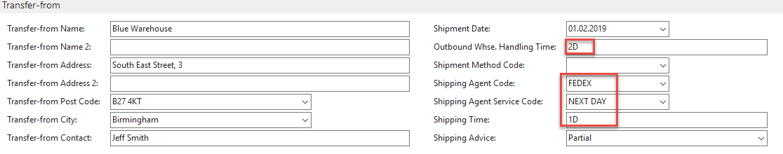
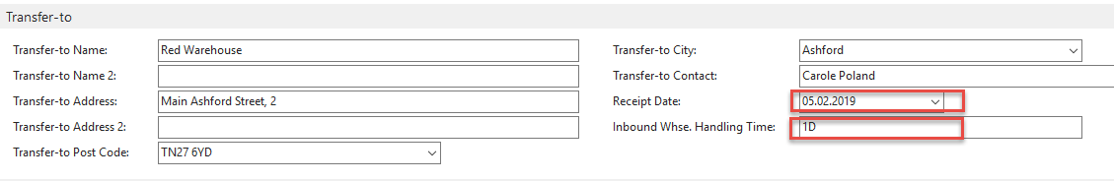
On the tab Transfer To you will see

Shipping date=1.2.2019 and Receipt date= 5.2.2019 ->4 days. Two days outbound warehouse handling time + 1 day shipping time + 1-day inbound warehouse handling time. It might be possible that in your current NAV2018w1 database you will have (you will use) different dates.
Post TO (transfer order) by F9
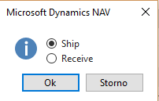
And TO line changed :

Before posting TO for the second time see please matrix item by location from item card or item list by using Icon
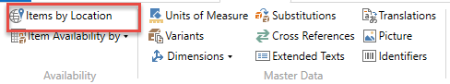
and
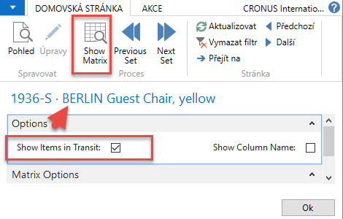
You will get this type of screen
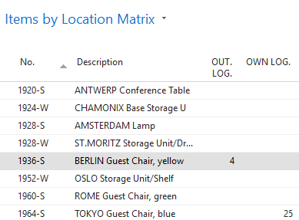

Click on a number to see transfer moves
Post TO 2nd time by F9
You will get
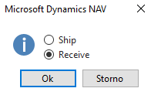
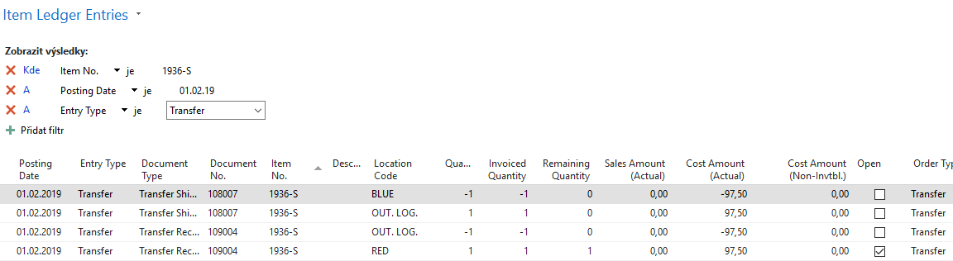
And see Item entry of chosen item 1936-S

