Simple scenario Accounting Schedules MS NAV 2019/20
Created by : Jaromír Skorkovský
Date : 6.11.2019

Reason : Orientation in the MS Dynamics NAV 2016|17. Material helping to understand basic discount principles and one basic type of financial reporting (accounting schedules)
For : MPH_AOMA, MPH_AOPR, winter term 2019

Used database : MS Dynamics NAV 2018w1 – RTS

Used abbreviations : Q=question, G/L=General Ledger, Simple Scenario = SS,
PWP=Power-Point
Accompanying material: PWP-Accounting Schedules

- A useful tool to create new financial reports used for financial analysis without programming. This tool complements standard mighty reporting system (hundreds of reports)

- Basic financial reporting is provided by running user-defined reports called Account Schedules. It is, besides hundreds of predefined and existing reports, a basic tool to access data of vital importance. All these reports use as resource data. General Ledger Entries created automatically by posting various documents (e.g., Sales and Purchase orders) by key F9. You can also calculate different parameters, such as IRR, ROI, and many more.

- Go to menu Financial Management ->General Ledger ->Reporting & Analysis ->Analysis & Reporting. There you can see Account Schedules.

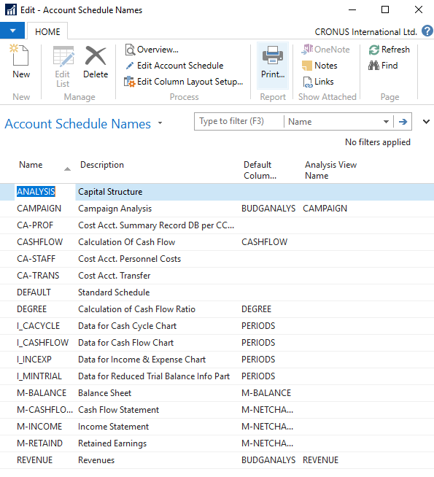

- In this form, go to the field Name in the header and find Analysis (one of many). There you see a template of the report created by somebody who already created this Accounting schedule in the demo database. To see data, go to the icon Edit Account Schedule and push this icon. There you see all G/L accounts used in this report. The tutor will explain the structure. Then you push the icon overview to see data. The structure of the Account schedule uses data taken from G/L entries based on the initial setup of matrix lines and columns:

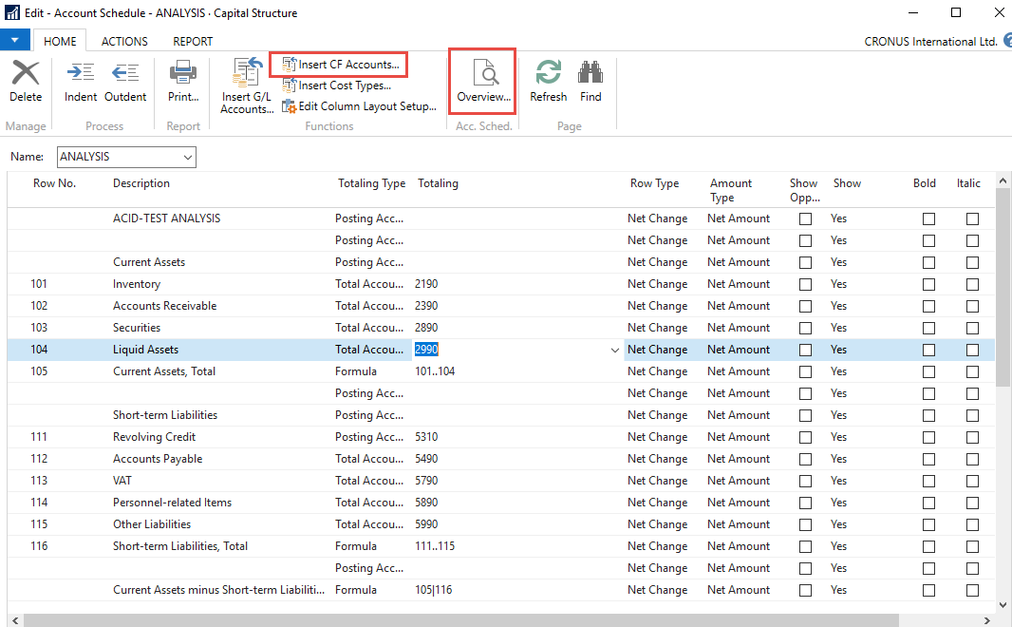

As you can see in the above form in the Row No, we do have variables (entered when created manually). In our case we do have 101,102 and so on. In the totaling column, we can see accounts.

And to see real data, you can also change periods by related fields (by date, dimension filters such as Department, a project of G/L budget filter). Dates window from to may be different on Autumn 2019 courses.

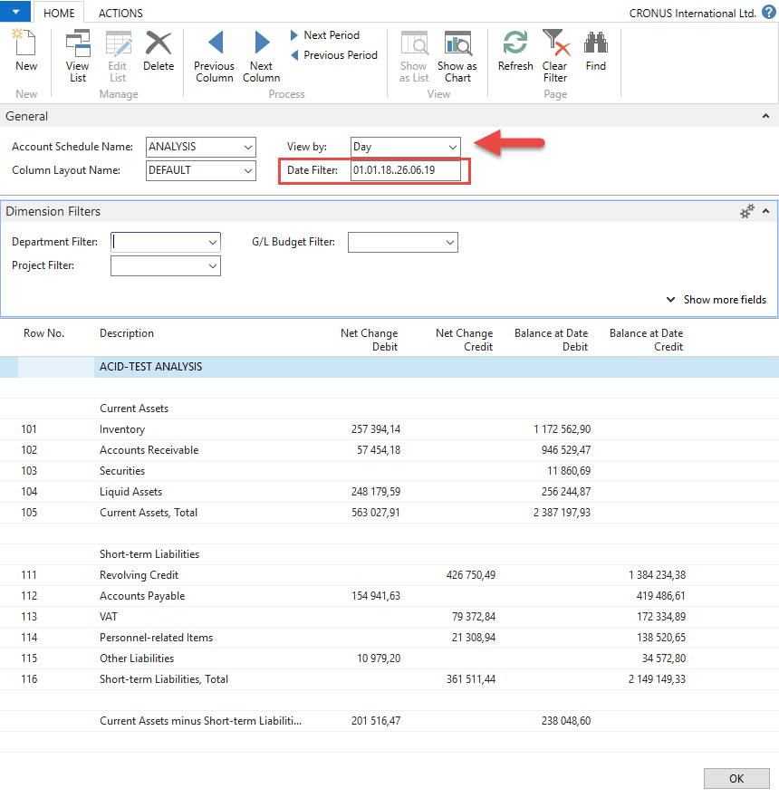

- If you change Default Column layout Name to BUDGANAL (Budget Analysis) you close and open it again by Overview, you will get the different data overview. You have to have some data in a budget matrix.

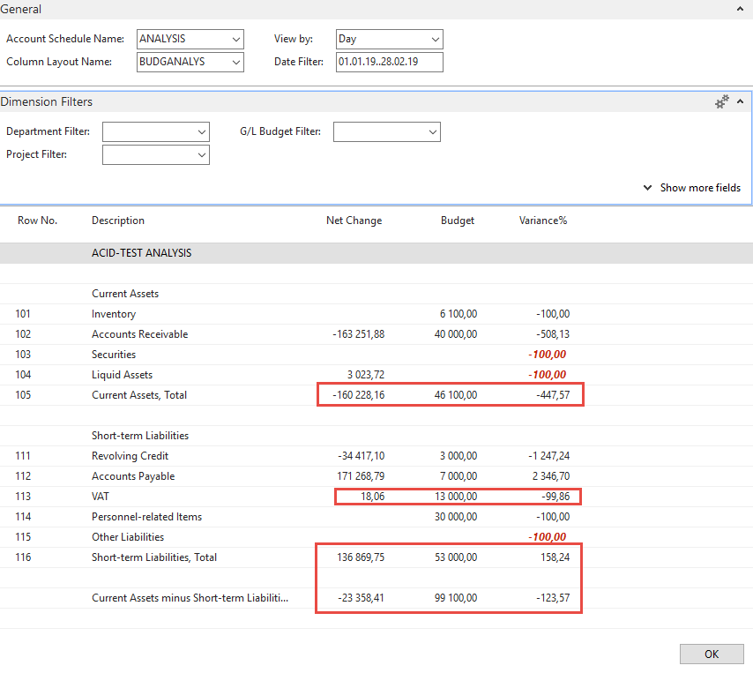

- Let´s create your analysis!! Go to the Name field and in the list enter new analysis name (e.g., TEST), as you can see below.

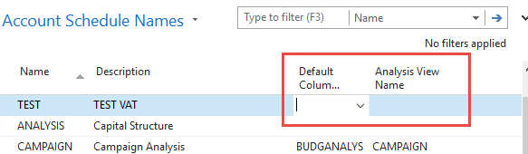

And enter Default column layout = DEFAULT! By use of mouse or F4 to see and chose this possibility.

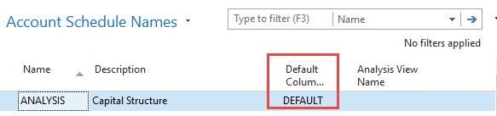

- With the help of F4 from the field Default column layout (see above) and by use of Advanced you will get this form after the creation of new line by Ctrl-N or icon=NEW:

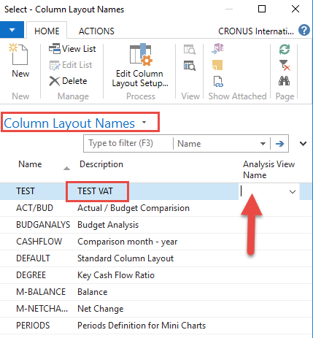

Next, you have to Create Analysis View Name. Use the F4 and Advanced button and the New. Enter VAT accounts From-To (5600-5790), which are G/L account used for VAT posting, dimensions (Area and Department), and use icon Update. It will create a subset of data used in our Accounting schedule. The last entry numbers are visible in the form below. The first picture is before Update and the second one after.

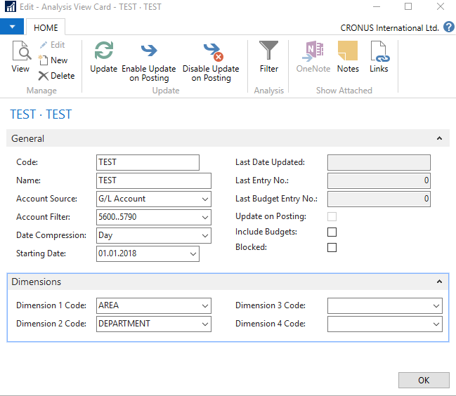

After the update you will get :

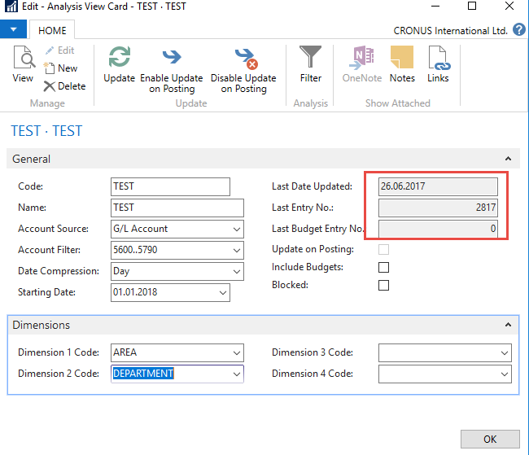

Finally, you will get this and use the layout of column=Default. Anyhow, this was already presented.

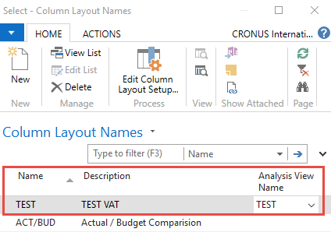

Go to Account Schedule Names, choose the TEST, and Edit Account Schedule icon. Then use icon create and enter two VAT account for purchase and two for sales and formulas as shown in the next form (use G/L account icon) and modify the first column manually to chosen variable names IN 10, IN 25….). These are in fact, variables that may be used in the calculation.

To enter new lines with description, use right-click and New line!

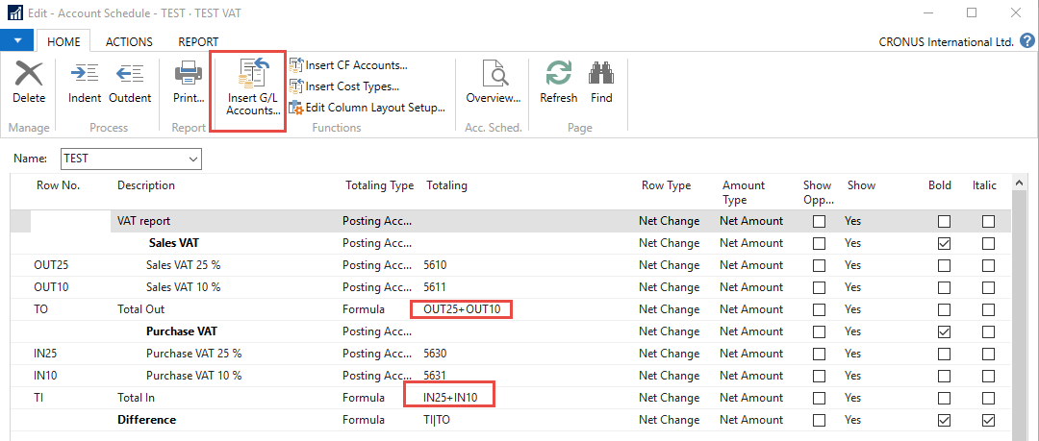

And you will get (after using icon Overview)

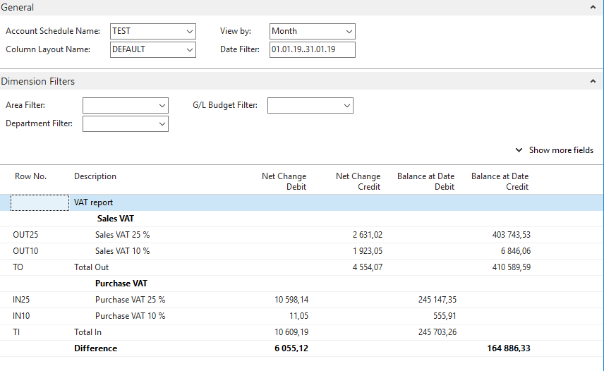

Next example related to budget creation with Dimension use, G/L entries creation and accounting schedule to see how actual and budgeted amount fit together (also used for South African clients)

- Create a new G/L account by use of icon new from Chart of account window and the indent chart of the account by the icon with this name. The number of the G/L account will be 8350 and name Artificial Intelligence Consultation. General Posting Type=Purchase, General Business Posting Group=National, General Production Posting Group=Services

Before adding new G/L account

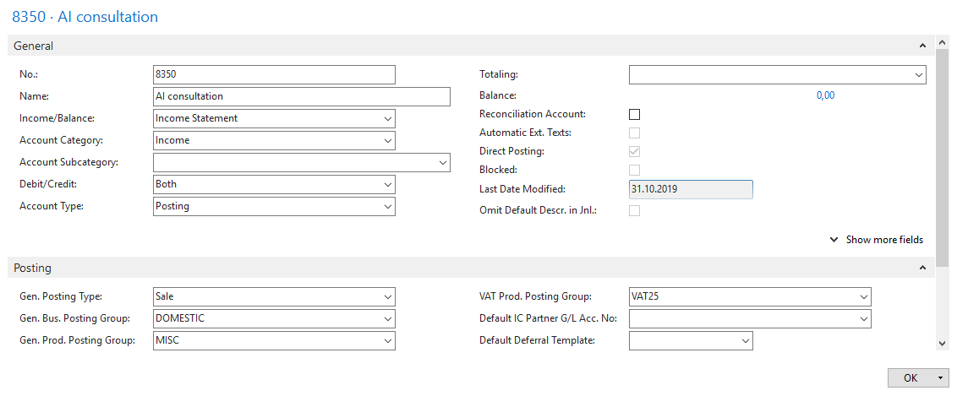

You must indent created Account by the icon above chart of account

After adding an indenting a new G/L account

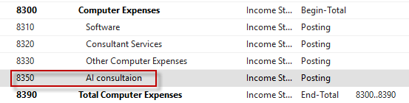

Create a new budget 2020

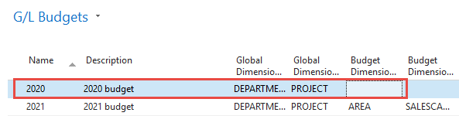

You have enter data into budget 2020. So open budget and before check that the working date is 26.2.2020 Use icon Edit Budget. In Filters remove data From-To, if any. To enter data, use the tree-dots button and afterward icon New.

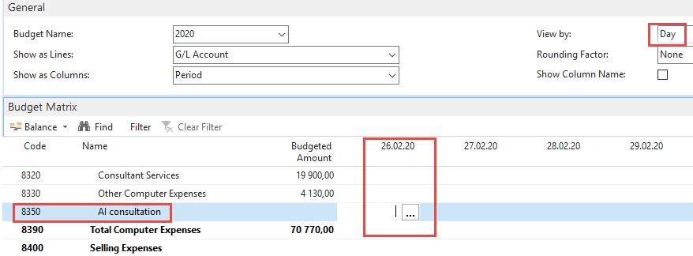.

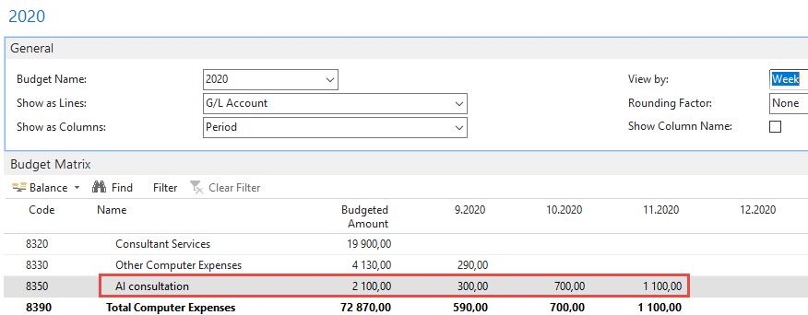

- The next step will be the Purchase of services, meaning two lines in Purchase Order and every line assigned to different dimension values (Department=SALES and Department=ADM). Use Purchase Invoice instead of Purchase Order. Vendor=10000. Be careful about the working date (remember it). It is crucial for the next example of the following steps. Mind you, that type of the purchase line will be G/L account (the one which we just created). For Sales dimension value this will be 1 hour and 180 GBP per hour. The second line for Dimension value ADM will be 1 hour and 60 GBP. To assign dimension values, use icon Line and, therefore, icon Dimension and icon New to add Dimension Department. Post it by F9. Below you can see firstly two purchase lines and then How to assign one of the two values to them. In our case, this will be Department=SALES. Mind you, that document was created on 26.2.2020.

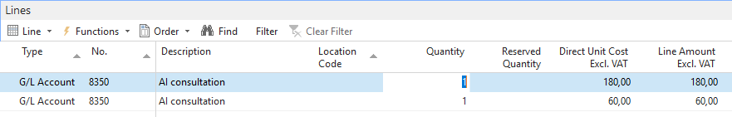

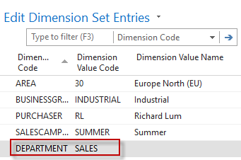

- Change the date to 6.3.2020 and create new purchase order with two lines as we have done previously. For ADM dimension the value will be 500 GBP, and fro Sales dimension the value will be 200 GDP

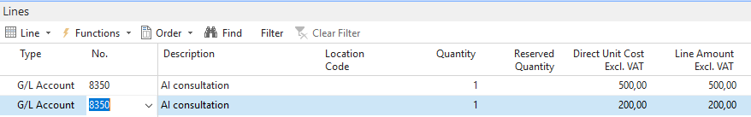

After posting the purchase invoice, you can see General Ledger Entries. In NAV 2018w1 we will use different dates (26.2.2020, 6.3.2020, and 14.3.2020

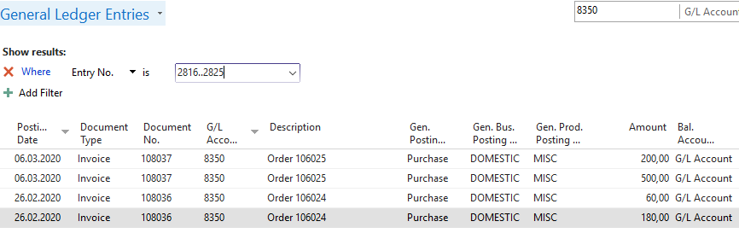

- We have to create a new Account schedule to see differences between budgeted and actual (real amounts). Go to Account schedule area and use NEW:

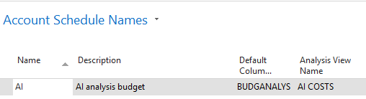

We enter New name=AI and already predefined Default Column=BUDGETANALYS. Then we enter brand new name for Analysis View Name, and the card will be as follows (parallelly follow the creation of this card and its update done by tutor.

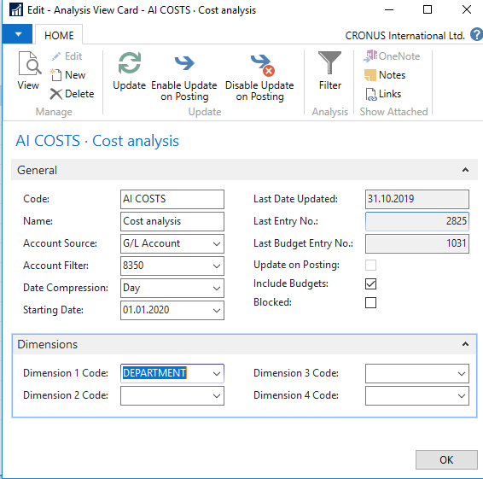

No we have to add new line into our new Accounting schedule AI by use of Edit icon and Insert G/L accounts

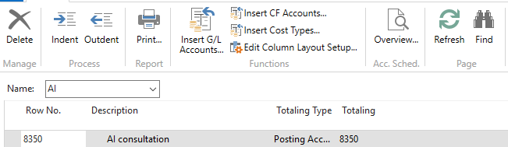

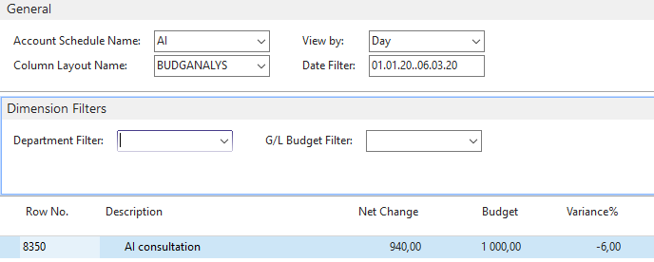

And then enter filter fro chosen dimension Deparment values (ADM od SALES)

