Simplified scenario Budget-Accounting schedule-Budgets – one budget account only Dynamics NAV-2018w1
Created by : Jaromír Skorkovský
Date : 10.12.2019

Reason : Orientation in the MS Dynamics NAV 2018. Material helping to understand basic accounting schedule and buderget principles
For : MPH_AOMA, MPH_AOPR,

Used database : MS Dynamics NAV 2018 W1 (British one) – RTS (role tailored client)
MS Dynamics NAV 2018 Czech – RTS
Used abbreviations : Q=question, G/L=General Ledger, Simple Scenario = SS,
PWP=Power-Point. PO-Purchase Order

This material is very useful for a better understanding of Accounting schedules and budgets. This material is related to more complex example handed over 6.11.2019

- Set up working date to 28.1.2021

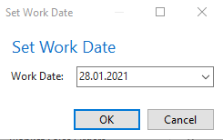

- Edit G/L Budget
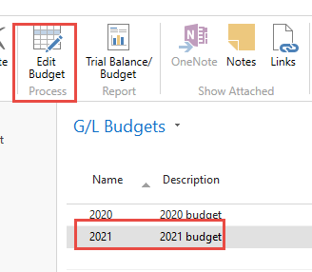

- In order to see only one-day use filters and Vie by: Day

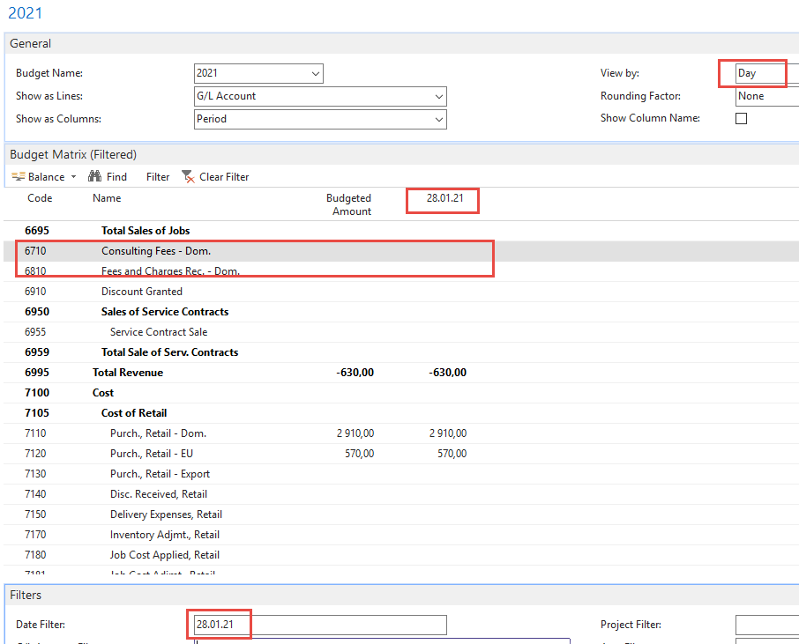

- Enter expected amount into budget field fro account 6710 (minus means debit side)

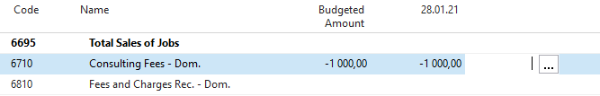

- Go to sales order and enter data into sale order line to create actual amount (use customer number 10000) and pos it by F9

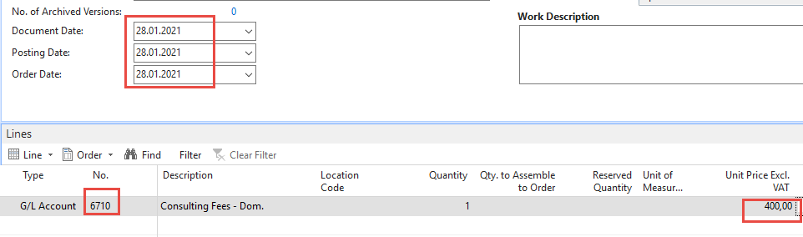

- See what was posted in G/L Registers

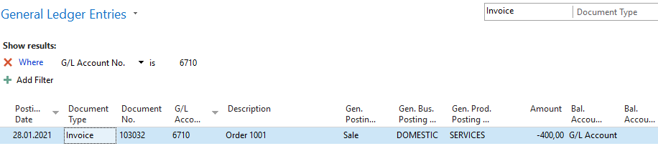

- Go to accounting schedule area

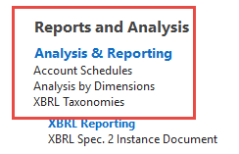

- Open it and create NEW

- By edit insert new G/L account /only one) – and to see absolute values check filed Show opposite Sign. Then confirm by OK

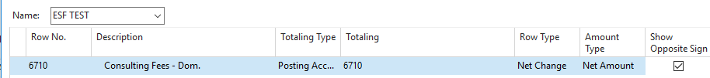

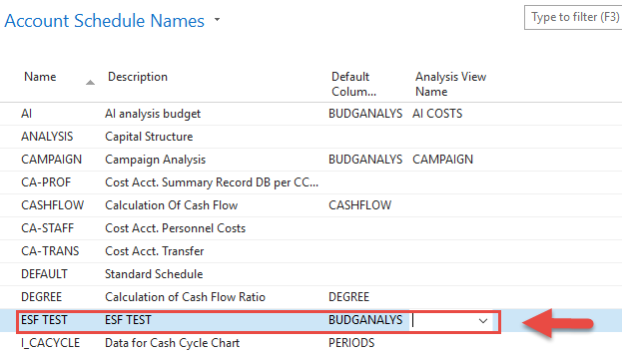

- Create a new Analysis View Name (advanced - NEW)

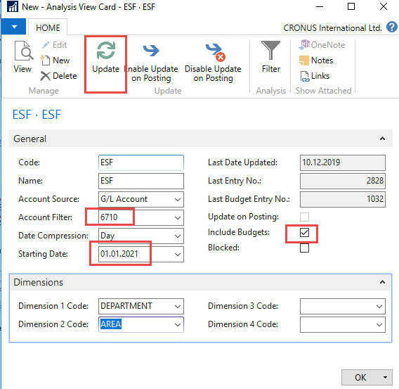

- You will get after Analysis View name creation

- Overview and you see, then only 40 % of the budget was OK.

