CRT construction task 1
It takes some experience to build a robust Current Reality Tree, which should not be done by a single person by the way (for the sake of robustness), and the best is to get used to read them first. A CRT has more or less a V shape with the topmost and numerous UDEs on the top, other UDEs that are causes from topmost UDEs and their own causes, and so on down to the few critical root causes, usually located (near or) on the base of the CRT. Once a tree is completed, it can be read either top-down or bottom-up. The construction is always top-down, from symptoms to causes to critical root causes.
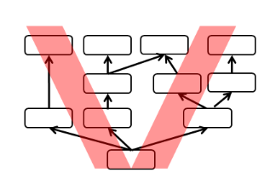
List of UDE (Undesirable Effects) –It looks like there may be more than one root problem!! Start always with final problems (impacts) harming your business !

- We do not stand out among competitors (unable to handle the competitive battle)
- Many competitors have similar offers
- Our offering is the only one we do have (we have only one product to offer)
- We lose our customers (we cannot attract new ones)
- Revenue is going down
- Our resources are more and more limited
- We have to copy competitors (we do not have strategy how to better than our competitors)
- In order to survive we have to offer lower selling price (our product is only copy of the ones offered by competitors)
- We cannot pay our company costs
- We have to close our business.

