**CRT construction task 6**

It takes some experience to build a robust Current Reality Tree, which should not be done by a single person by the way (for the sake of robustness), and the best is to get used to read them first. A CRT has more or less a V shape with the topmost and numerous UDEs on the top, other UDEs that are causes from topmost UDEs and their own causes, and so on down to the few critical root causes, usually located (near or) on the base of the CRT. Once a tree is completed, it can be read either top-down or bottom-up. The construction is always top-down, from symptoms to causes to critical root causes.

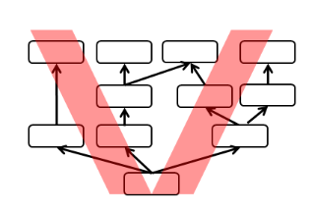

**List of UDE (Undesirable Effects) –**It looks like there may be more than one root problem!! Start always with final problems (impacts) harming your depressing situation! Especially if you are hungry!!!! There should be two significant Root problems (even these may represent one major problem). And it looks like three major impacts…

1. Some customers do not complain , they just do not return
2. The customer are dissatisfied with the steak
3. The cook do not prepare stake to the customer´s specification (rare, medium, well done..)
4. Some customers do not like the quality of steak house services
5. The grill is too hot
6. Some customer leave before being served due to long lines (waiting times)
7. The grill is too cool
8. The cook is overloaded
9. Meals are served with great delay
10. Future sales are lost
11. Current sales are lost
12. Not enough financial resources to repair (buy new) grill
13. Thanks to continuous adjustment of malfunctioning grill food preparation takes longer