Instructions
a) upgrade of the MS Dynamics NAV 2018 license
b) connection to the ORION terminal server
c) the location of the installation script
d) installation instructions for MS Dynamics NAV 2018

Created by: Jaromír Skorkovský, KPH-ESF-MU Czech Republic
Date: 08.09.2020
Reason: training, internal material
Database: MS Dynamics NAV 2018
Intended for students of courses (MPH_AOPR)

- upgrade of the MS Dynamics NAV 2018 license is not valid for international students because they do not have installed ERP MS Dynamics NAV 2018w1 so far

- Connection to the terminal server Orion Terminal Server

Students of the ESF faculty can access the faculty applications ASPI, Witness, MS Dynamics NAV 2018, or TaxEdit from a network outside the ESF. Access is provided through a connection to a terminal server.
For licensing reasons, access to the terminal server is only allowed to ESF students. Faculty staff do not have access to the terminal

The connection is possible from Windows 7 and later operating systems (using Remote Desktop with network-level authentication)

Possible connection method
Just start the client for "Remote Desktop Connection" (mstsc.exe). You will find the client:
In Windows 10, between programs under the letter "P"; Windows accessories; Remote Desktop Connection
When logging in to the "computer" field, enter the text: Orion.econ.mu¬ni.cz, or the IP address: 147.251.190.14
English version of the screen will be supplied later:

Connection to tet the remote screen

Computer: 147.251.190.14

User name: ESF/your name

Připojit =Connect

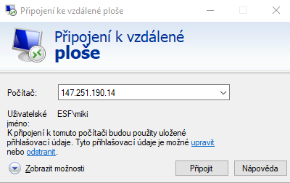

As a login for the login, type a string in the form: ESF \ your UČO
Use your faculty password as the password.

If you are notified of a problem with the certificate, select "YES" - connect.
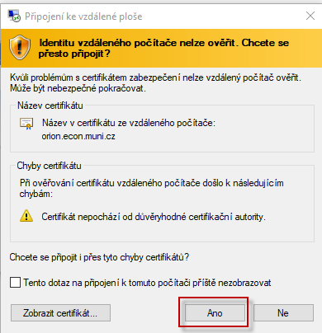

Start ERP Microsoft Dynamics NAV 2018w1 (English database) by the related icon.

- Instructions for installing MS Dynamics NAV 2018 using the installation script. The manual is intended for those students who have not yet installed this ERP system. It is a copy of the material that was part of the study materials for the summer semester 2020.

MS Dynamics Nav 2018w1+ home installation procedure
CZ + EN database

Minimum recommended PC configuration:
i5 processor or higher 8 GB RAM or more Windows 10 OS

You can find the source on the network in :
Programs (\\ ds02) (Q) \ MS Dynamics NAV \ NAV2018 directory
copy the whole subdirectory to your newly created TEMP directory (see below)

To download the entire package, the size of which is in the order of gigabytes,
you will need to be physically present at the ESF and connected to the faculty network. If for some
reason, you fail, then you will have to use the ORION server from time to time, where
the program we will work with is installed. There is no need to be physically on the ESF – remote
access is enough.

- If installed, uninstall older versions of MS NAV + older versions of Microsoft SQL Server
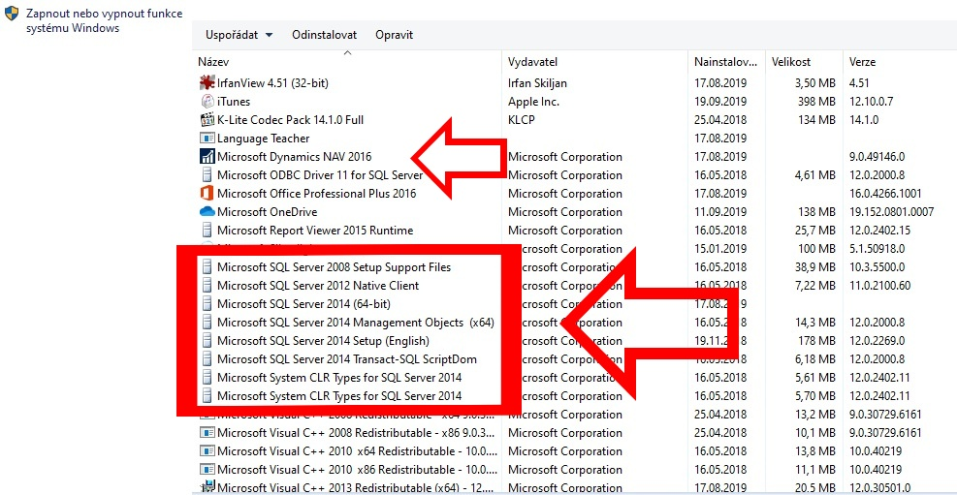

- Create a new C: \ Temp directory (if it does not exist)

- Copy the NAV2018 directory from the flash drive to C: \ Temp
(the directory C: \ Temp \ NAV2018 will be created)

- Find and Run C: \ Temp \ NAV2018 \ instal.cmd
!!! Run as Administrator - right-click - Run as Administrator as you can see below:

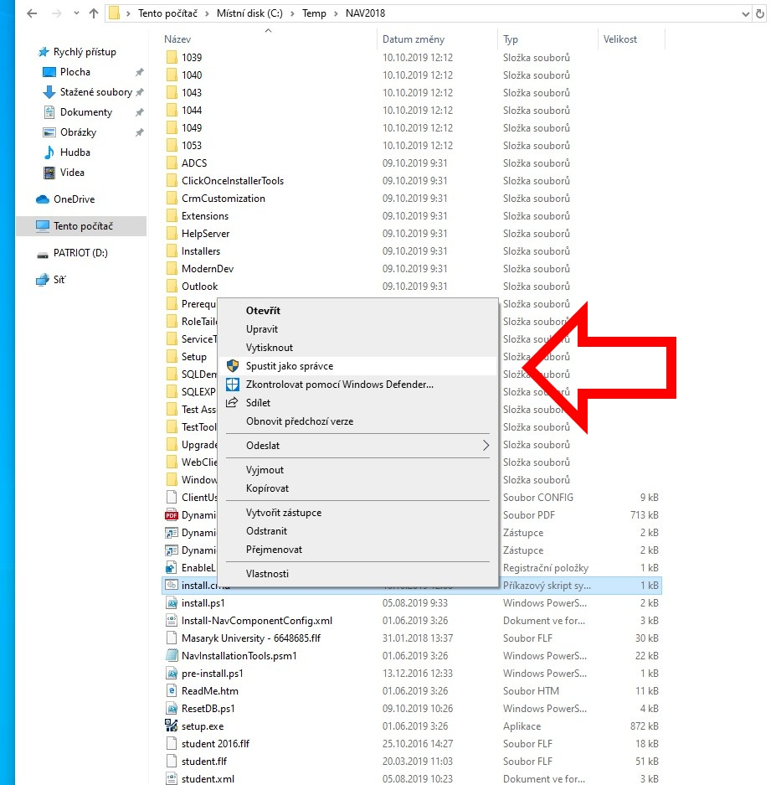

- Click through the installation guide for MS Dynamics NAV. Do not change anything during the wizard; confirm the default option “Install pre-configured product components.”

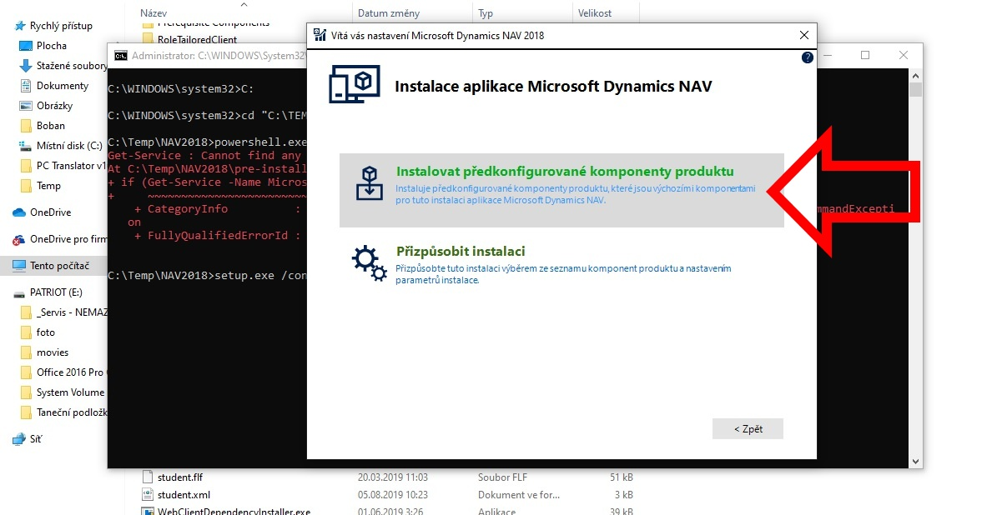

- If the installation script runs without problems, two icons for launching the Czech and English databases (“Dynamics NAV 2018” and “Dynamics NAV 2018 W1”) will appear on the desktop, and the program will start automatically twice for both databases.

