Preparation for midterm test
Structure of test:
- Quiz part: From start (introduction) and till PPE (including) – will be approx. 20 questions
- Calculus: From start (accruals) till Consolidated BS (including) – will be approx. 5 examples

Recommended preparation:
For practical part: I recommend to go through all files with calculations highlighted below:
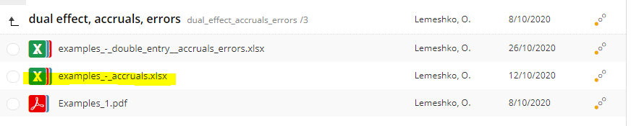
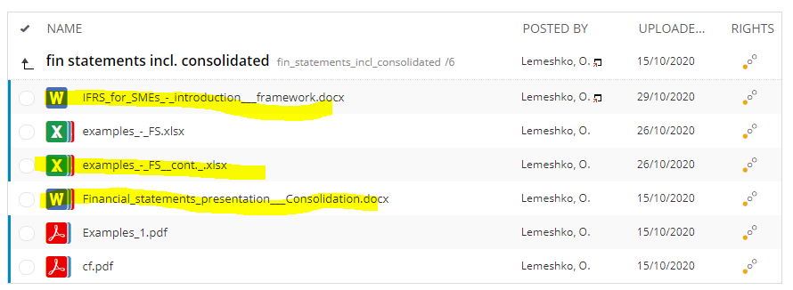
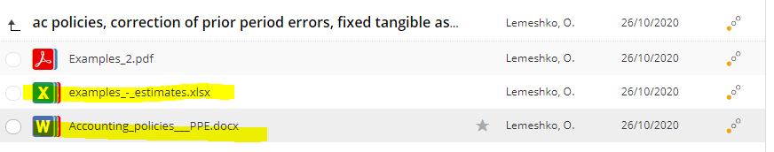

For theoretical part: answers to quiz questions you will find here:
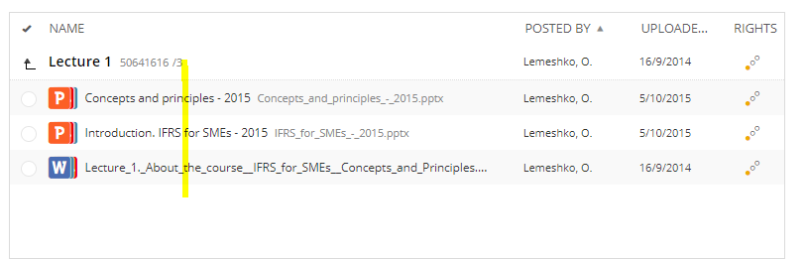
+ folders with lecture 2 and 3:
