Exercise session 5
Sulutions

Problem 1
Suppose that you have a sample of n individuals who apart from their mother tongue (Czech) can speak English, German, or are trilingual (i.e., all individuals in your sample speak in addition to their mother tongue at least one foreign language). You estimate the following model:
wage = β₀ + β₁educ + β₂IQ + β₃exper + β₄DM + β₅Germ + β₆Engl + ε ,
where

educ | . . . | years of education
IQ | . . . | IQ level
exper | . . . | years of on-the-job experience
DM | . . . | dummy, equal to one for males and zero for females
Germ | . . . | dummy, equal to one for German speakers and zero otherwise
Engl | . . . | dummy, equal to one for English speakers and zero otherwise

  - Explain why a dummy equal to one for trilingual people and zero otherwise is not included in the model.
If we included the dummy for people who are trilingual, we would have the complete set of dummies in the model (describing all three possible options - German speaker, English speaker, both foreign languages). Since we have the intercept in the model, this would lead to perfect multicollinearity.
  - Explain how you would test for discrimination against females (in the sense that ceteris paribus females earn less than males). Be specific: state the hypothesis, give the test statistic and its distribution.
For women, the dummy DM is equal to 0 and the model stands as follows:
wage = β₀ + β₁educ + β₂IQ + β₃exper + β₅Germ + β₆Engl + ε .
For men, the dummy DM is equal to 1 and the model stands as follows:
wage = β₀ + β₁educ + β₂IQ + β₃exper + β₄ + β₅Germ + β₆Engl + ε .
Therefore, ceteris paribus, the difference between the wage of men and the wage of women is equal to β₄. If this coefficient is positive, then men earn more than women. Hence, our hypothesis to be tested is
H₀ : β₄ ≤ 0 vs H_{A} : β₄ > 0 .
This leads to a one-sided t-test with the test statistic
$$t=\frac{\hat{β_{4}}}{SE(\hat{β_{4}})}\sim t_{n-k}$$
where k = 7 in this case. When we compute this test statistic, we compare it to the critical value t_{n-7,0.95}. If the test statistic is larger than this critical value, then we reject the H₀ at 95% confidence level and we conclude that there is discrimination against females. where k = 7 in this case. When we compute this test statistic, we compare it to the critical value t_{n-7,0.95}. If the test statistic is larger than this critical value, then we reject the H₀ at 95% confidence level and we conclude that there is discrimination against females.
  - Explain how you would measure the payoff (in terms of wage) to someone of becoming trilingual given that he can already speak (i) English, (ii) German.
The payoff of a trilingual person is
wage = β₀ + β₁educ + β₂IQ + β₃exper + β₄DM + β₅ + β₆ + ε ,
the payoff of a German speaking person is
wage = β₀ + β₁educ + β₂IQ + β₃exper + β₄DM + β₅ + ε ,
and the payoff of an English speaking person is
wage = β₀ + β₁educ + β₂IQ + β₃exper + β₄DM + β₆ + ε .
Hence, by becoming trilingual, a person who can already speak English gains β₅ and a person who can already speak German gains β₆. If we assume that both coefficients are positive, this payoff should be positive.
  - Explain how you would test if the influence of on-the-job experience is greater for males than for females. Be specific: specify the model, state the hypothesis, give the test statistic and its distribution.
To allow the on-the-job experience to be greater for males than for females, we have to define a slope coefficient on exper that would be different for males and for females. We can do so using the following model:
wage = β₀+β₁educ+β₂IQ+β₃exper+β₄DM +β₅Germ+β₆Engl+β₇exper·DM +ε .
Where we have created an interaction term exper*DM. In this case, the impact of on the on-the-job experience on wage would be β₃ for females and β₃ + β₇ for males. Hence, if β₇ is positive, then men gain more from experience than women. Hence, our hypothesis to be tested is
H₀ : β₇ ≤ 0 vs H_{A} : β₇ > 0 .
$$t=\frac{\hat{β_{7}}}{SE(\hat{β_{7}})}\sim t_{n-k}$$

where k = 8 in this case. When we compute this test statistic, we compare it to the critical value t_{n−8,0.95}. If the test statistic is larger than this critical value, then we reject the H₀ at 95% confidence level and we conclude that the influence of on-the-job experience is greater for males than for females.

Problem 2
Are rent rates influenced by the student population in a college town? Let rent be the average monthly rent paid on rental units in a college town in the United States. Let pop denote the total city population, avginc the average city income, and pctstu the student population as a percentage of the total population. One model to test for a relationship is
$$\log\left(rent\right)=β_{0}+β_{1}\log\left(pop\right)+β_{2}\log\left(avginc\right)+β_{3}pctstu+u$$
(i) State the null hypothesis that size of the student body relative to the population
has no ceteris paribus effect on monthly rents. State the alternative that there is an
effect.
$$H_{0}:β_{3}=0, H_{1}:β_{3}≠0$$
(ii) What signs do you expect for $β_{1}$ and $β_{2}$?
Other things equal, a larger population increases the demand for rental housing, which should increase rents. The demand for overall housing is higher when average income is higher, pushing up the cost of housing, including rental rates. Therefore, we expect positive signs.
(iii) The equation estimated using 1990 data from RENTAL.RAW for 64 college towns is
(0.844) (0 .039) (.081) (.0017)
$$\hat{\log\left(rent\right)}=0.43+0.066\log\left(pop\right)+0.507\log\left(avginc\right)+0.0056pctstu+u$$

$n=64, R^{2}=.458$

What is wrong with the statement: “A 10% increase in population is associated with
about a 6.6% increase in rent”? Interpret the coefficient on pctstu.
The coefficient on log(pop) is an elasticity. A correct statement is that “a 10% increase in population increases rent by .066*10 = .66%.”. Increasing the proportion of student population by one unit increases the rental rates by 0.56%.
(iv) Test the hypothesis stated in part (i) at the 1% level.
Test statistic $t=\frac{0.0056}{.0017}=3.29$
Critical value at 1% given the degree of freedom =64-4=60 and two-tailed student distribution will be 2.660, so we reject the null hypothesis that $β_{3}=0$

Problem 3
When estimating wage equations, we expect that young, inexperienced workers will have relatively low wages and that with additional experience their wages will rise, but then begin to decline after middle age, as the worker nears retirement. This lifecycle pattern of wages can be captured by introducing experience and experience squared to explain the level of wages. If we also include years of education, we have the equation:
$$Wage=β_{0}+β_{1}*Educ+β_{2}*Exper+β_{3}{Exper}^{2}+u$$
- What is the marginal effect of experience on wages? $β_{2}+2*β_{3}*Exper$
- What sign do you expect for each of the coefficients? Why? $β_{2}$ positive $β_{3}$ negative, because there should be diminishing marginal increase in the wages with experience
- Estimate the model using data cps_small.gdt. Do the estimated coefficients have expecting signs?
genr exp2=exper^2
ols wage const educ exper exp2
Output:
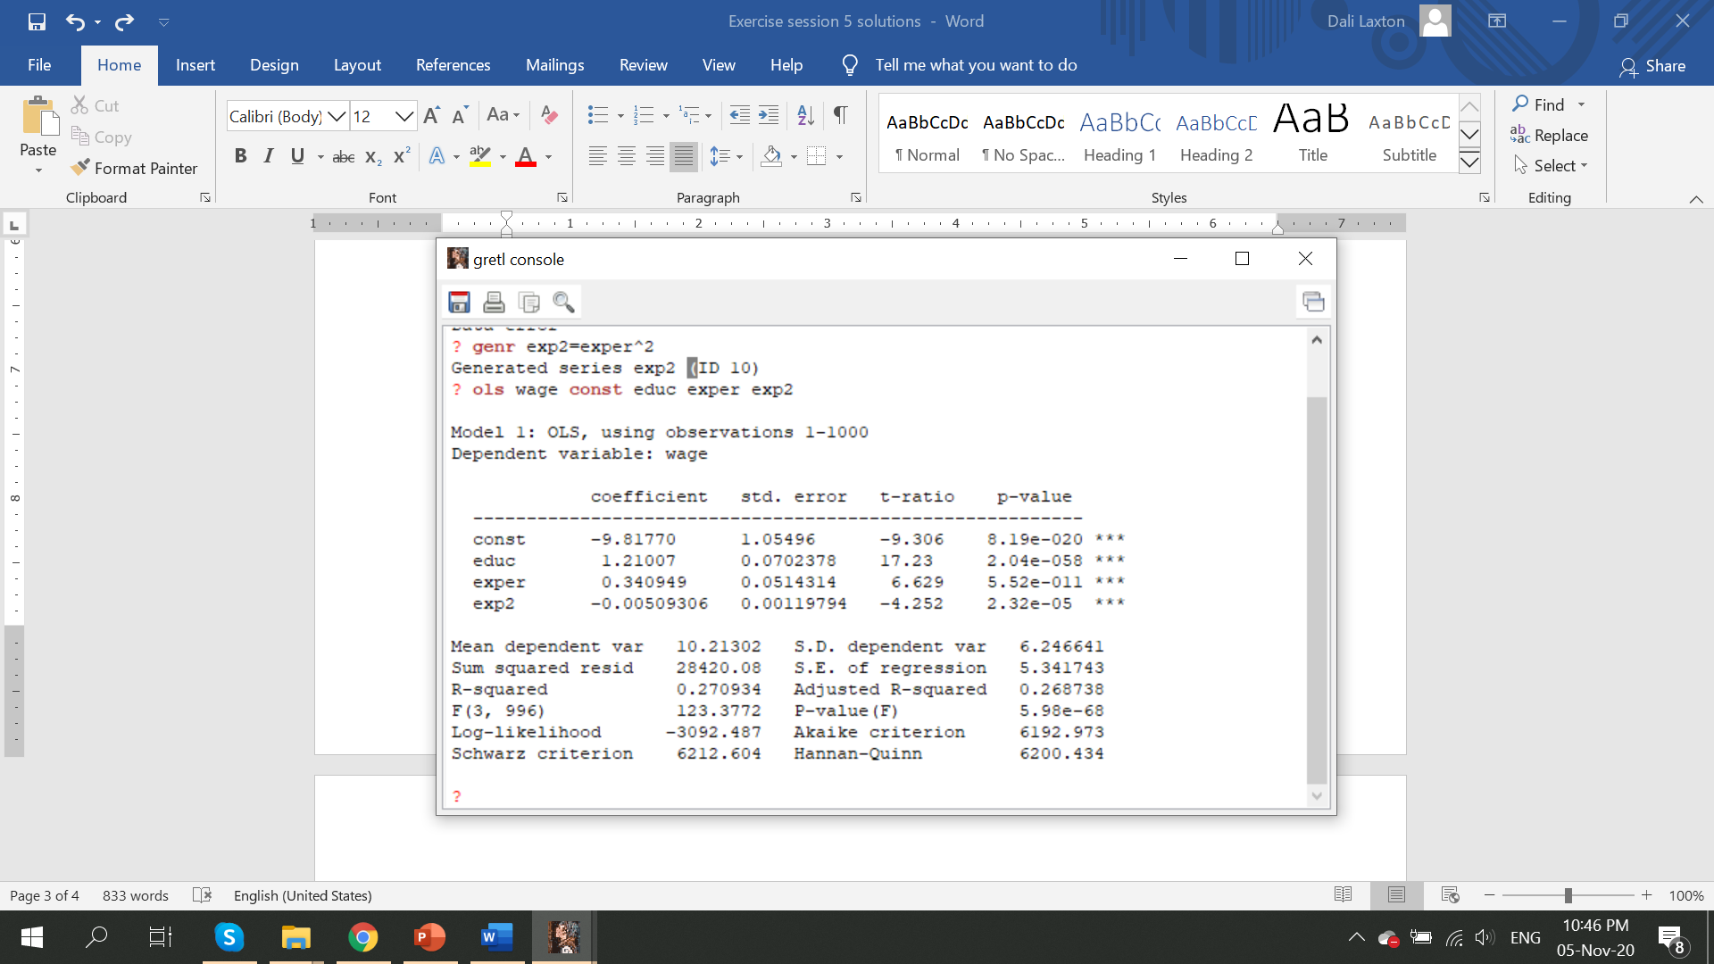
Yes
- Test the hypothesis that education has no effect on wages. What do you conclude?
Test statistic for educ is very large 17.23, therefore we reject such hypothesis even without looking at critical values
- Test the hypothesis that the explanatory variables have no effect on wages. What do you conclude?
Here we are testing a joint hypothesis that $β_{1},β_{2} and β_{3}=0$, which we already have in GRETL output. See red circle in the GRETL output. The p-value is very small, therefore we reject H₀
- Include the dummy variable black in the regression. Interpret the coefficient and comment on its significance.
ols wage const educ exper exp2 black

The coefficient on black is -1.71, which means that being black rather than white reduces your wages by 1.71 dollars per hour. The coefficient on black is statistically significant at the 1% level since test statistic is -2.882 and the critical value in the student table is -2.57. Also P-Value=0.004<0.01, meaning statistically significant at 1% level. Three stars in the end of variables are also indicators of statistical significance at 1% level.
- Include the interaction term of black and educ. Interpret the coefficient and comment on its significance.
genr bleduc=black*educ
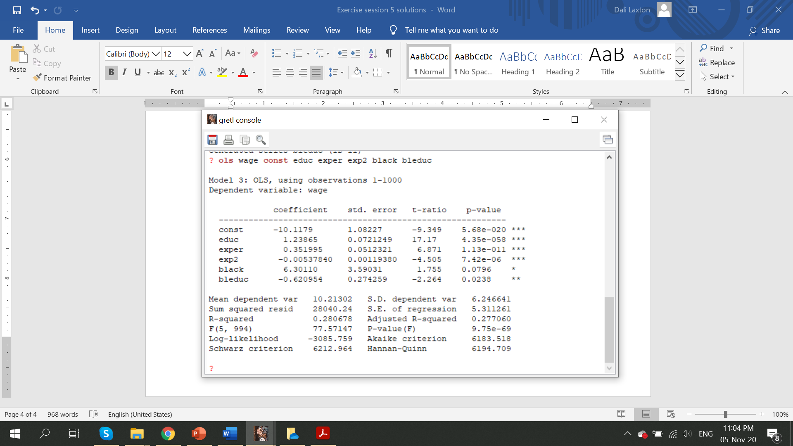
Coefficient on bleduc implies that for each extra year of education blacks receive less wages than whites by 0.62. It is statistically significant at the 5% level (2 stars). Including this term also reduces significance of the black variable alone and strangely, changes its sign to positive.
- Transform dependent variable in logarithmic form and estimate the equation. Interpret the coefficients.
genr lwage=log(wage)
ols lwage const educ exper exp2 black bleduc

Increasing educ by one year increases the wage by 11%
Increasing exper by one year increases the wage by 100*(0.03-0.0006*exper) percent
Black and bleduc do not have significant impact on logarithmic wages

Problem 4
Given the following regression model:
𝐼𝑛𝑓𝑙𝑎𝑡𝑖𝑜𝑛_{𝑖} = 𝛽₀ + 𝛽₁𝐼𝑛𝑡𝑒𝑟𝑒𝑠𝑡𝑅𝑎𝑡𝑒_{𝑖} + 𝑢_{𝑖}
Where both variables are measured in percentage points, a sample of 100 countries is used in order to estimate the above model and the following information is given:
𝑉𝑎𝑟(𝐼𝑛𝑓𝑙𝑎𝑡𝑖𝑜𝑛_{𝑖} ) = 100; 𝑉𝑎𝑟(𝐼𝑛𝑡𝑒𝑟𝑒𝑠𝑡𝑅𝑎𝑡𝑒_{𝑖} ) = 50; 𝐶𝑜𝑣(𝐼𝑛𝑓𝑙𝑎𝑡𝑖𝑜𝑛_{𝑖} ,𝐼𝑛𝑡𝑒𝑟𝑒𝑠𝑡𝑅𝑎𝑡𝑒_{𝑖} ) = −25; 𝑆𝑆𝑅 = 49
- Find the OLS estimation of the effect of interest rates on inflation and the estimated standard error.
$$β_{1}=-\frac{25}{50}=-0.5$$

$$σ^{2}=VAR\left(u_{i}\right)=\frac{SSR}{n-2}=\frac{49}{98}⟹σ=0.71$$

$$SE\left(β_{1}\right)=\frac{σ}{\sqrt{n*var\left(Interest Rate\right)}}=\frac{0.71}{\sqrt{100*50}}=0.01$$

- Interpret your estimation results. If interest rate increases by 1%, then inflation reduces by 0.5 percentage points
- Calculate a one-tailed t-test in order to validate the significance of the estimated slope coefficient at 1% significance level.
T=-0.5/0.01=-50 it is statistically significant at the 1% level
- What could you say about the explanatory power of the above model?
SST=n*Var(inflation)=100*100=10000
R²= SSE/SST=(SST-SSR)/SST=(10000-49)/10000=0.99 very high explanatory power

