**Exercise 7**

To examine the quantity theory of money, Brumm (2005) [‘‘Money Growth, Output Growth, and Inflation: A Reexamination of the Modern Quantity Theory’s Linchpin Prediction,’’ *Southern Economic Journal*, 71(3), 661–667] specifies the equation:

where *INFLAT* is the growth rate of the general price level, *MONEY* is the growth rate of the money supply, and *OUTPUT* is the growth rate of national output. According to theory we should observe that and . The data used in this paper is contained in the file *brumm.gdt*. It consists of 1995 year data on 76 countries.

1. Estimate the model by OLS and interpret all the parameters.

**ols Inflation const Money Output**

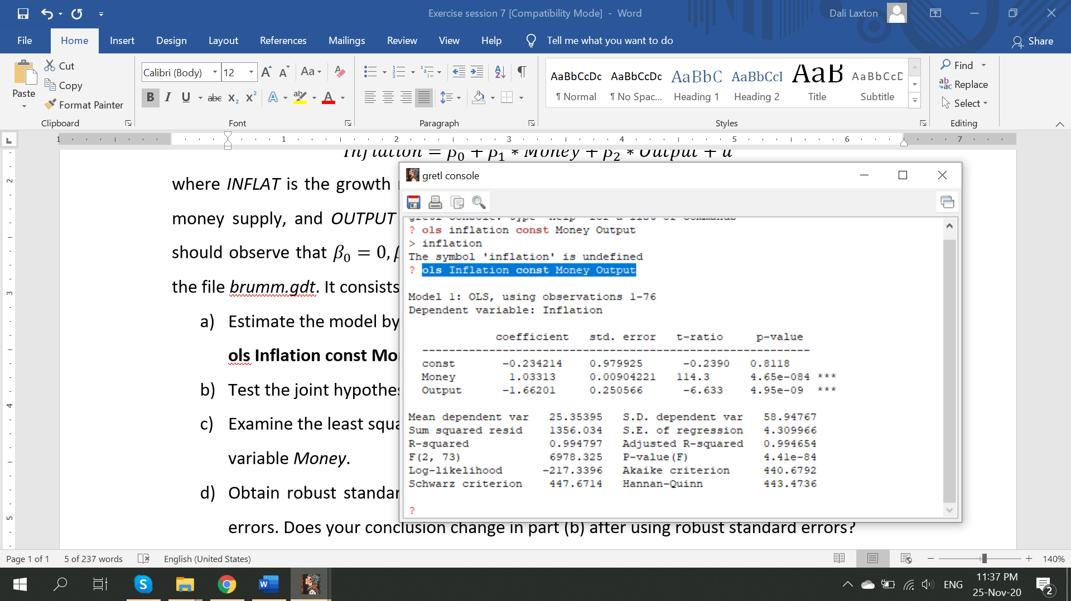

1. Test the joint hypothesis that and . What do you conclude?

**restrict**

**b[1] = 0**

**b[2] = 1**

**b[3] = -1**

**end restrict**

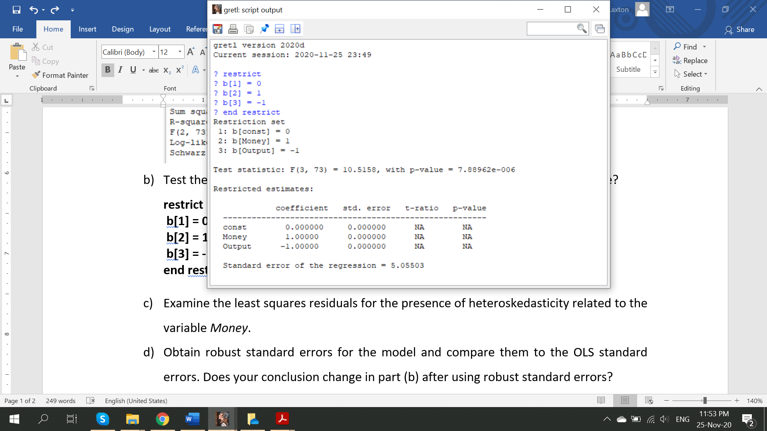

1. Examine the least squares residuals for the presence of heteroskedasticity related to the variable *Money*.

**series resid=$uhat**

**gnuplot resid_sq Money**

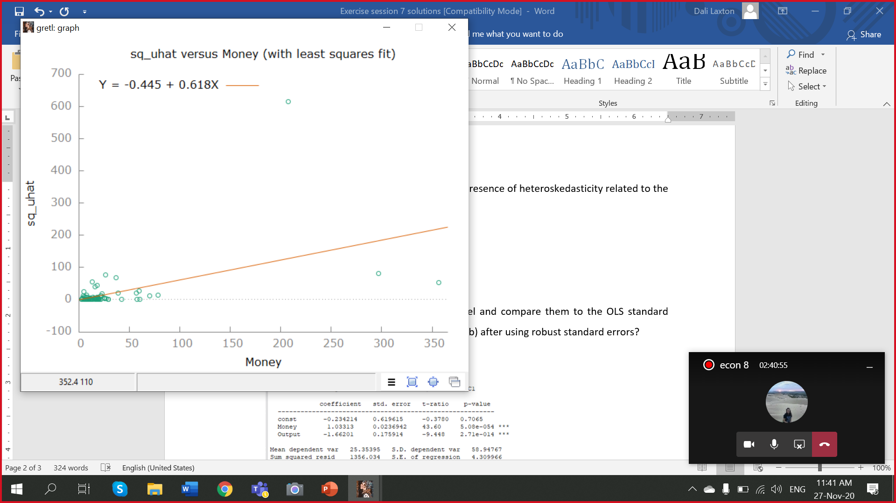

**modtest --white**

1. Obtain robust standard errors for the model and compare them to the OLS standard errors. Does your conclusion change in part (b) after using robust standard errors?

**ols Inflation const Money Output –robust**

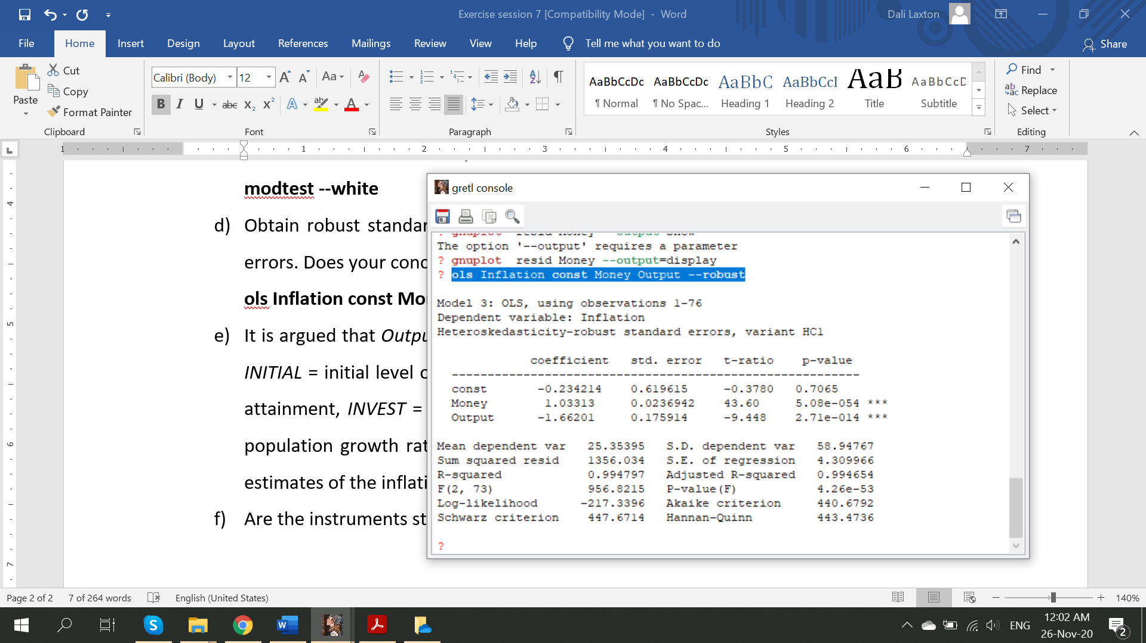

**Conclusion does not change – they are jointly not equal to the theoretical parameters**

1. It is argued that *Output* may be endogenous. Four instrumental variables are proposed, *INITIAL* = initial level of real GDP, *SCHOOL* = a measure of the population’s educational attainment, *INVEST* = average investment as a share of GDP, and *POPRATE* = average population growth rate. Using these instruments, obtain instrumental variables (2SLS) estimates of the inflation equation (do the two stage procedure).

**First stage:**

**ols Output const initial poprate school invest Money**

**series Output_hat=$yhat**

**Second stage:**

**ols Inflation const Money Output_hat**

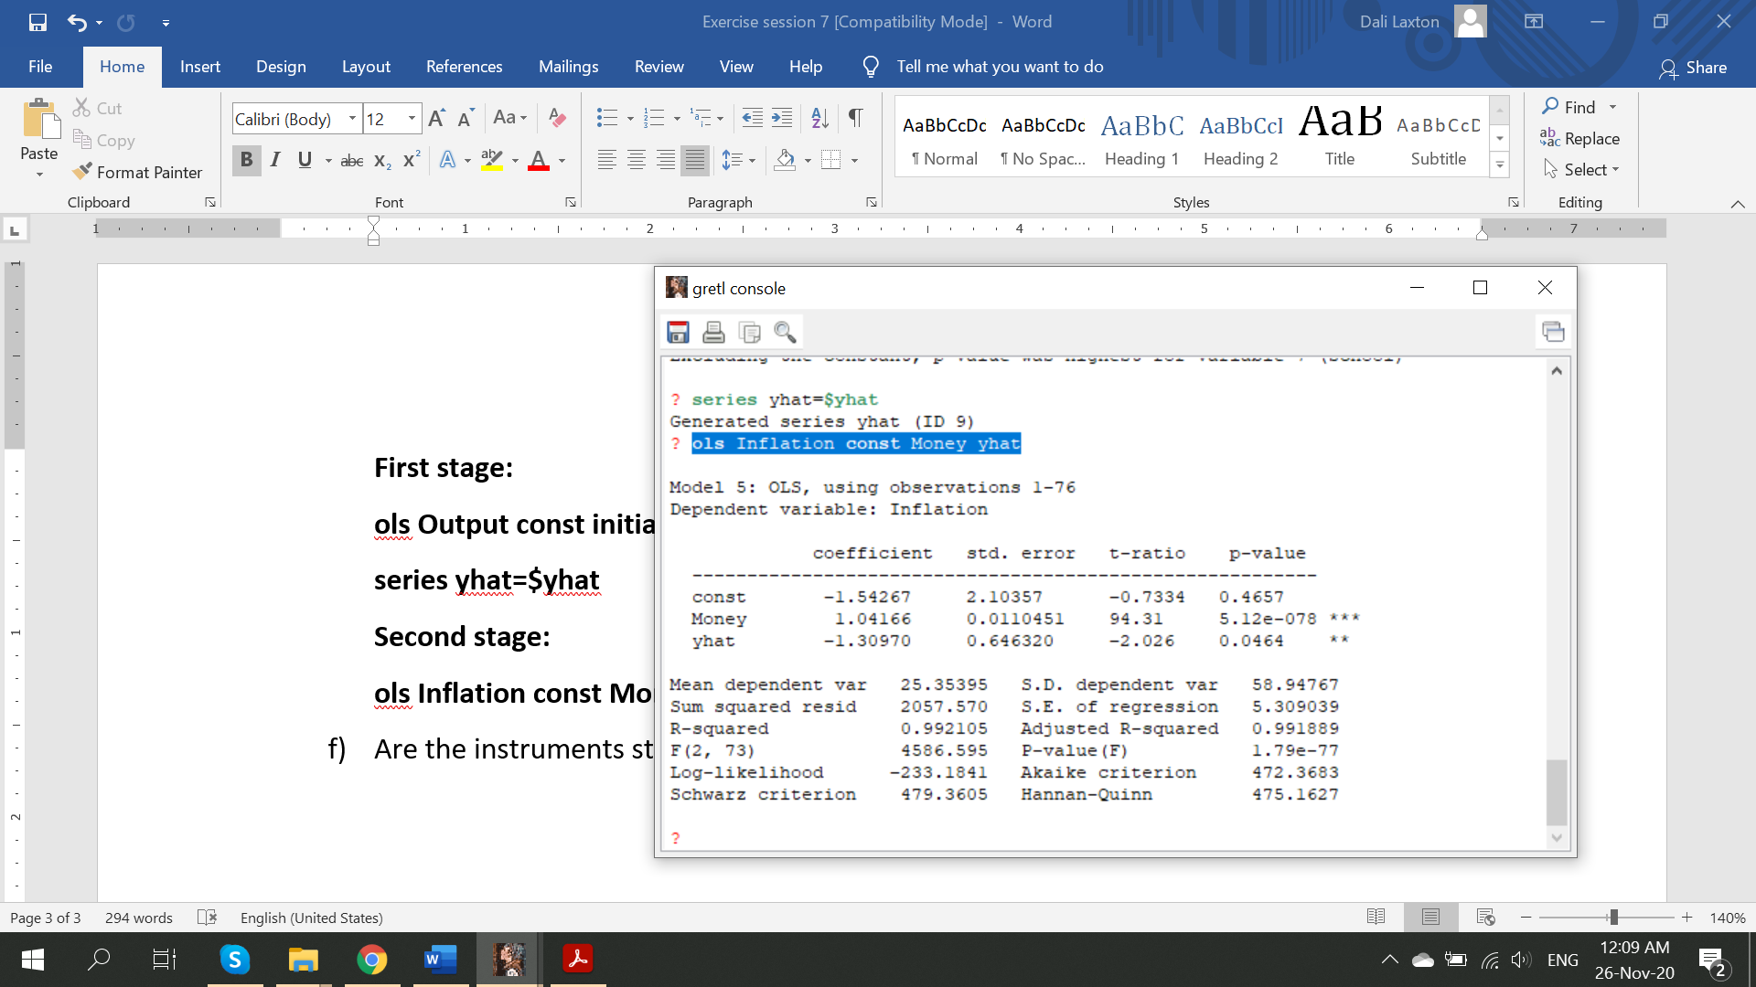

1. Are the instruments strong? **Only invest predicts the Output significantly, other variables are weak instruments. The theoretical parameters are again jointly rejected. The impact of output on the inflation is now lower than before.**