Exercise session 2

**Answer the following questions**

1. Give three examples of important tradeoffs that you face in your life.
2. Why should policymakers think about incentives?
3. Explain the two main causes of market failure and give an example of each.
4. The company that you manage has invested $5 million in developing a new product, but the development is not quite finished. At a recent meeting, your salespeople report that the introduction of competing products has reduced the expected sales of your new product to $3 million. If it would cost $1 million to finish development and make the product, should you go ahead and do so? What is the most that you should pay to complete development?
5. Analyze what happens to the market for pizza if the price of tomatoes rises.
6. Does a change in producers’ technology lead to a movement along the supply curve or a shift in the supply curve? Does a change in price lead to a movement along the supply curve or a shift in the supply curve?
7. Explain each of the following statements using supply and demand diagrams.
   1. When a cold snap hits Florida, the price of orange juice rises in supermarkets throughout the US.
   2. When the weather turns warm in New England every summer, the prices of hotel rooms in Caribbean resorts plummet.
   3. When a war breaks out in the Middle East, the price of gasoline rises, while the price of a used Cadillac falls.
8. Because bagels and cream cheese are often eaten together, they are complements.
   1. We observe that both the equilibrium price of cream cheese and the equilibrium quantity of bagels have risen. What could be responsible for this pattern—a fall in the price of flour or a fall in the price of milk? Illustrate and explain your answer.
   2. Suppose instead that the equilibrium price of cream cheese has risen but the equilibrium quantity of bagels has fallen. What could be responsible for this pattern—a rise in the price of flour or a rise in the price of milk? Illustrate and explain your answer.
9. Suppose that the price of basketball tickets at your college is determined by market forces. Currently, the demand and supply schedules are as follows:

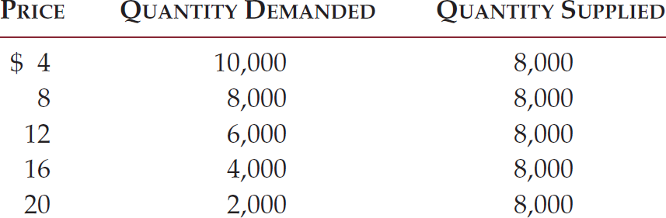

* 1. Draw the demand and supply curves. What is unusual about this supply curve? Why might this be true?
  2. What are the equilibrium price and quantity of tickets?
  3. Your college plans to increase total enrollment next year by 5,000 students. The additional students will have the following demand schedule:

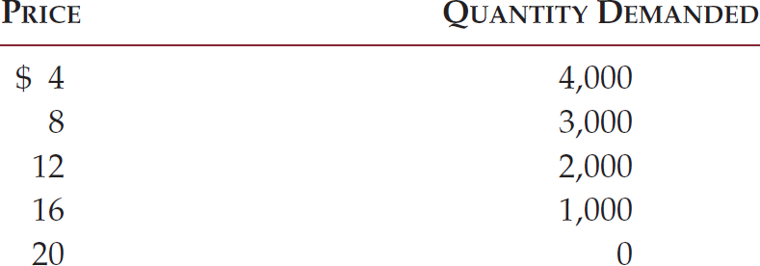

Now add the old demand schedule and the demand schedule for the new students to calculate the new demand schedule for the entire college. What will be the new equilibrium price and quantity?