Exercise session 2 solutions

Answer the following questions

- Give three examples of important tradeoffs that you face in your life.

Answer: …

- Why should policymakers think about incentives?

Answer: Policymakers need to think about incentives so they can understand how people will respond to the policies they put in place. The text’s example of seat belt laws shows that policy actions can have unintended consequences. If incentives matter a lot, they may lead to a very different type of policy; for example, some economists have suggested putting knives in steering columns so that people will drive much more carefully! While this suggestion is silly, it highlights the importance of incentives.

- Explain the two main causes of market failure and give an example of each.

Answer: The two main causes of market failure are externalities and market power. An externality is the effect of one person’s actions on the well-being of a bystander, such as from pollution or the creation of knowledge. Market power refers to the ability of a single consumer/producer to unduly influence market prices, such as in a town with only one well or only one cable television company.

- The company that you manage has invested $5 million in developing a new product, but the development is not quite finished. At a recent meeting, your salespeople report that the introduction of competing products has reduced the expected sales of your new product to $3 million. If it would cost $1 million to finish development and make the product, should you go ahead and do so? What is the most that you should pay to complete development?

Answer: The fact that you have already sunk $5 million is not relevant to your decision anymore, because that money is gone. What matters now is the chance to earn profits at the margin. If you spend another $1 million and can generate sales of $3 million, you’ll earn $2 million in marginal profit, so you should do so. You are right to think that the project has lost a total of $3 million ($6 million in costs and only $3 million in revenue) and you should not have started it. However, if you do not spend the additional $1 million, you will not have any sales and your losses will be $5 million. What matters now is minimizing your loss. In fact, you would pay up to $3 million to complete development; any more than that, and you will not be increasing profit at the margin.

- Analyze what happens to the market for pizza if the price of tomatoes rises.

Answer: If the price of tomatoes rises, the supply curve for pizza shifts to the left because there has been an increase in the price of an input into pizza production, but there is no shift in demand. The shift to the left of the supply curve causes the equilibrium price to rise and the equilibrium quantity to decline, as figure below shows.
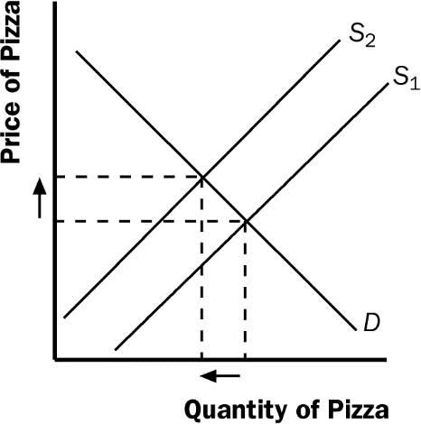

- Does a change in producers’ technology lead to a movement along the supply curve or a shift in the supply curve? Does a change in price lead to a movement along the supply curve or a shift in the supply curve?
Answer: A change in producers' technology leads to a shift in the supply curve. A change in price leads to a movement along the supply curve.

- Explain each of the following statements using supply and demand diagrams.

  - When a cold snap hits Florida, the price of orange juice rises in supermarkets throughout the US.
Answer: Cold weather damages the orange crop, reducing the supply of oranges and raising the price of oranges. This leads to a decline in the supply of orange juice because oranges are an important input in the production of orange juice. This can be seen in Figure 1 as a shift to the left in the supply curve for orange juice. The new equilibrium price is higher than the old equilibrium price.
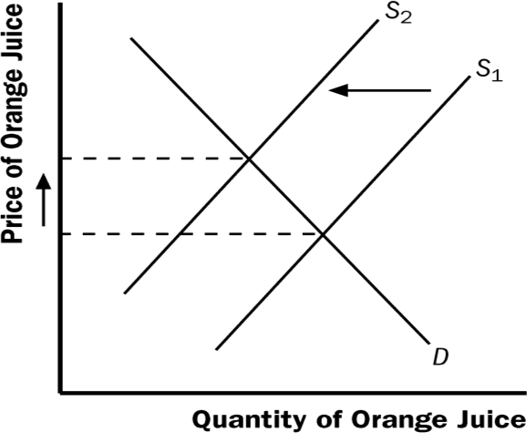

Figure 1

  - When the weather turns warm in New England every summer, the prices of hotel rooms in Caribbean resorts plummet.
Answer: People often travel to the Caribbean from New England to escape cold weather, so the demand for Caribbean hotel rooms is high in the winter. In the summer, fewer people travel to the Caribbean, because northern climates are more pleasant. The result, as shown in Figure 2, is a shift to the left in the demand curve. The equilibrium price of Caribbean hotel rooms is thus lower in the summer than in the winter, as the figure shows.

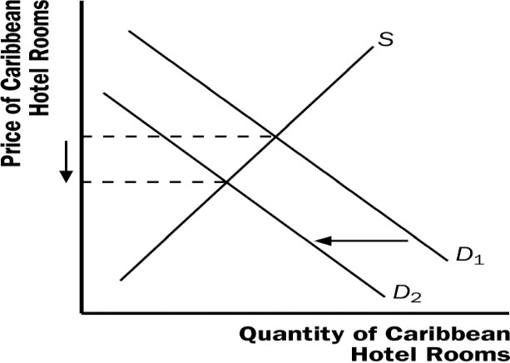

Figure 2

  - When a war breaks out in the Middle East, the price of gasoline rises, while the price of a used Cadillac falls.
Answer: When a war breaks out in the Middle East, many markets are affected. Because a large proportion of oil production takes place there, the war disrupts oil supplies, shifting the supply curve for gasoline to the left, as shown in Figure 3. The result is a rise in the equilibrium price of gasoline. With a higher price for gasoline, the cost of operating a gas-guzzling automobile like a Cadillac will increase. As a result, the demand for used Cadillacs will decline, as people in the market for cars will not find Cadillacs as attractive. In addition, some people who already own Cadillacs will try to sell them. The result is that the demand curve for used Cadillacs shifts to the left, while the supply curve shifts to the right, as shown in Figure 4. The result is a decline in the equilibrium price of used Cadillacs.
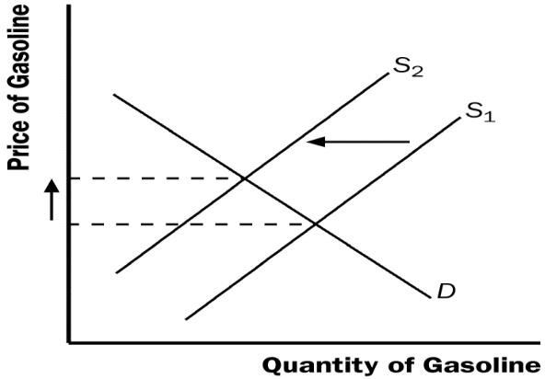
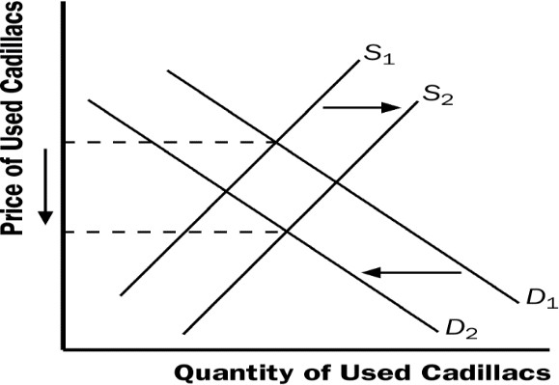

Figure 3 Figure 4

- Because bagels and cream cheese are often eaten together, they are complements.

  - We observe that both the equilibrium price of cream cheese and the equilibrium quantity of bagels have risen. What could be responsible for this pattern—a fall in the price of flour or a fall in the price of milk? Illustrate and explain your answer.
Answer: Because flour is an ingredient in bagels, a decline in the price of flour would shift the supply curve for bagels to the right. The result, shown in Figure 5, would be a fall in the price of bagels and a rise in the equilibrium quantity of bagels.
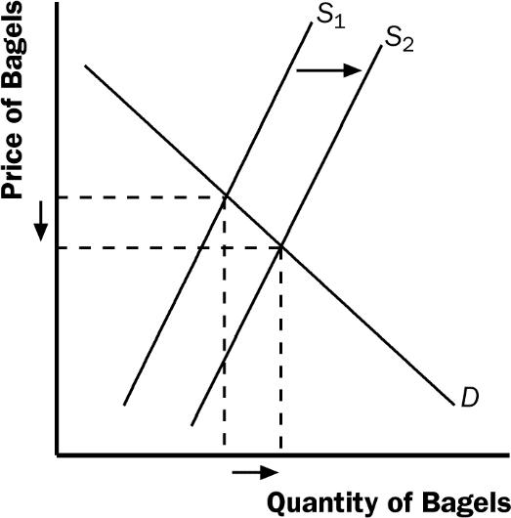

Figure 5

Because cream cheese is a complement to bagels, the fall in the equilibrium price of bagels increases the demand for cream cheese, as shown in Figure 6. The result is a rise in both the equilibrium price and quantity of cream cheese. So, a fall in the price of flour indeed raises both the equilibrium price of cream cheese and the equilibrium quantity of bagels.
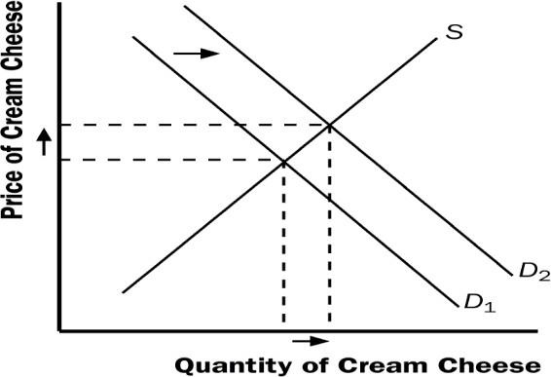
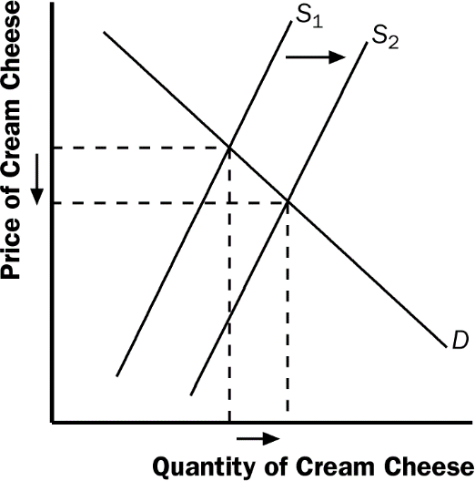

Figure 6 Figure 7

What happens if the price of milk falls? Because milk is an ingredient in cream cheese, the fall in the price of milk leads to an increase in the supply of cream cheese. This leads to a decrease in the price of cream cheese (Figure 7), rather than a rise in the price of cream cheese. So a fall in the price of milk could not have been responsible for the pattern observed.

  - Suppose instead that the equilibrium price of cream cheese has risen but the equilibrium quantity of bagels has fallen. What could be responsible for this pattern—a rise in the price of flour or a rise in the price of milk? Illustrate and explain your answer.
Answer: In part (a), we found that a fall in the price of flour led to a rise in the price of cream cheese and a rise in the equilibrium quantity of bagels. If the price of flour rose, the opposite would be true; it would lead to a fall in the price of cream cheese and a fall in the equilibrium quantity of bagels. Because the question says the equilibrium price of cream cheese has risen, it could not have been caused by a rise in the price of flour.
What happens if the price of milk rises? From part (a), we found that a fall in the price of milk caused a decline in the price of cream cheese, so a rise in the price of milk would cause a rise in the price of cream cheese. Because bagels and cream cheese are complements, the rise in the price of cream cheese would reduce the demand for bagels, as Figure 8 shows. The result is a decline in the equilibrium quantity of bagels. So a rise in the price of milk does cause both a rise in the price of cream cheese and a decline in the equilibrium quantity of bagels.
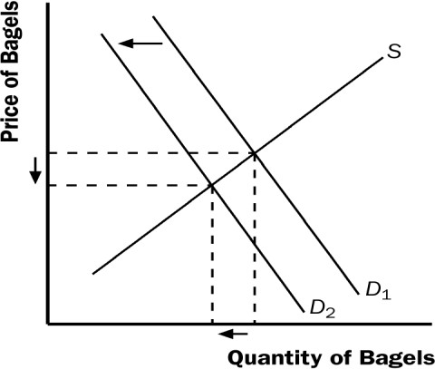

Figure 8

- Suppose that the price of basketball tickets at your college is determined by market forces. Currently, the demand and supply schedules are as follows:
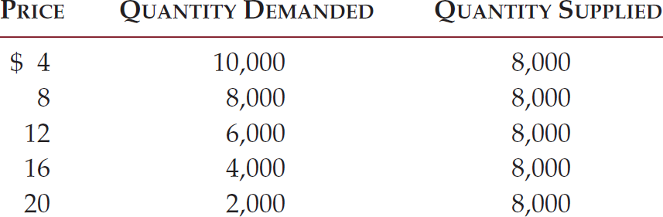

  - Draw the demand and supply curves. What is unusual about this supply curve? Why might this be true?
Answer: As Figure 35 shows, the supply curve is vertical. The constant quantity supplied makes sense because the basketball arena has a fixed number of seats at any price.
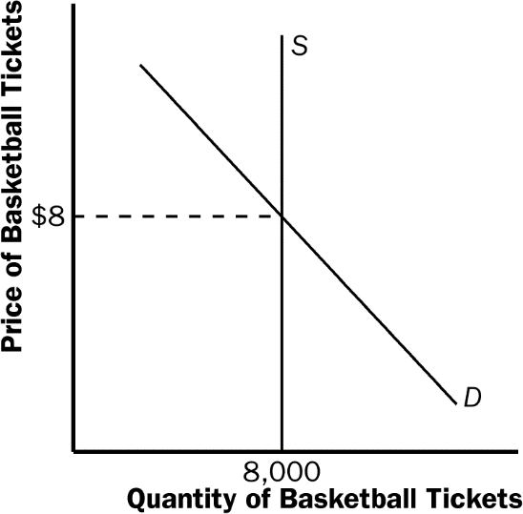

Figure 9

  - What are the equilibrium price and quantity of tickets?

Answer: Quantity supplied equals quantity demanded at a price of $8. The equilibrium quantity is 8,000 tickets.

  - Your college plans to increase total enrollment next year by 5,000 students. The additional students will have the following demand schedule:
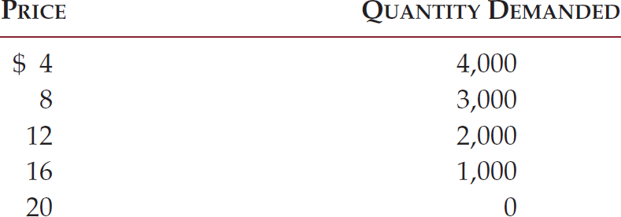

Now add the old demand schedule and the demand schedule for the new students to calculate the new demand schedule for the entire college. What will be the new equilibrium price and quantity?

Answer:

Price | Quantity Demanded | Quantity Supplied
$4 | 14,000 | 8,000
$8 | 11,000 | 8,000
$12 | 8,000 | 8,000
$16 | 5,000 | 8,000
$20 | 2,000 | 8,000

The new equilibrium price will be $12, which equates quantity demanded to quantity supplied. The equilibrium quantity remains 8,000 tickets.

