Case #9. Cobalt Miners in Greenland Face an Uncertain Environment

This case is based on excerpts from two articles:

“Cobalt poses human rights test for Biden on clean energy,” E&E News, March 15, 2022

https://www.eenews.net/articles/cobalt-poses-human-rights-test-for-biden-on-clean-energy/
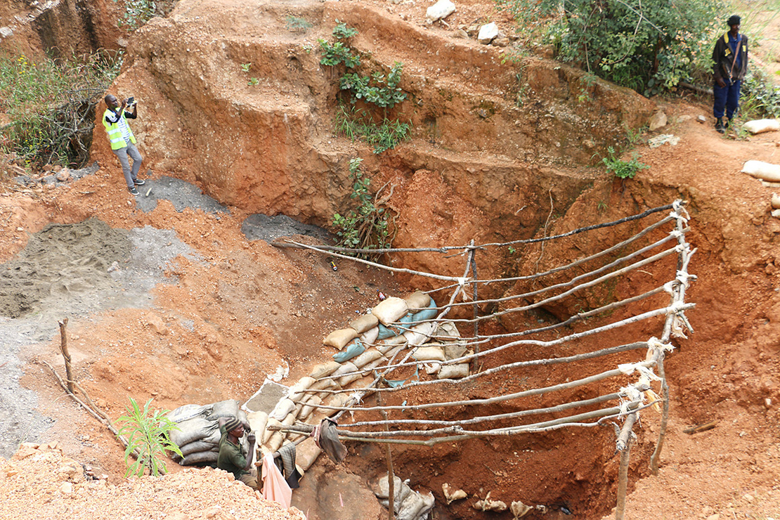
Part of a cobalt mine in Katanga province in the Democratic Republic of Congo. Fairphone/Flickr

the total quantity of cobalt produced by mines in the DRC has doubled in the last decade, from 60,000 tonnes in 2010 to 120,000 tonnes in 2021.
The Democratic Republic of Congo (DRC), sometimes called the “the Saudi Arabia of the electric vehicle age,” produces about 70 percent of the world’s cobalt. About 80 percent of cobalt processing occurs in China before being incorporated into lithium-ion batteries.
But given the country’s dominance, auto and technology companies are effectively stuck sourcing from the DRC, advocates say, until engineers figure out how to make cheap cobalt-free batteries.
“There’s just no appetite in America for this at the moment,” said Anneke Van Woudenberg, executive director of U.K.-based human rights organization, Rights and Accountability in Development (RAID) .
In 2021, allegations of forced labor in Chinese polysilicon factories prompted the US Congress to pass a blanket ban on solar imports tied to one region of that country. Customs officials impounded huge shipments from at least three companies, and blacklisted one major Chinese supplier. Polysilicon is a key input for most types of solar panels.
Products using Congolese cobalt, like the lithium-ion batteries used in EVs and energy storage, have escaped those kinds of enforcement actions. Advocates say that’s because while the conditions in many Congolese cobalt mines are brutal — featuring low pay, long hours, harsh conditions and, sometimes, abuse from superiors — they fail to meet the standard for forced labor. That’s a key legal distinction that can prompt abrupt seizures by customs guards and other tough measures.
Still, the Biden Administration has refused to categorically rule out the existence of forced labor in Congolese cobalt mines…
The US Interior Department released a set of principles for sourcing minerals, which stressed the importance of “socially responsible” mining. The Energy Department unleashed a voluminous set of reports on supply chains, identifying cobalt supplied from Congo as a risk for manufacturers and a need to promote human rights standards at mines abroad.
A US Department of Energy report identified cobalt as an area in the lithium-ion battery supply chain where the department wants to see “environmental, climate or human rights issues” in the supply chain “adequately addressed.” However, that report did not address reports of human rights abuses at Congolese mines.

Advocates also hesitant
Compared to the solar panel actions, few people are advocating for the U.S. to use the blunt instrument of government to reign in bad actors in the world of cobalt mining.
“I don’t know if any NGO is filing that kind of complaint for cobalt,” said Jim Wormington, senior researcher for Human Rights Watch. “The main reason why they probably wouldn’t do that is that even pro-human rights groups don’t want Congolese cobalt to not be bought.”
ndeed, Western human rights advocates, or their Congolese affiliates, aren’t eager to see strict sanctions against cobalt buyers, for fear of endangering miners’ livelihoods in a deeply impoverished part of the world.
“No one amongst those actors are advocating for a move away from cobalt production in DRC,” said Daniel Mulé, a policy lead on extractive industries for Oxfam America. “I don’t think that’s the right approach for [original equipment manufacturers], vehicle manufacturers or from the U.S government.”
Organized labor hasn’t pressed their interest in onshoring of cobalt mining either. Although most cobalt from DRC goes to China for processing and many mines are owned by Chinese companies, China-hawk conservatives have, for the most part, also stayed out of the fray. Even American cobalt miners don’t want to see a clampdown hit their biggest competition.
The predicament raises a question: When might cobalt’s human rights record undermine the work of electric automakers and battery companies?
“The answer is, as soon as it’s prioritized by politicians in the United States,” said Morgan Bazilian, professor and director of the Payne Institute for Public Policy at the Colorado School of Mines. “It’s as simple as that.”
The U.S. has cracked down on Congolese minerals before.
Congress included language in the 2010 financial law that targeted the sale of conflict minerals from the DRC. The goal was to address profits from four commodities mined in Congo — gold, tin, tantalum and tungsten — that civil society groups linked to violence in the aftermath of the Second Congo War.
Cobalt mining first sparked media interest years later, in 2016, when Amnesty International released a report documenting child miners at informal mine sites known colloquially as “artisanal mines.”
About 40,000 children labored in those mines, making up about one-fifth of the world’s cobalt supply at the time, the group estimated…
Manufacturers have sought to address the human rights dilemma by cutting cobalt out of their supply streams. Although cobalt-free batteries are not considered by automakers to be ready for wide use in EVs, Tesla Inc. and other EV manufacturers do plan to wean off the metal over time.
At the same time, through corporate responsibility initiatives, companies have deployed complicated webs of certification — like the a — to answer any concerns about human rights in their cobalt supplies themselves.
Those involved in this system of industry-led checks say it’s a step in the right direction.
“They’re not perfect, but [companies] actually are doing quite a good job on them,” said Raphaël Deberdt, a minerals program associate at the Responsible Sourcing Network, whose director sits on the board of the Responsible Minerals Initiative. The initiative is an industry auditing program that tracks for abuses in certain mineral supply chains, including cobalt.
Some industry analysts say it’s important for the public to know these systems of self-auditing are no replacement for government regulation.
“Allowing companies to self-report, it’s really one half of the coin. It’s really about ensuring there is a big stick where there are consequences,” said Kwasi Ampofo, head of metals and mining for BloombergNEF.
“Companies would prefer to self-regulate themselves. It’s up to the government to decide how high they should jump.”
This is also where the solar industry’s problems with Chinese polysilicon are distinct from those of Congolese cobalt: They involve unambiguous evidence of widespread, state-sponsored forced labor, which crosses a legal red line.
China’s forced labor programs, which detain Uyghurs and other Muslim minority groups, essentially create a pipeline from jails to factories, including sites that make polysilicon and its precursors for solar panels, according to rights advocates.
Political and cultural indoctrination often gets paired with obligatory labor, curtailed freedom of movement, surveillance and threats. Human rights advocates say the programs are a form of cultural genocide.
In the U.S., customs agents have broad discretion to detain any import they suspect is made with forced labor, under the 1930 Tariff Act.
That took place with solar shipments on at least three occasions last year, according to news reports and solar industry sources. One such shipment reportedly involved 100 megawatts’ worth of panels — enough for several utility-scale solar projects.
In August 2021, the Solar Energy Industries Association’s (SEIA) president, Abigail Ross Hopper, emphasized how aggressive customs enforcement could hurt solar’s growth, saying it “cannot be understated” .
Spokespeople for SEIA now say they believe most of their members have moved supply chains out of Xinjiang, where forced labor programs are centered. The region’s products will soon be the subject of a blanket ban under a law passed by Congress late last year.
In the DRC, by contrast, human rights groups for years have documented conditions at cobalt mine sites they view as abhorrent — but which they say fail to meet that key legal threshold for forced-labor enforcement.
In November, RAID reported that, at five of the largest cobalt mines in the DRC, workers have been physically abused by managers, paid far below a livable wage and trapped in unfair labor agreements.
Unlike the Amnesty report on artisanal mines, RAID was able to directly link the cobalt mined at the facilities they alleged of wrongdoing to manufacturers that utilized the metal. But the group didn’t identify any activities they would describe as forced labor or child labor.
“There are lots of other problems, but not those two specific issues,” RAID’s Van Woudenberg told E&E News.
After initial media coverage of the report, U.S. companies reached out to RAID, and the group has briefed staff of a U.S. Senate committee, Van Woudenberg said, but there hasn’t been any action from the government or American companies.
According to Terry Collingsworth, executive director of legal nonprofit International Rights Advocates, the only recent example of bipartisan legislation that would target cobalt arrived earlier this year when Sens. Tom Cotton (R-Ark.) and Mark Kelly (D-Ariz.) introduced legislation that would ban defense contractors from purchasing cobalt, lithium, graphite and rare earths mined or processed in China. But advocates doubt the bill would pass in the current environment.
“The threshold at the moment, in the United States, to get passage of human rights legislation, you’ve got to reach an extraordinarily high bar,” RAID’s Van Wormington said.

, “Forget Gas Prices. The Billionaire Club’s Run on Cobalt Says Everything About Our Battery-Powered Future,” by Willem Marx in the April 21, 2022, issue of Vanity Fair. It is an excerpt of the full article.
Photography by Richard Mosse
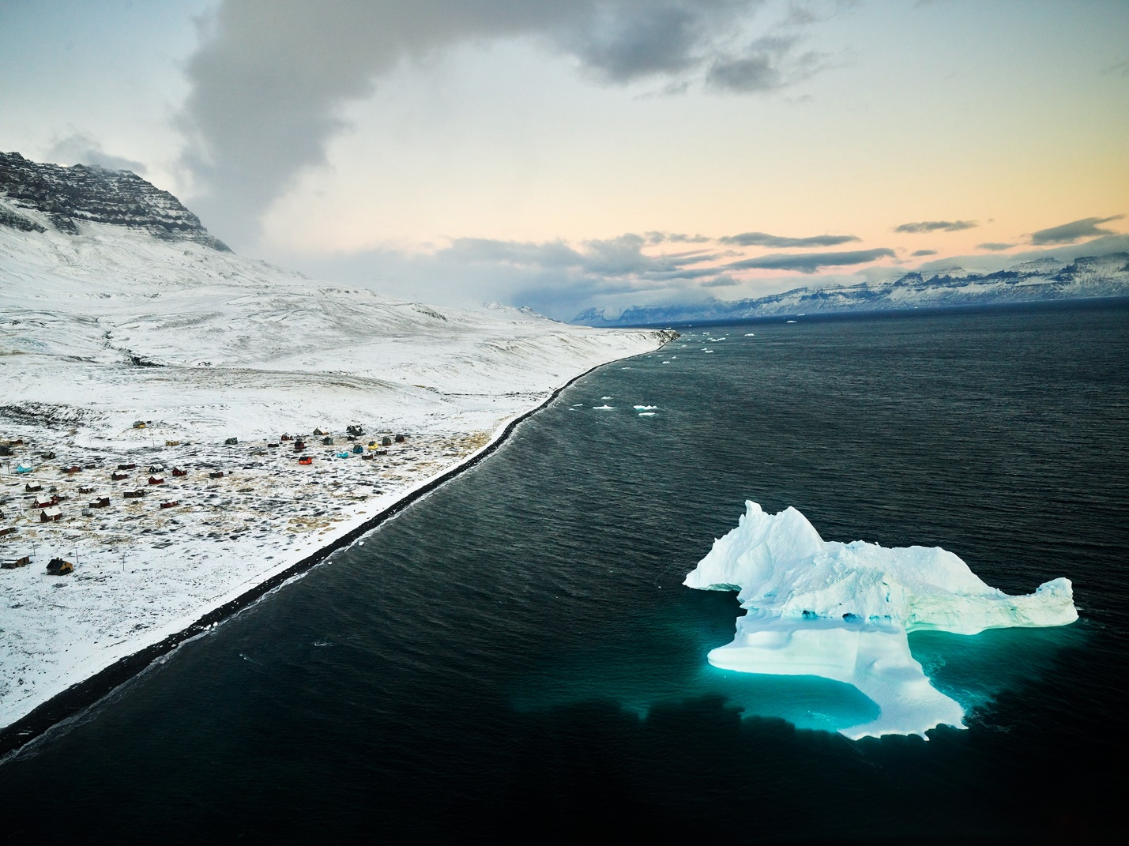
THIN ICE
Once a coal-mining town, Qullissat, in Greenland, now stands emptied of residents.Photographs by RICHARD MOSSE.

History
The summer of 2006 was the height of a period that became known as the commodities “Super Cycle,” in which a hardy vanguard of investors sought to sate industrializing China’s seemingly endless appetite for raw materials, particularly metals. Relying on low-cost financing, dealmakers at Credit Suisse, First Boston, HSBC, Goldman Sachs, and Morgan Stanley scoured the world for once state-owned mining companies in need of fresh funds or those primed for privatization. But the capital markets group at J.P. Morgan had proved more adept than its peers at this international treasure hunt, earning tens of millions in fees thanks to a series of mining-company flotations that grew ever more exotic, remote, and risky. And a venture into the Democratic Republic of the Congo (DRC)—one of the world’s wealthiest nations in terms of natural resources but among the poorest by gross domestic product—by Western banks sat at the riskiest end of that spectrum.
The bankers’ invitation had come from a handful of foreign businessmen who’d secured the rights to resume digging at a mining site named KOV more than a decade after the DRC’s state mining company, name? essentially abandoned it. Also along was Daniel Gertler, 32 at the time and the youngest of the businessmen involved, who saw raw opportunity. This deal would help him move beyond his family’s trade in diamonds to become a player in the commodities world, cementing him as a dominant force in the DRC’s economic engine and the country as the source of some 70 percent of the world’s cobalt supply.
The cobalt that today remains unmined at KOV—one of Gertler’s largest remaining interests in the DRC—is worth more than $39 billion. The metal has become a critical component in the global transition to a greener future, a reality reflected in its soaring price: $29,000 per metric ton in July 2020; (The current price in June 2022 was $55,000 metric ton, an 87% increase over 2021). Most lithium-ion batteries depend on cobalt, and everything from iPhones to Teslas depends on those batteries.
But the green gold of cobalt has become a dirty business—bad enough that Elon Musk, CEO of Tesla, has vowed to engineer cobalt out of his vehicles. In 2019, a U.S. human rights organization, International Rights Advocates, Inc, filed suit against Tesla, Apple, Dell, and other tech giants on behalf of the families of 14 children killed or injured mining in the DRC; the lawsuit was dismissed in November 2020. Meanwhile, Gertler and dozens of companies linked to him are under U.S. sanctions for allegedly corrupt deals, while Glencore, the Swiss-based commodities giant and current majority owner and operator of KOV, faces ongoing investigations from the U.S. Department of Justice and the Commodities and Futures Trading Commission, as well as Britain’s Serious Fraud Office, Switzerland’s Office of the Attorney General, and the Netherlands Public Prosecution Service. The U.S. Treasury used an NGO’s calculations that indicated Gertler was responsible for stiffing the DRC on more than $1.3 billion in lost revenue between 2010 and 2012 alone. Although Gertler found brief reprieve in the final days of the Trump administration, Biden Administration officials swiftly reimposed sanctions. As a result, Gertler, who is Israeli, is prohibited from using U.S. financial institutions and is largely barred from the international banking system.
In an effort to simultaneously save the planet and turn a profit, Breakthrough Energy Ventures, an enterprise funded by, among others, three of the richest Americans-- Bill Gates, Jeff Bezos, and Michael Bloomberg-- has set its sights as far afield as Greenland, whose citizens may eventually embrace such lucrative pursuits too.
The search occupies the minds of a growing army of geologists, software engineers, and data scientists at KoBold Metals, a U.S. technology firm focused on accelerating and expanding the exploration process for cobalt and other so-called battery metals, including nickel. The lack of alternatives to Congolese cobalt is “a major motivator” for KoBold’s workforce, according to cofounder and CEO Kurt House, a Harvard PhD who stated, “We can’t solve all governance problems of the world, we can’t solve corruption and labor, at least on our own—but what we can certainly do is diversify supply,” One location where his firm hopes to find cobalt and nickel is Disko, an island off the remote west coast of Greenland.
“If we diversify supply, if we find a major cobalt discovery in Greenland, we can guarantee that cobalt is going to be produced under extremely high labor standards, and extremely high environmental standards, and then you have a choice,” House posits. “Apple can then buy its cobalt from us, where it’ll have a really reliable chain of custody, and no corruption issues, and no child labor issues, and minimal environmental impact.”
In 2019 KoBold received backing from one of Silicon Valley’s top venture capital funds, Andreessen Horowitz, and from Breakthrough Energy Ventures.
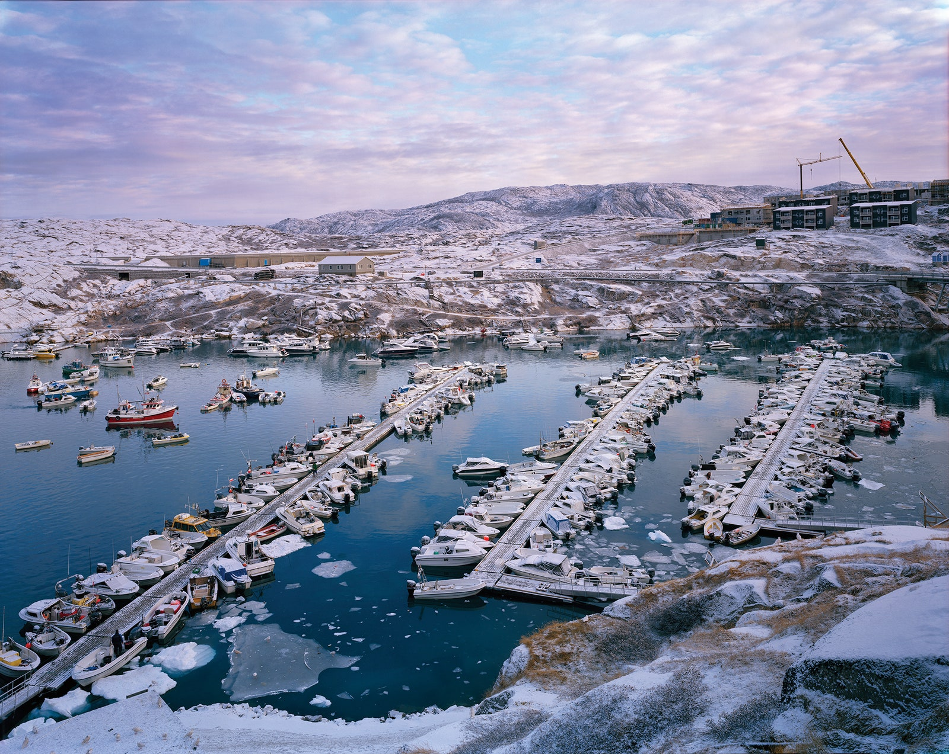
A view from the Bluejay offices overlooking the growing town of Ilulissat, Greenland. Photographs by RICHARD MOSSE.
…The cobalt that KoBold hopes to discover beneath Disko’s stark, frigid, and remote surface will differ greatly in its geology from that found in the lush, heavily populated mining belt of southeastern DRC and northern Zambia. And the cobalt will likely coexist with much larger quantities of not just copper but nickel as well. These kinds of ore bodies, known as magmatic sulfide deposits, can be relatively deep underground and difficult to locate, but once identified and extracted, their metal can be easier to process.
KoBold’s unconventional mining approach uses machine learning (ML) algorithms to predict productive mining locations, reportedly for both cost-savings and environmental benefits.
“This is the best Norilsk analog in the world,” House had said before the trip, referring to a Siberian deposit site that was originally mined by Gulag prisoners under Stalin. Today, a company called Nornickel is the world’s largest producer of refined nickel, and its mines in the Norilsk region produced more than 4 percent of global cobalt in 2021. Over the past decade, the deposit has helped generate more than $120 billion in revenue. The two largest stakes in it are controlled by prominent Russian oligarchs. (One, Oleg Deripaska, was sanctioned by the U.S. in 2018 for his links to the Russian government following Vladimir Putin’s 2014 invasion of Crimea. The U.K. sanctioned Deripaska in March. The other, Vladimir Potanin, saw around $3 billion of his net worth temporarily wiped the day Russia invaded Ukraine in February.)
“IF GOD GAVE US A DIFFERENT PERIODIC TABLE, THEN THINGS WOULD BE DIFFERENT. BUT IT JUST IS WHAT IT IS.”
As part of the due diligence, Connie Chan, general partner at Andreessen Horowitz, examined the broader battery industry, since the challenges around cobalt supply have encouraged researchers to experiment with replacing cobalt. The literature and experts gave her reassurance about future demand for cobalt, at least in the medium term and cobalt’s properties ensure it remains the best-performing option for use in batteries. A vehicle battery requires several thousand dollars of cobalt; a phone handset just a few cents. To electrify the world’s automotive fleet at current market prices, we need a “tremendous amount” of metals. Using International Energy Agency estimates, the necessary discoveries of new cobalt, nickel, lithium, copper, and rare earth elements will be worth around $10 trillion at current prices.
“We’re supposed to be going after the biggest, hairiest problems that are around,” says Eric Toone, the technical lead on the investment committee at Breakthrough Energy Ventures, the $2 billion–plus fund established by Gates that has backed KoBold. “There is almost no way to wrap your head around what scale means when we get talking about energy,” he says. “A billion dollars is certainly a significant amount of money, right? But compared to the amount that’s required to do what we’re trying to do, it’s a drop in the bucket.”
The history of the KOV pit in the DRC is crucial to an understanding of the current stakes in Greenland.
In 2006 the NGO Global Witness published a report that called for a strengthening of regulations against child labor in the Congo, where “the presence of children in the mines is so visible,” the authors wrote, “that it is very unlikely that companies would not be aware of the problem.” A spokesperson for Glencore, which took control of the mine in 2009, said that “there are no teenagers under 18 working for our operations in the DRC. We do not tolerate any form of child, forced, or compulsory labor anywhere in our business or our supply chain.”
Future trouble may have been foreshadowed, but the J.P. Morgan team worked to minimize Gertler’s role and focused instead on the abandoned pit’s potential, forging ahead with plans for Nikanor’s imminent IPO. Buried in the prospectus shared with potential investors was an acknowledgement that Gertler had by then already faced allegations of “improper dealings with the Government of the DRC” (that lawsuit was dismissed) tied to the country’s diamond mines.
Many of the sales, loans, and divestments involved companies incorporated in offshore jurisdictions like the British Virgin Islands, where ownership is unidentifiable. The unwelcome attention that shoddy mining operations have drawn over the years continues to scare major miners and investors away from the country’s mineral riches and is indirectly driving the discovery efforts 6,500 miles away, in Greenland.
The Greenland Mining Environment
While formally an autonomous territory, Greenland remains part of the Danmarks Rige, or Danish realm. Its government must still defer to Denmark on matters of defense and foreign affairs, and it relies on Danish taxpayers for roughly half its $600 million annual budget. For some time Greenlandic nationalists have argued the potentially lucrative revenues from mining could help replace that subsidy and strengthen the case for full independence.
In November 2020, a ban on uranium extraction threatened a joint Australian-Chinese mining project focused on rare earth elements. Months earlier, oil and gas exploration ended because of “severe” risk of a potential spill. The World Wildlife Fund’s project coordinator for Greenland approvingly described the prohibition as a “gutsy” move, particularly given the potential for tax revenues. But Naaja Nathanielsen, Greenland’s current mining minister, insists it was a no-brainer for a nation with a pristine Arctic environment where fishing provides thousands of jobs and a huge chunk of economic output. She is broadly supportive of the mining sector but plans to update transparency and environmental requirements. Currently, just two small mines operate in the entire country, extracting rubies and preparing to mine anorthosite, a mineral used in manufacturing.
A few years ago, the US made a $12 million economic grant to encourage mining cooperation. At Greenland’s only mining school, where students learn to dynamite rocks and build pit roads, the director has developed a million-dollar partnership with U.S. counterparts to help construct a training facility for an underground mine—the kind that might be built on Disko. Well before that, though, Bluejay Mining, KoBold’s exploration partner on Greenland will need to sign an “impact benefit agreement” with the local community that could include employment guarantees. And given that any mine would be dozens of miles from the nearest residents with no roads in sight, as one Greenlandic investment expert speculated, “without foreign labor you will not be able to run projects like this.”
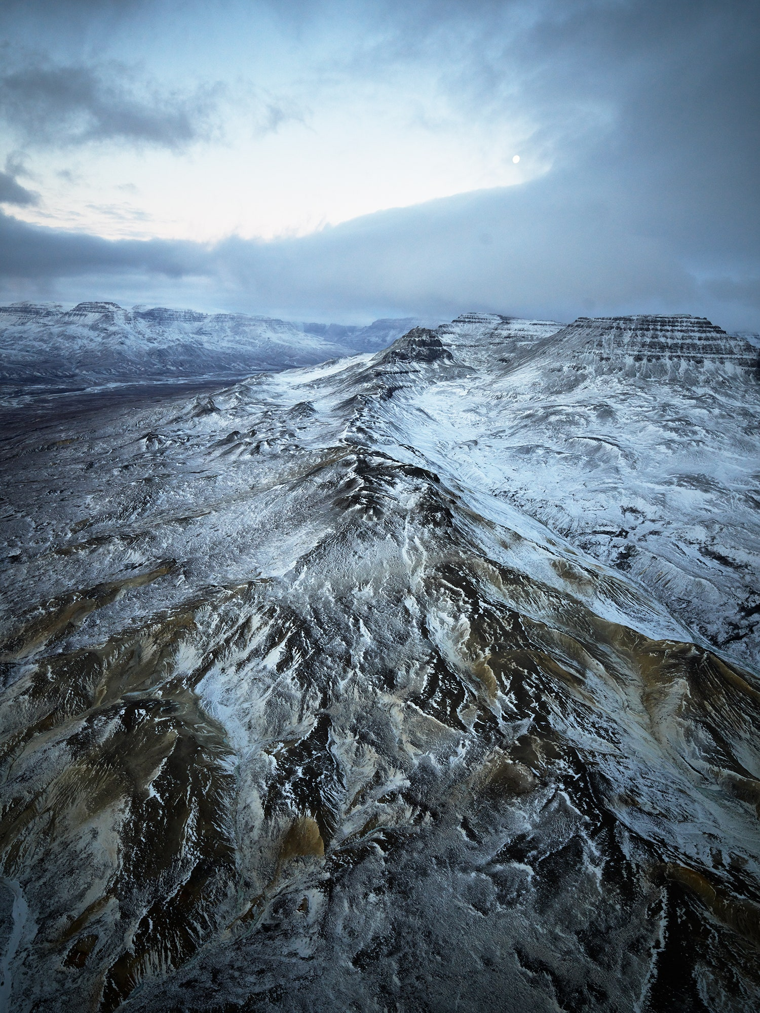
Beneath the ridges of Disko Island is a potential wealth of battery metal deposits.Photographs by RICHARD MOSSE.
Gertler’s Continuing Problems in the DRC
In December 2017, the U.S. government directly accused Gertler of having “amassed his fortune through hundreds of millions of dollars’ worth of opaque and corrupt mining and oil deals,” and the Treasury Department’s Office of Foreign Assets Control added him to a sanctions list, alongside a raft of his businesses. In February 2017, Glencore paid $534 million to buy out Gertler’s remaining shares in Katanga and another mine, but he was still left holding some previously acquired royalties. The office of the DRC’s president announced that one of Gertler’s companies will return some $2 billion of oil and mining assets to the country—more than 2 percent of its GDP.
As a confidant of then President Kabila, Gertler played a role in bringing peace to the DRC in the early 2000s, according to one former U.S. assistant secretary of state, even traveling to Washington in an effort to end the drawn-out conflict. But almost two decades on, he has been fighting his own kind of rearguard action for influence in the U.S. capital, hiring former FBI director Louis Freeh’s lobbying firm in late 2019, with Dershowitz as part of his team.
Gertler or his proxies began to register new companies, often in Kinshasa, the capita of the DRC, rather than the Caribbean. He also began visiting a Congolese branch of a Cameroonian bank, Afriland First Bank, which businessmen with links to Hezbollah and the North Korean government have allegedly used to evade their own U.S. sanctions by ensuring that international transfers from that bank—including via the SWIFT system—do not share identifying details of transactions. (Gertler has denied trying to evade sanctions and any wrongdoing.)
Gertler visits the DRC less frequently nowadays, spending more time at his home outside Tel Aviv, but he did travel to Kinshasa in late February 2022 to sign an “amicable agreement” with the country’s justice minister to end ongoing litigation between the two sides.
There are signs that a new DRC administration is seeking to change that status quo. During a speech in Kolwezi in May 2021, DRC President Felix Tshisekedi told his audience he was “tired of the situation I’ve been seeing in this country for years now…. People are coming here with nothing in their pockets but they go back to become billionaires, while we ourselves still remain poor.”
MAIN ACTORS IN THE GREENLAND CASE
Investors: KoBold, Andreessen Horowitz, and Breakthrough Energy Ventures
Naaja Nathanielsen, Greenland’s current mining minister
Responsible Sourcing Network/Responsible Minerals Initiative
World Wildlife Fund

CASE QUESTIONS
- (12) Construct the best, worst and most likely scenarios for KoBold, Andreessen Horowitz, and Breakthrough Energy Ventures investment in developing its Disko cobalt mine in Greenland over the following time lines: 2, 5 and 10 years. Be sure to include possible developments outside of Greenland, e.g., actions or inactions by NGOs globally and in the DRC, governmental actions in the DRC and Greenland, cobalt market, etc..
Before construction your scenarios, be sure to examine the examples in the Exhibits 9.x.
- (3) Given the volatile history of cobalt mining in the DRC, if you were one of the investors and additional millions were required now, would you contribute?

