Note about the difference between a power diagram and a scenario

- In the “boxes,” a power diagram has Actors; in a Scenario, the “boxes” are Events, Actions or Decisions that may or may not involve an Actor in the case.
- The “Arrows” between boxes in a power diagram represent power relations of one Actor over another Actor. In a Scenario, the “Arrows” represents (a) passage of time, &/or (b) causality, i.e., The Event, Action or Decision in Box B follows from the Event, Action or Decision in Box A.

INSTALLMENT C.

Module 9. Environmental Forecasting and Scenario Building

Module 9: Outline

- Scenario Building
  - The past as prologue for the future
  - Predicting actor behavior
  - Predicting future events
  - Constructing “What if?” statements
  - Connecting the dots (and possible future events)
  - Assessing your assumptions about the future

- Environmental Forecasting
  - economic forecasting
  - technological forecasting
  - political forecasting
  - social forecasting

Module 9: Text

Scenario-building
When one detects a signal in the environment, often it is not interpreted in terms of its potential impact on the firm. The process of deriving a path of decisions and events which could ultimately come to have an impact on a firm is called "scenario-building." Scenario building consists of a series of "What if?" statements: "What if this decision was made?" "What if that event occurred?" and then this decision followed, then that event, etc. A scenario is only as good as its inherent assumptions. The utility of scenario-building is in identifying the critical assumptions and looking at variations on those assumptions that could alter projected or assumed outcomes.
A firm will want to undertake a scenario or forecast for those signals which it believes could ultimately have a SIGNIFICANT impact on the firm. The scenario not only clarifies the probability of a possible outcome for the firm, but also identifies the key junctions in the path where the scenario builder could intervene and somehow change the outcome.
A scenario also points the firm toward the important actors and developments to which it should turn the focus of its environmental monitoring system. For example, if the key junction in a scenario is a decision by a potential new competitor, major customer, specific government agency or non-governmental organization (NGO), the firm will want to track the actions of this actor very closely so as to detect any movement toward the key decision that could make the hypothetical scenario a reality.

Environmental Forecasting
Scenario-building can be compared to a closely-related process called "social forecasting." The former focuses on what could occur in the future and the process by which it would occur. The latter focuses on what probably will occur, i.e., it forecasting starts with what could occur and then assigns probabilities to various possible events. Thus, there is overlap in these two concepts.
Most firms do economic forecasting on an on-going basis. Using past trends and known information as to how the present situation could alter these trends, extrapolations are made into the future at the time a decision and the time horizon of the associated planning process under consideration. Depending on the nature of the firm, economic forecasts are made of all or some of the major macroeconomic factors--interest rates, equity markets, the money supply, government revenues and spending, disposable consumer income, demographics--as well as economic factors more specific to the firm or industry--competitor sales, new product success, pricing strategy, etc.
In recent years, some firms have sought to apply the techniques of economic forecasting to forecasting changes in other sectors of the corporate environment. Technological forecasting is an attempt to predict the rate and direction of technological innovation in a particular industry, market or technology, based on past experience and current trends. The lifetime of a new product in the semiconductor industry, for example, can be predicted on the basis of past changes in this market. Historical data tells forecasters that a new semiconductor product has an average life expectancy of about five years, and development costs should be allocated accordingly. Technological forecasting has also attempted to actually forecast new technological innovations. Leonardo de Vinci and Jules Verne had a remarkable knack for this kind of technological forecasting. However, the forecasts of their more systematic successors have proven to be far less accurate. For example, at one point in the 11050s, some analysts predicted that the typical American family garage would contain a car and a helicopter, and below the garage would be a nuclear fallout shelter.
Political forecasting is an attempt to anticipate changes in the political environment, to include everything from broad changes--the electorate is becoming more conservative, less concerned about government regulation, more concerned about the budget deficit, etc.--to predictions of the reelection or defeat of a candidate, to possible new legislation that will be introduced, and its success in the legislature, to the status of a particular government agency, to the decisions that will be made in the courts (the highest court in a country is becoming more conservative, m ore politicized, etc.)
Political forecasting becomes the basis for a firm's contribution and lobbying strategy. It may lead a firm to back favorite parties or candidates who might be in trouble or abandon others who have no hope of winning. It will also lead to decisions to exert efforts at one point in the public policy-making process rather than another. The role of political forecasting in formulating political strategy is discussed further in Modules 8 and 10.
Finally, some companies have attempted social forecasting--forecast major social changes, changes that would include emerging "hot" issues, political activism among youth, e.g., the “Arab Spring” or social unrest because of unemployment among young Spaniards, more leisure, bankrupt pension systems, etc. Among the proponents of social forecasting, there has been only a modest success in persuading corporations to undertake this effort. Those inroads which forecasting has made in corporations have been in the strategic planning process. Managers are being required to specify their assumptions about the environment within which their firm will operate at the time horizon of the plan. At a minimum, this requirement has forced the managers to think beyond a simple extrapolation of existing operational history and seriously consider what parts of their environment could change appreciable over the period of the plan.

Best, Worst and Most Probable Scenarios

Having identified the important actors and developments that will influence the future in various parts of the environment for a firm, the next question is to assess the probability of various futures occurring. While we could assess gradations of probability to various futures, at the simplest level we can speak in terms of what are the best, worst and most probable scenarios for the future. With these three scenarios defined, we can then adjust them as developments in the key environmental areas and among key environmental actors occur. The Figure below depicts a worst case scenario, proposed by an economist in September 2012, whereby the Euro Zone collapses. How realistic is this scenario today? For example, in terms of the worst Euro Zone scenario, what didn’t happen and why not? At this time, what is now your best, worst and most probable case scenarios for the future of the Euro Zone, i.e., what would a scenario for the collapse of the EU look like if the starting point was today, given the “Brexit” vote in the UK?

See Exhibits 9.1, 9.2 and 9.3 for good scenario examples from a previous case.

Assigning Probabilities to Individual Scenario Elements
As noted above, we can assign aggregate probabilities to various scenarios using a simple scale—best, worst and most likely. However, we could assign probabilities to individual scenario elements. For example, in the scenario above, we could assign a probability to each of the evet boxes or “cells,” starting with the probability of a Greek default. We then would move to assess the probability of Bond rates rising in Italy and Spain and a Run on the EU Banks. If all of these individuals probabilities are low, then the overall probability of the Euro Collapse is low—our best case scenario. If they are all high, it is our worst case scenario. But if any of the intervening probability are mixed, we can construct a “most likely” scenario.

Entry-level Employee Perspective
As an entry-level employee, given the environmental monitoring system you have set up for the company, you could then be asked by your supervisor or a senior manager in your company to forecast developments in key area of your business operations, e.g., technological developments, governmental actions in a key country, customer buying trends, or competitors in a key product market. Would you be comfortable doing this—trying to predict the future? (If it is any comfort, any commitment to set up a company, develop a product, manufacture that product, and market it assumes a future in which the necessary supply-side resources will be available and the market demand will be there among customers. In doing so, could you highlight key actors and possible developments in your forecast that would require closer tracking and recommend adjustments to your forecast and best, worst and most-likely scenarios on a recommended frequency, e.g., daily, weekly, monthly, annually?
In another context, could you respond to a proposed action by your supervisor or a senior manager in your company by identifying the key assumptions about the future in that proposed action and politely ask for clarification of the basis for his or her certainty as to how the future will likely play out?

Appendix A. For climate scenario analysis to really drive change, stakeholder engagement is essential
- Helena Nathan-King, Consultant and CSA lead for EcoAct, an Atos Company - North Europe
https://www.cdp.net/en/articles/climate/for-climate-scenario-analysis-to-really-drive-change-stakeholder-engagement-is-essential

May 21 2021
Since the outbreak of Covid-19, we have seen a growing interest in climate scenario analysis as organisations focus on managing business risks.
The pandemic has meant that organisations suddenly faced difficult circumstances and have had to adapt quickly to survive. This growing awareness of risk management enables an organisation not only to avoid risk but make the most of opportunities and thrive.
As the impacts of climate change become more apparent, climate risk awareness is now on the Board agenda. Pressure from investors, consumers and governments is mounting on organisations to properly assess the risks of climate change and set science-based targets in line with limiting warming to 1.5 ºC.
Questions are also arising around the impacts that climate change has on business operations. Organisations are now being asked to demonstrate how they have considered these possible eventualities, to understand how they fare in low-carbon transition pathways.

What is climate scenario analysis?
One of the key recommendations of the TCFD, climate scenario analysis is a valuable tool for understanding the consequences – both positive and negative - of climate change for businesses and encouraging longer term strategic thinking about risks and opportunities.
By framing climate risks and opportunities in the context of potential future warming scenarios, it allows companies to assess the impact of future risks and opportunities arising from climate change across their value chain, make the necessary preparations, and demonstrate their resilience to stakeholders.
Last year, 54% of companies that respond to CDP reported using it.
A new requirement from the UK Government, announced in November 2020, requires listed companies to disclose alignment with TCFD for financial years starting on or after 1st January 2021. We therefore expect to see scenario analysis to become increasingly popular as companies look to manage risk and develop strategy.
Climate scenario analysis is an essential yet challenging component of understanding and preparing for the impacts of climate change on assets, markets and economies. Far from being abstract, expert users of TCFD-aligned disclosures report the impact of climate change on a company’s business and strategy as being the “most useful” for decision making.
The ultimate goal of risk and opportunity identification is to support strategic planning and risk management, with the ability to provide the associated financial impacts.

What does good stakeholder engagement in climate scenario analysis look like?
Stakeholder engagement helps to identify and prioritise major climate related risks and opportunities facing an organisation. At EcoAct, this involves interviews with an agreed list of stakeholders to determine their understanding of climate change and its relationship to the organisation, including any known or anticipated impacts. The outcomes of these interviews would be a climate-related risk and opportunity long-list register in preparation for a stakeholder workshop.
We normally find that stakeholders are very engaged and aware of climate change issues. Although the process is often embarked upon because of regulation or investor pressure, climate change is something most stakeholders really care about and want to see more action taken.
Scenario analysis clearly benefits from engagement of a wide range of stakeholders because it delivers a broader view of the organisation. It also plays a key role in raising awareness throughout departments and drives culture change that is both risk and climate focused.

What are the long-term benefits of stakeholder engagement in climate scenario analysis?
Engaging a wide range of stakeholders sets the whole business on the start of a much greater journey. It encourages a culture of awareness and engagement of climate-related issues throughout the business.
This cultural shift acts to embed change throughout the organisation by ensuring that climate change is understood within the context of the organisation. This is exactly the ambition laid out by the TCFD Recommendations in 2017.
We have also found that modifying the language used around to align with the way the company talks about risk and climate change adds long-term benefits to the process. Using terminology that is familiar to stakeholders and considers relevant local and cultural differences means it can be embedded into their risk processes more easily and thereby have more impact.
Personalising scenario analysis through stakeholder engagement turns it into a useful tool that drives meaningful climate action, instead of just another piece of compliance and reporting.
EcoAct, an Atos company since October 2020, is an international sustainability consultancy and project developer that supports companies and organisations by providing the most efficient and holistic solutions to effectively meet the challenges of climate change. EcoAct is a CDP Accredited Solutions Provider: https://www.cdp.net/en/partners/ecoact

Appendix B. What are Shell Scenarios?

https://www.shell.com/energy-and-innovation/the-energy-future/scenarios/what-are-scenarios.html

(See videos on Shell site)
Shell has been developing possible visions of the future since the early 1970s, helping generations of Shell leaders, academics, governments and businesses to explore ways forward and make better decisions. Shell Scenarios ask “what if?” questions, encouraging leaders to consider events that may only be remote possibilities and stretch their thinking.

How are Shell Scenarios used?
The sheer breadth and depth of perspective gained from our scenarios continues to inspire many successful partnerships and initiatives around the world, on individual country levels as well as regional and global.
We have been developing Scenarios within Shell for almost 50 years. They are plausible and challenging descriptions of the future landscape. They stretch our thinking and help us to make crucial choices in times of uncertainty and transitions as we grapple with tough energy and environmental issues.
Watch: Navigating an uncertain future

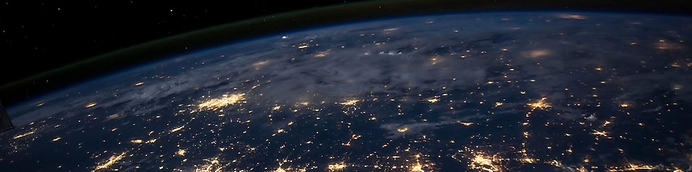

What are Shell Scenarios?
Shell has been developing possible visions of the future since the early 1970s, helping generations of Shell leaders, academics, governments and businesses to explore ways forward and make better decisions. Shell Scenarios ask “what if?” questions, encouraging leaders to consider events that may only be remote possibilities and stretch their thinking.

How are Shell Scenarios used?
The sheer breadth and depth of perspective gained from our scenarios continues to inspire many successful partnerships and initiatives around the world, on individual country levels as well as regional and global.
We have been developing Scenarios within Shell for almost 50 years. They are plausible and challenging descriptions of the future landscape. They stretch our thinking and help us to make crucial choices in times of uncertainty and transitions as we grapple with tough energy and environmental issues.

Shell Scenarios in action
Here is a project that the Shell Scenarios team has been involved with recently.
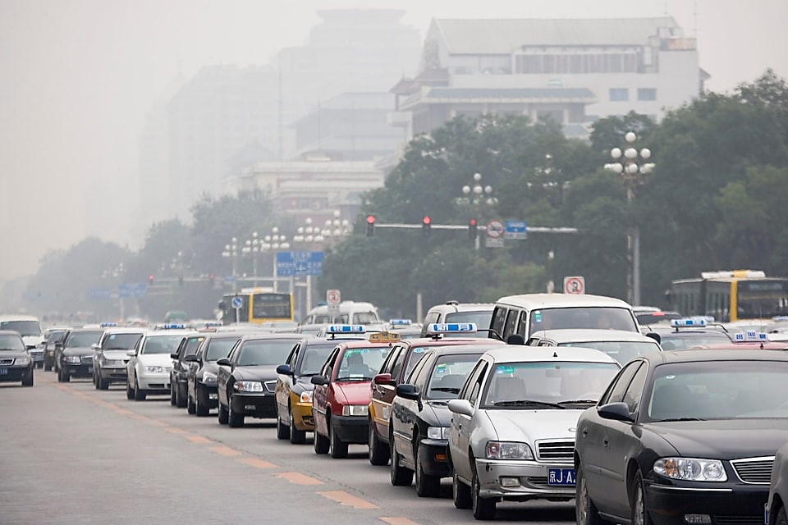

Developing natural gas in China
The Scenarios team has produced a joint study with the Development Research Centre (DRC) of China’s State Council to examine how natural gas could evolve as a mainstream energy source in China.
Natural gas is the ideal alternative to coal, as it is cleaner, more efficient and easier to transport and store. But although its use globally has grown rapidly over the last decade or two, gas has significant challenges to overcome before it can become a core component of China’s energy system.
The Shell-DRC study sets out a strategic aim to increase the share of gas in the energy mix to 10% in 2020 and 15% in 2030, up from 5.8% in 2014. This reflects the goals set out in China's Twelfth Five Year Plan and the 2016 Paris Agreement on climate change.
Markets alone will not be able to deliver this increase in the share of gas, and additional policy frameworks and incentives will be required. Based on detailed economic modelling, the joint study has put forward recommendations for strengthening environmental regulations including effective carbon pricing. The study also recommends comprehensive reform of gas market mechanisms, regulations, and institutions, including greater competition in upstream gas exploration and production, diversifying sources of imported gas to drive greater competition in wholesale and retail gas markets, and effective regulation of gas transmission and distribution infrastructure to ensure third party access on competitive terms.
The study was a key input into China’s Thirteenth Five Year Plan.

