MPH_AOPR (Operations Management and ERP - BC) – Questions Autumn _ Winter 2023

Created by : Ing. J.Skorkovský,CSc. KPH ESF MU BRNO, Czech Republic ;
1730@mail.muni.cz;skorka@cmail.cz; , miki@econ.muni.cz , tel : +420 731 113 517
Date : 29.11.2023
Version : XI.

All questions have to be studied with related study materials handed over to students during Brno's lessons (Autumn-Winter 2023). It is valid only for the MPH_AOPR course.

It will be reviewed (explained) during the remaining lesson on 29.11.2023 or 4.12.2023 at the latest, considering that some dates should be reserved for the seminar work presentation day

The week starting on 27.11.2023 is more and less assigned for the presentations. This statement is not valid for practical part of the course on Wednesdays.

Exam dates on is.muni.cz be open on 29.11.2023. These days are already published on www.is.muni.cz and will also be presented by your professor afer unlocking. All resources were uploaded to study material and MS TEAMS (partly at interaction syllabi.)

Erasmus students have first priority when enrolling for the exams dates of 18.12.203 and 20.12.2023.

The below-listed material corresponds to all MS Dynamics 365 Business Central functions and their impact on operation management during practical lessons.

Mind you, access to MS Dynamics 365 Business Central is available on the cloud using your ID and passwords.

During the exams you can use already prepared activities on your private (personal) databases, however, all processes must be explained in detail, just as you had done in your partial presentations in classes

Files can also be found in MS TEAMS for your TEAM MPH_AOPR_2023.

Resources copied from study material folder
Comment : Files covering the methodology such as Linear Programming principles, CRM and Pareto analysis in Business Central, Use of Dimensions in Business Central-Basics Little´s law and possibly Yield management will be uploaded after they are "on the scene". The reason for this is that I modify these files before their presentation

Operation Management area

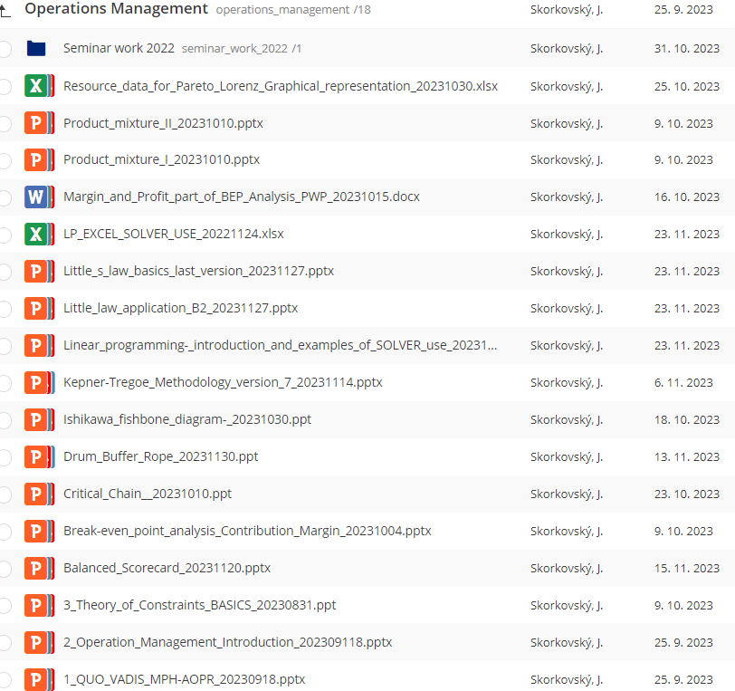

Business Central area
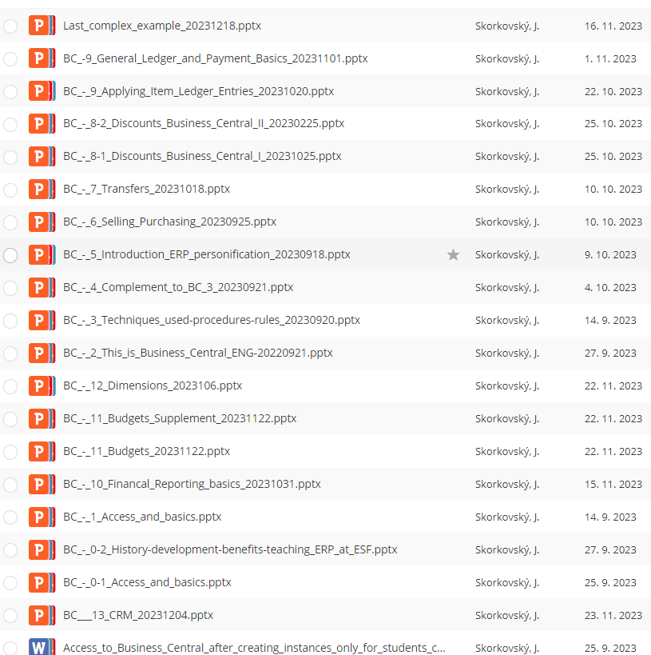

Practice Questions MS Dynamics 365 Business Central for course MPH_ AOPR

- The modularity of the ERP systems. What are process areas might be controlled by Business Central?
- Use of a search window to find application areas.
- Main windows (forms) used in ERP and syntax for Debits and Credits (posted General Ledger Entries) – card window, line window, matrix window (e.g., Item by location from Item cards), header and line window such as form and sub-form, which is the basic structure for every BC document (Sales Order, Purchase Order, Contact Card (CRM) and Transfer Order)
- Main tables (Item, Customer and Vendor - primary data fields such as Balance, a Basic unit of measure, the Payment condition, Costing Methods, etc. G/L account- where can these accounts be found? You can use any time Help and Support, which the icon on the upper-right corner window can access.
- Purchase an item and impacts of F9 (posting) -> Item and Vendor entries and G/L entries. Create a new Purchase Order and show all impacts (Item ledger entries, General Ledger entries, and Vendor Ledger Entries!
- Sale of an item and impacts of Sales Order by F9 -> item and customer entries, G/L entries. Create new Sales Order and show all impacts (Item ledger entries, General Ledger entries, and Customer Ledger Entries!
- The Payment of the open entry (Customer or Vendor) uses the Financial Journal and impacts. Show how to get payment from the chosen Customer with a non-zero Balance on the Customer Card. Explain what the meaning of Open entry is!
8. All presented Discounts (price discount, line discount in %, and invoice discount) and the use of these incentives! What kind of discounts do we have in BC? Show setup of discount specified by examiner and impact of applied discount in sales lines!
9. Contact Card and its profile and use of it. The connection of the contact card to the Customer (Vendor) card. What is the use of a contact card profile? How is the contact card connected to the Customer? Valid only if this part of BC will be presented (provided) in the course!
10. What is an Opportunity and Sales cycle? (Show from the Contact card or Salesperson card). And how to create a new interaction from the contact card (use of wizard)? Use already-made Opportunities, where you can easily access Sales Cycles from the opportunity lines (see main hotkeys short-hands). Explain how you can create a profile that can split customers into three levels (A, B, and C- a simple example of Pareto analysis- this can also be used in question 18 in the theoretical section) as presented during academic sessions. )
See file: CRM-Opportunities_Pareto_Sales Cycle Scheme in study material
Valid only if this part of BC will be presented in the course!
11. Transfer Order (Present to examiner transfer of a chosen item from Blue to Red Location). After Transfer Order is posted (F9), show by Ctrl-F7 created item entries! How many item entries are made during the transfer? Which time parameters related to the location card influence the time of transfer? Which time parameters influence shipping time (see Customer card or Transfer Routes by using the searching window.
12. Financial reports. Start the chosen Financial report. Name of the analysis and its template and how to edit it (raws, view and column) and see data by overview). Explain the benefits and use of it.
13. Explain and show the primary use and benefits of Budgets. Explain and demonstrate the use of the Financial report tool to see actual and expected values and differences.
You can use already created Financial report in your personal database as well as created budgets!
14. Explain the primary use of dimensions and already created sales analysis (only If delivered during the course!)
15. Explain the basics of dimensions (used, for instance, in the example related to budgets) –see question 13. (only If delivered during the course!)

A listing of Theory Resources – will be used below to show you mapping knowledge –resources.

A. Operation Management Introduction.
B. Theory of Constraints
C. Critical Chain (CCPM)
D. Boston Matrix and Product Life Cycle (PLC)
E. Ishikawa fishbone diagram and its combination with Pareto Analysis
F. Pareto Analysis Simplified
G. Reserve clause (not used so far)
- OLAP and Business Intelligence (if provided)
- Magic Quadrant Matrix from Gartner company (if provided)
- Kepner -Tregoe Methodology
- Total Quality Management (if provided)
- Drum-Buffer-Rope principles
- Reserve clause (not used so far)
- Reserve clause (not used so far)
- Balanced Scorecard
- Reserve clause (not used so far)
- Linear programming basics (will be part of the course from 21.11. till 5.12.)
- Yield management (if provided)
- Little's law (will be part of the course from 21.11. till 5.12.)
- Break Even Point analysis

Theory Questions (resources A-S):

Structure of the theory question:

Comment: Indicative questions, written below in italics, are only ancillary issues!
It is assumed that Your answers might be more involved! OM=Operation Management.

Number Description: Resource (slides if required )

- Name key OM activities and use of OM: A
- Name critical skills which should be part of the OM knowledge portfolio: A
- What is a Deming cycle? What is supposed to be the main task to improve company processes? : A
4. The evaluation of the project result (you can use your project from seminar work and related risk analysis). How can we know that the project was successful? Consider time, due date, capacities of resources, budgets limits, required knowledge portfolio, and project changes: A, B, and C
5. Reserve clause (not used so far)
6. Specify the basic concept of the Theory of Constraints: B and C
Very complex question! It covers, among other questions 7,8,9, and also 10.
7. TOC metrics: B
Name three main metrics and their trends, and explain the benefits of using these metrics. How to calculate NET Profit and ROI by using these metrics?
8. Cost World and Throughput World: B
Define and explain differences between Cost World and Throughput World
9. TOC five steps: B
10. Drum-Buffer-Rope (explain only main principles): L
11. Primary trees (Thinking process tools) – Current Reality Tree, Evaporating Cloud Tree, and Future Reality Tree: B
Explain the primary use and how these trees are constructed. This question is more and less also related to your seminar work!
12. What is bad multitasking?: C
13. Critical path and Critical Chain differences: C
Specify differences between CP (Critical Path and CC (Critical chain)!
14. Use of project buffer (buffer management concept and graph with three zones): C
Specify the use of buffers, and how the size of the buffer is set.
15. Total Quality Management Basics: K (only if provided)
16. Ishikawa fishbone diagram: E
17. Boston matrix and Product Life Cycle (PLC). State some examples of PLC: D (only if provided)
18. Pareto analysis and its applications (use of PWP presentation Ishikawa allowed): E –You can
the show already created PARETO example in BC (see PWP related to CRM) (only if provided)
19. OLAP (Business Intelligence): H (only if provided)
Basic principles and use of using BI (Business Intelligence). What is the N-dimension cube?
20. Basic principles of Kepner –Tregoe method supporting decision making: J
Must-to-have and Nice-to-have criteria and their use, principles of questions WHO, WHEN, WHERE, and EXTENT and Why to distinguish between It Is, and It Is Not.
21. Magic Gartner Quadrant Matrix: I (only if provided)
22. Balanced Scorecard (BSC) basic principles and use. What is KPI? Name all four sections of BCS: O
23. The primary use of Linear programming: Q (Target function and constraints. Reason for using Solver Explain by use of PWP.You can use related Excel file LP Solve with detailed explanation)
24. Basic rules of Yield management: R (only if provided) Processes where revenue management methodology can be used, Show and No-show, Overbooking principles, Cu – under-estimated and Co – over-estimated, calculations – presented examples in PWP can be used during the exam
25. Little's law formulation and use: S
26. Break Even Point basics : T
27. Product mixtures (explain these approaches from related PWP from Study material- you must open these files during testing-exam). Names of the files : Product mixture I and II
28. Yield Management : R (only if provided)

