Access to Business Central after creating instances for students only
For remote access outside the faculty, you must first connect to the MUNI VPN.
Material has been prepared by: Jaromír Skorkovský (1730) (1st teacher)
Revision : Martin Hajný (Navertica)
Term: 2023-2024
Number of students in the course Corporate Information Systems 2: 13
Number of students in Operations Research and ERP: 15 ( as of the date of 14.9.2023)
2nd teacher: Martina Gajdová: 100529 - Corporate Information only
Computer room: VT206

- Login of any student (in our case (model), the student with the number 514411)
In a genuine attempt to connect to Microsoft Dynamics 265 Business Central, each student will, of course, use their original Personal Identification Number (PIN)
https://dynamics-esf.ucn.muni.cz/514411
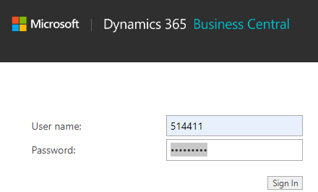
The prime password (first access only ) for everyone (students only) is Password1, and after first login, a new password must be specified. I our course it will be your secondary passoword. ( )
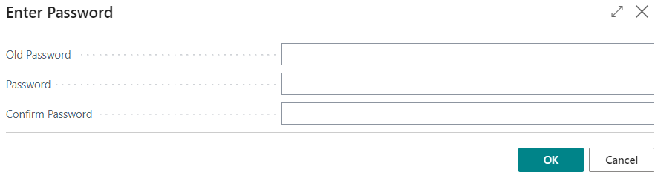

Subsequent logins of any student (in our case, the student with the personal identification number (UČO) and his/her secondary passoword
https://dynamics-esf.ucn.muni.cz/514411
And following form will be ( User One should be your specification)

