Humanistic leadership

In this case study, we will first introduce the general theoretical background of Humanist leadership and then deal with a specific case study on this topic.

# Theoretical background

The world has been rapidly changing for the past decades, and the process appears to become accelerated every few years. With the ongoing changes, employees are required to be learning and adjusting to the new technologies and trends constantly, which may prove rather demanding. The softness of a human touch may be observed as slowly becoming a rare skill among people. Is there a way out? And from the other way around, why would some leaders for example in South Korea resort to such measures as giving up a luxurious lifestyle in order to improve the employee experience, or engaging a management team to gather and clean the work site in the early morning hours as Kim, Kim and Park (2020) discuss in their study? In this short paper, we aim to find the dots that would connect the previous questions and offer a view of the method in practice.

In most cases, the business aims to generate profit. In humanistic leadership, managers place people over profit to make business more sustainable (Nathanson, 2021). Humanism represents an alternative to economicism. Economicism implies that the maximization of profit or shareholder value is the supreme goal of a company (Melé, 2013). Pirson and Lawrence (2010) observe in their work that we can slowly see the change in business and management from economicism to humanism. There is a significant number of studies in which there is evidence that people look for respect, acceptance, communion, and shared values instead of short-sighted personal utility increases (Pirson, 2010). This is one of the reasons why humanist leadership outperforms other types of leadership that are based on economicism.

It is essential to mention that humanism doesn’t change the behavioral style of leadership. Some people might prefer an autocratic style of leading, others democratic or task-oriented. All that is possible and cooperates with humanist leadership, but the leaders must always be aware of the humanist approach, which is putting people over profit and making the business more sustainable. That is now, in the era of the post-pandemic economical crisis, war on Ukraine, with all its economic and noneconomical influences, needed more than ever.

# Case study

## Introduction to the study

A study conducted by scholars in Spain concerning the utilization of humanistic leadership in the furniture chain IKEA has been chosen as a practical example of the theory formerly presented. Apart from the focus of this paper, the study also encompasses the tool of employer branding (EB), at times used in marketing campaigns to manage potential employees‘ perception of the brand (Pérez-Pérez et al., 2022). The design of the study consisted of semi-structured interviews with top management leaders and middle managers of the IKEA company, accompanied by- and anchored in a review of scientific literature (Pérez-Pérez et al., 2022).

The research questions addressed in the case study are the following:

1. Should every company utilize an anthropological model and EB?
2. What model of internal communication promotes both?
3. How is a sense of belonging transmitted?
4. How are extrinsic motives (the benefits of that come from the external environment: having or acquiring incentives, retribution, awards, status, recognition or prestige) communicated?
5. How are intrinsic motives (learn or acquire operational knowledge: know role, enjoy work, and overcome challenges) communicated?
6. How are transcendent or prosocial motives (the utility or benefit that an action will have for other people: serving and satisfying the real needs of people and human development) communicated?
7. Is IKEA a business paradigm with EB? If so, does IKEA utilize an anthropological model?

(Pérez-Pérez et al., 2022)

Where the humanistic leadership shines through the theme of the study are the hypotheses, in which the authors of the study perceive an anthropological management model as largely influencing successful EB campaigns (Pérez-Pérez et al., 2022).

Upon summarization of the hypotheses, a form of a preparatory research followed. In order to gain a more firm grasp of the topic, as it could have been classified as a poorly developed area of research, an exploratory case study was conducted by the authors. This phase consisted of reviewing of literature about the topic to generate hypotheses that might later prove useful, as similar methods had been successful in different studies. The opening exploratory case study was only the first step, as the main research would follow.

Once the exploratory case study was completed, a series of semi-structured interviews was initiated. The interviews were held with 25 middle managers of IKEA ÍBERICA and 3 in-depth interviews with IKEA executives were held. These interviews took place between August 2020 and January 21 and the reasoning behind them was finding out whether the company does in fact follow a prosocial management model. These interviews would then be a subject of an analysis.

## Analysis and results

The analysis of the interviews could be divided into several steps, the first of them being concerned with the individual identification with the mission of the company in question. During the interviews, the participants were asked about the purpose of the company, with their answers placing the customers on the top of the value hierarchy. As a result, the researchers concluded that the responses of the interviewees are consistent with the mission on which the brand aims to be.

In the step that followed, the employees‘ identification with the values of the company was the focus of the researchers. Out of the values presented on the IKEA website, the most popular answers among the interviewees were leading by example, caring for people and the planet, and doing things together, respectively. What these findings would go on to illustrate is the notion that coworkers have a decisive role in the environment of the company.

The third aspect of identification that was measured was tied to the vision of IKEA. Even in this case, the objectives most commonly reported by the employees during the interviews were related to caring for people and the planet, and awareness of the costs of actions of an individual. For a visual representation of the answers of the interviewees, see the picture below:

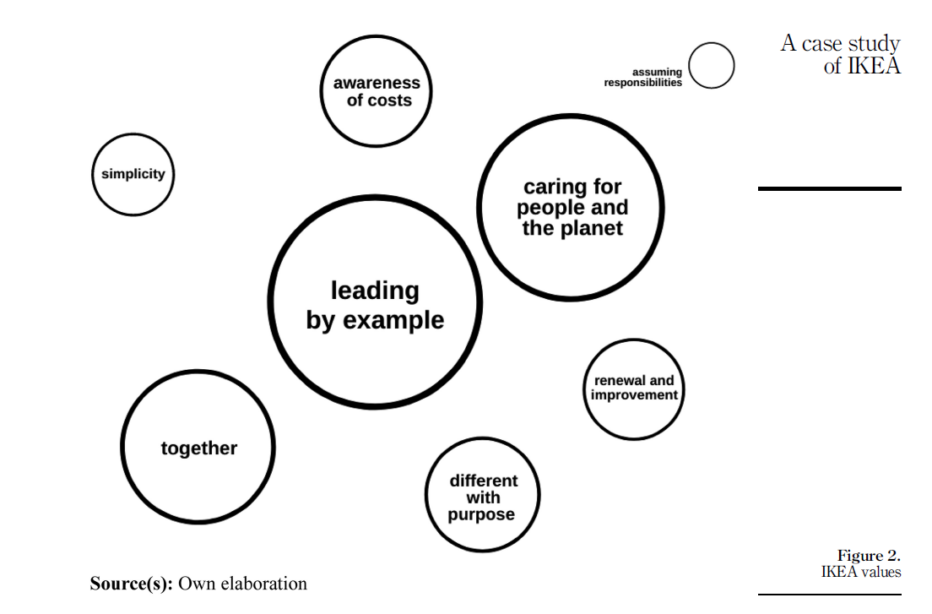

taken from Pérez-Pérez et al., 2022

### Degree of attractiveness of IKEA

68% of interviewees express satisfaction and a high degree of attractiveness with Ikea. Order of items contributing to satisfaction: possibility of learning, possibility of personal and career development, motivation, respect for diversity, adaptability, and work-life balance. The cause of listed items are results of leadership, philosophy and ethics and interest in stakeholders. 16% of interviewees detailed aspects for improvement, and 4% expressed dissatisfaction, but without provided reason. 12% did not provide an answer.

### Motivation

The need was identified as providing functional furniture for a decent price, allowing creation of inspiring homes on society and customer level, and the sense of belonging, on internal level.

### Internal communication

Internal communication is leading priority to “perfect alignment between the interests of the company and the people; the strategy is that they live it, that they feel it, that they love it, and that they are part of it.”, which aligns with organizational theory.

### EB during the pandemic

Ikeas mission during the pandemic was to attempt to link to own vision and values throughout difficulties. 92% of respondents agreed that the purpose is the most essential element.

Values were deepened, especially unity and the most important element – sense of belonging.

Objectives during the pandemic did not significantly change, and attractiveness remains like what is used to be during normal times.

## Limitations of the case study

Despite the thoroughness of the case study presented in this paper, there might be limitations as far as the universality of its results is concerned. Even though the authors specified the conditions under which the case study was conducted, there could be several points which the readers may find helpful instead of accepting the case study at its face value. In the next paragraphs, these points will be mentioned and shortly elaborated on.

### Restricted view of the scope

The first ceiling to the interpretation of the results of the case study can be found in the choice of the research sample. For this specific case study, the authors chose a sample consisting of middle- and high management of Spanish branch of IKEA. Although it may be beneficial to focus on these groups, as the demands on their mental labor could potentially be higher than on those occupying more manual-labor oriented positions in the company, this sample choice puts a limit to the broadness of the case study in question.

### Restrictions imposed by the nature of the questions used and the interview format

Another point worthy of mentioning might be the formulation of the questions asked by the interviewers and the general format of the conducted interviews. While the repeatedly asked questions may be adding to the aspect of uniformity within the dialogues and simplifying the analyses that would follow, they may also prevent the speakers from choosing their own formulations or even suggest the answers right away. Similarly, the interviews being semi-structured may have a comparable effect on those speakers who would prefer to talk less formally.

### Humanistic leadership in Europe

The last point to be added to the limitations is the reality that the case study was conducted on European soil, which may be more susceptible to humanistic approaches. Those managers who participated in the study may have a different outlook on life than their colleagues in American IKEA branch, just as they might have a different outlook on life in comparison to European employees in Ireland. Given the geographical restriction of this study, its interpreters could find as beneficial that the culture may influence the answers of the interviewed managers. Additionally, the entire concept of humanistic leadership being dependent on the general state of the society in the region should be considered, as the values perceived by employees may differ largely on a broader territory.

## Conclusions

According to the authors of the case study, in this case, EB efficiency is dependent on implementation of humanistic model which IKEA utilizes. Given the results proposed by the authors of this study, IKEA represents a good example of a company utilizing a humanistic approach where each employee is a free and responsible person. Based on findings on managerial level, there is a near perfect alignment of company interests and employee interests. There is awareness that the interests and goals of a company are also the goals of employees and come before generating income. Middle managers are highly effective, and employees are identifying with company mission. Analysis of humanistic model of IKEA also shows example how other organizations and business leaders can develop communities and societies based not on profit maximalization. Lastly, this case study could prove useful, yet the readership may find utility in questioning some of the methods, as the results of the study do not appear to be universally applicable.

# Literature

1. NATHANSON, Craig, 2021. The Humanistic Leadership Model (HLM). *Journal of Business & Technology*. **5**(1).
2. MELÉ, D., 2013. Antecedents and current situation of humanistic management. *African Journal of Business Ethics*. **7**(2), 52-61.
3. PIRSON, M. A. a P. R. LAWRENCE, 2010. Humanism in Business - Towards a Paradigm Shift?. *Journal of Business Ethics.* **93**(4), 553-565.
4. KIM, H. Y., J. H. PARK a H. J. KIM, 2020. South Korean humanistic leadership. *Cross Cultural & Strategic Management*. **27**(4), 589-605.
5. PERÉZ-PERÉZ, L., I. BERLANGA a J. S. VICTORIA, 2022. Internal communication and employer branding within a humanistic model: a case study of IKEA (Spain, 2019–2021). *Corporate Communications: An International Journal*. **ahead-of-print**(ahead-of-print). ISSN 1356-3289.