Paraphrasing

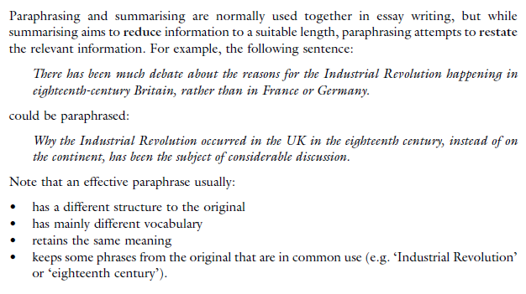

Task 3
Read the text below and then evaluate the three paraphrases (1=best), giving reasons.


TASK 1 The text below has some style problems

Many students use poor academic style in their writing, like using I, we and you. A simple way to improve this is to study good examples of academic style and to follow them. Their writing score will go up as a result. And it will be useful at university. Style is always a problem for non-English students, who make lots of mistakes when they start to write academic English, by using, for example, phrasal verbs instead of more formal verbs. This is something that such students need to learn to overcome if they wish to reach a higher grade. What other ways are there for students to improve their style? One way is to ask the teacher for advice. A considerable number of students don't listen to their teachers, and therefore do not improve. This is a terrible situation. It is important for students to remember that they are now adults, not kids. If they do not follow teachers' advice, their writing style will not improve.

TASK 2 Remove all repetition and redundancy, rewriting where necessary.
