Lab 1.3.3: Troubleshooting a Small Network

Topology Diagram
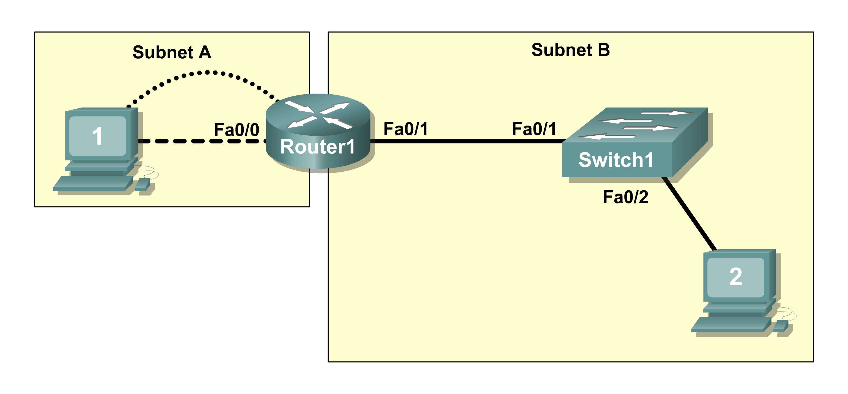

Learning Objectives
Upon completion of this lab, you will be able to:
- Verify that a paper design meets stated network requirements
- Cable a network according to the topology diagram
- Erase the startup configuration and reload a router to the default state
- Load the routers with supplied scripts
- Discover where communication is not possible
- Gather information about the misconfigured portion of the network along with any other errors
- Analyze information to determine why communication is not possible
- Propose solutions to network errors
- Implement solutions to network errors

Scenario
In this lab, you are given a completed configuration for a small routed network. The configuration contains design and configuration errors that conflict with stated requirements and prevent end-to-end communication. You will examine the given design and identify and correct any design errors. You will then cable the network, configure the hosts, and load configurations onto the router. Finally, you will troubleshoot the connectivity problems to determine where the errors are occurring and correct them using the appropriate commands. When all errors have been corrected, each host should be able to communicate with all other configured network elements and with the other host.
Task 1: Examine the Logical LAN Topology
The IP address block of 172.16.30.0 /23 is subnetted to meet the following requirements:

Subnet | Number of Hosts
Subnet A | 174
Subnet B | 60

Additional requirements and specifications:
- The 0 subnet is used.
- The smallest possible number of subnets that satisfy the requirements for hosts should be used, keeping the largest possible block in reserve for future use.
- Assign the first usable subnet to Subnet A.
- Host computers use the first IP address in the subnet. The network router uses the last network host address.
Based on these requirements, the following topology has been provided to you:

Subnet A
Specification | Value
IP mask (decimal) |  | 255.255.255.0
IP address | 172.16.30.0
First IP host address | 172.16.30.1
Last IP host address | 172.16.30.254

Subnet B
Specification | Value
IP mask (decimal) |  | 255.255.255.128
IP address | 172.16.31.0
First IP host address | 172.16.31.1
Last IP host address | 172.16.31.126

Examine each of the values in the tables above and verify that this topology meets all requirements and specifications. Are any of the given values incorrect? ___________
If yes, correct the values in the table above and write the corrected values below:
______________________________________________________________________________
______________________________________________________________________________
Create a configuration table similar to the one below using your corrected values:

Device | IP address | Mask | Gateway
Host1 | 172.16.30.1 | 255.255.255.0 | 172.16.30.254
Router1–Fa0/0 | 172.16.30.254 | 255.255.255.0 | N/A
Host2 | 172.16.31.1 | 255.255.255.128 | 172.16.31.126
Router1–Fa0/1 | 172.16.31.126 | 255.255.255.128 | N/A

Task 2: Cable, Erase, and Reload the Router
Step 1: Cable the network.
Cable a network that is similar to the one in the topology diagram.
Step 2: Clear the configuration on the router.
Clear the configuration on the router using the erase startup-config command and then reload the router. Answer no if asked to save changes.
Task 3: Configure the Host Computers
Step 1: Configure host computers.
Configure the static IP address, subnet mask, and gateway for each host computer based on the configuration table created in Task 1. After configuring each host computer, display and verify the host network settings with the ipconfig /all command.
Task 4: Load the Router with the Supplied Scripts

enable
!
config term
!
hostname Router1
!
enable secret class
!
no ip domain-lookup
!
interface FastEthernet0/0
description connection to host1
ip address 172.16.30.1 255.255.255.0
duplex auto
speed auto
!
interface FastEthernet0/1
description connection to switch1
ip address 192.16.31.1 255.255.255.192
duplex auto
speed auto
!
!
line con 0
password cisco
login
line vty 0
login
line vty 1 4
password cisco
login
!
end
Task 5: Identify Connectivity Problems
Step 1: Use the ping command to test network connectivity.
Use the following table to test the connectivity of each network device.

From | To | IP Address | Ping Results
Host1 | NIC IP address | 172.16.30.1
Host1 | Router1, Fa0/0 | 172.16.30.254
Host1 | Router1, Fa0/1 | 172.16.31.126
Host1 | Host2 | 172.16.31.1
Host2 | NIC IP address | 172.16.31.1
Host2 | Router1, Fa0/1 | 172.16.31.126
Host2 | Router1, Fa0/0 | 172.16.30.254
Host2 | Host1 | 172.16.30.1
Task 6: Troubleshoot Network Connections
Step 1: Begin troubleshooting at PC1.
From host PC1, is it possible to ping PC2? _________
From host PC1, is it possible to ping the router fa0/1 interface? _________
From host PC1, is it possible to ping the default gateway? _________
From host PC1, is it possible to ping itself? _________
Where is the most logical place to begin troubleshooting the PC1 connection problems?
_________________________________________________________________________________
_________________________________________________________________________________

Step 2: Examine the router to find possible configuration errors.
Begin by viewing the summary of status information for each interface on the router.
Are there any problems with the status of the interfaces?
_________________________________________________________________________________
_________________________________________________________________________________

If there are problems with the status of the interfaces, record any commands that are necessary to correct the configuration errors.
___________________________________________________________________________________
___________________________________________________________________________________

Step 3: Use the necessary commands to correct the router configuration.
Step 4: View a summary of the status information.
If any changes were made to the configuration in the previous step, view the summary of the status information for the router interfaces.
Does the information in the interface status summary indicate any configuration errors on Router1? _______
If the answer is yes, troubleshoot the interface status of the interfaces.
Has connectivity been restored? ________
Step 5: Verify the logical configuration.
Examine the full status of Fa 0/0 and 0/1. Is the IP addresses and subnet mask information in the interface status consistent with the configuration table? _______
If there are differences between the configuration table and the router interface configuration, record any commands that are necessary to correct the router configuration.
________________________________________________________________________________________________________________________________________________________________________

Has connectivity been restored? ________
Why is it useful for a host to ping its own address?
________________________________________________________________________________________________________________________________________________________________________

Task 7: Clean Up
Unless directed otherwise by your instructor, erase the configurations and reload the switches. Disconnect and store the cabling. For PC hosts that are normally connected to other networks (such as the school LAN or to the Internet), reconnect the appropriate cabling and restore the TCP/IP settings.

