DTEDI Schedule – Spring 2020
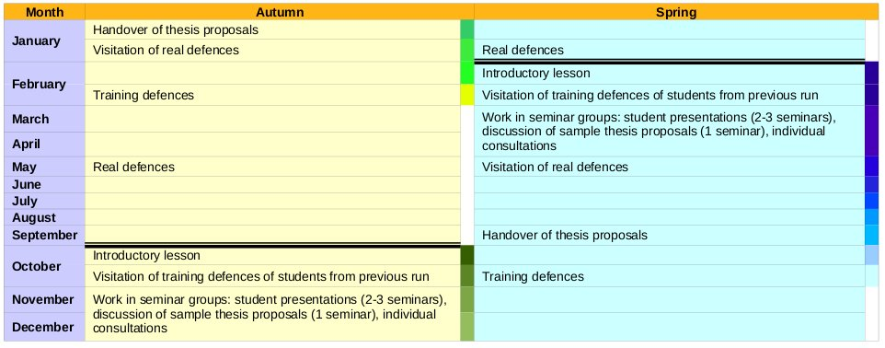
Introductory lesson:
- 26. 2. 2020 09:00 – 11:00, C417
- Introduction, motivation, DTEDI content, thesis proposal guideline, …
- Formal requirements (Ada Nazarejová)
- Assignment to seminar groups
- Schedule of the semester, plan of students introductory presentations

Training defenses of students from previous semester:
- You are welcome to attend training defenses of your colleagues from previous run and became a member of “scientific committee” for this moment.
- Schedule:
  - 23. 04. 2020 12:00 – 14:00, online: Presentation of ...
  - 07. 05. 2020 12:00 – 14:00, online: Presentation of Jaroslav Čechák, David Wiesner, David Střelák
  - 21. 05. 2020 13:00 – 15:00, online: Presentation of Tomáš Effenberger, Vít Novotný, Ivana Hutařová Vařeková
- Online access via Zoom: https://cesnet.zoom.us/j/95020665347?pwd=M24wdkx3UnRhQmV3T0FHZm9NWTladz09

Work in seminar groups
- Student presentations: Introduction to research topics. 20 min. of presentation + 10 min. of discussion. The goal is to present your research area and PhD activities to the general public.
- Discussion of sample thesis proposals.
- Individual consultations. At any time.
- Schedule:
  - 16. 04. 2020 12:00 – 14:00, online: Presentation of Matěj, Jan, Iris
  - 30. 04. 2020 12:00 – 14:00, online: Presentation of Luděk, Martin, Lukáš
  - 14. 05. 2020 12:00 – 14:00, online: Presentation of Deniz, Adam, Jakub, Iris
- Online access via Zoom: https://cesnet.zoom.us/j/95020665347?pwd=M24wdkx3UnRhQmV3T0FHZm9NWTladz09

Attendance at real defenses
- 25. 5. – 29. 5. 2020 (will be specified)
- Attendance at real defenses followed by discussion.

Handover of your thesis proposal
- September 2020

Your training defenses
- will be specified

Enrolled students:
- Agaoglu Deniz
- Daubner Lukáš
- Janovský Adam – preferoval středu, čtvrtek nebo pátek. V pondělí bych mohl od 17h dále, v úterý od 18h dále.
- Karolyi Matěj
- Kico Iris
- Klaška David [opak]
- Lédl Jakub – nevyhovuje pouze pondělí 10–12, úterý 12–18, středa 12–14 a čtvrtek 14–16, v libovolný jiný čas budu moci
- Lux Filip [opak]
- Macák Martin
- Matyska Luděk [opak]
- Melnikova Aleksandra [opak] – no presentation
- Mrázek Jan

