Hodnocení 6 nejlepších nástrojů pro datové modelování

PowerDesigner
PowerDesigner is arguably the industry’s leading data modelling tool. Its features include: fully integrated models, different modelling techniques that cater to both an IT-centric audience and non IT-centric. It also supports a powerful metadata repository and various output formats. It has a nice and polished user interface with easily readable help documentation aiding the user to quickly solve ad hoc problems.
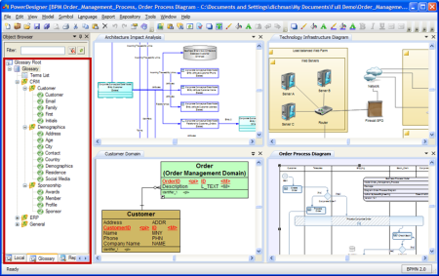

ER/Studio
ER/Studio is an intuitive data modelling tool that supports single and multi-platform environments, with native integration for big data platforms such as – MongoDB and Hadoop Hive. It can forward and reverse engineer models, includes a compare and merge function and is able to create reports in various formats (XML, PNG, JPEG). Built-in features automate routine tasks and supports the popular database platforms. ER/Studio is a great tool that that is easy to start working with due to its intuitive design and good user support.

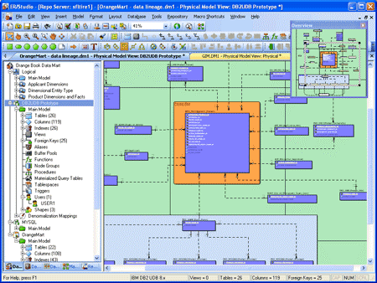

Sparx Enterprise Architect
Enterprise Architect is a feature rich data modelling tool that prides itself on being the cost-efficient option. It helps business users build robust and maintainable systems quickly and can easily scale to accommodate large teams collaborating on shared projects. Enterprise Architect also has the capability of running a dynamic model simulations to verify the correctness of models and provide better understanding of how specific business systems operate.
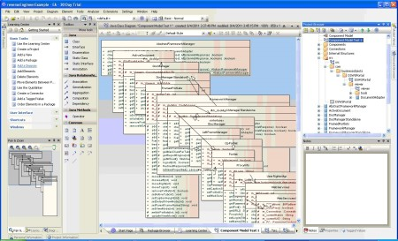

Oracle SQL Developer Data Modeler
Oracle data modeller is a free graphical tool to help business users with data modelling tasks. This tool is robust, offering features and utilities centred around productivity. This includes easily accessible report tool, DDL preview capabilities, built in quality check tool and a sophisticated search engine.
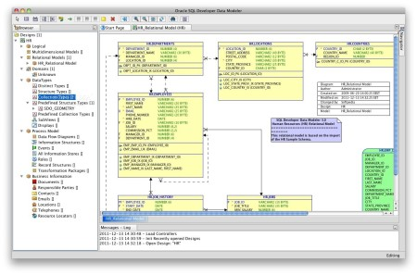
CA ERwin
ERwin is one of the leading data modelling solutions that provides a simple, polished user interface for a complex data environment. This solution provides business agility – models and metadata can be managed in a common repository to ensure consistency and security. ERwin supports high customisation and automation allowing macro language, custom datatypes, APIs and much more. It also has an extensive user community enabling consumers to share knowledge and expertise.

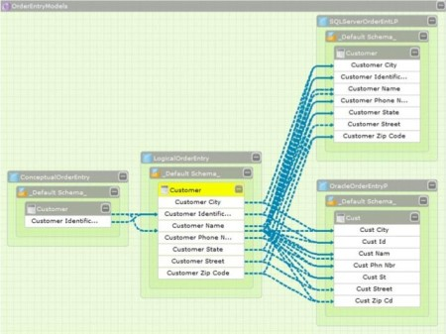

IBM - InfoSphere Data Architect
InfoSphere is an innovative data modelling tool that runs on an open-source platform – Eclipse. Infopshere focuses on three key areas: efficiency, simplicity and integration. This tools helps business users create logical and physical data model diagrams which can be used for a variety of applications and systems. This end-to-end solution can be used to create, deploy and update data models in a quick and efficient manner. It also provides easy integration with other related IBM products.
