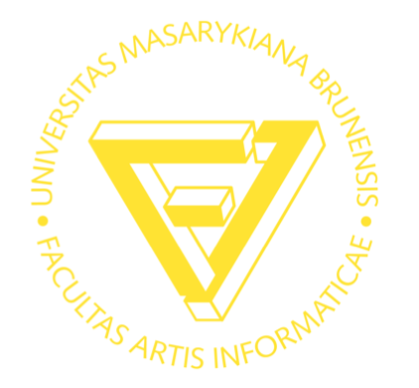
PV236 Time Management and Effectiveness, AUTUMN 2011

Masaryk University, Faculty of Informatics, SSME Master Study

September, 2011 – December, 2011
Lecturer Michala Homolova
Mobile +420 733 595 688
Email michalahomolova@gmail.com

STUDENT QUESTIONNAIRE | Time Management and Effectiveness

DUE DATE |

INSTRUCTIONS | Dear Students! Please fill in the information below to help me get to know you better & faster. Email me this document in a PDF format (if possible) by Friday, September 23rd (please use michalahomolova@gmail.com & name the file: Your Name PV236 Autumn11 Student Questionnaire) and bring a hard copy to our second class on Monday, September 26th. Thank you for your cooperation and I look forward to meeting you!

Name
Email Address
Phone Number
Hometown (optional)
Job Title (if applicable)
Company (if applicable)
Industry (if applicable)
(Industry you work in or industry of interest)

Work Experience

Time Management and Effectiveness
(Please state how busy you are, why do you cope with time and/or why you have decided to take this course)

Your Expertise
(Please tell me about your expertise/talents/skills)

Your Passions
(Please tell me about your passions – what do you LOVE to do?)

More About You
(Any other information you want to share about yourself)

THANK YOU!

