DTEDI Schedule – Autumn 2013

Overview
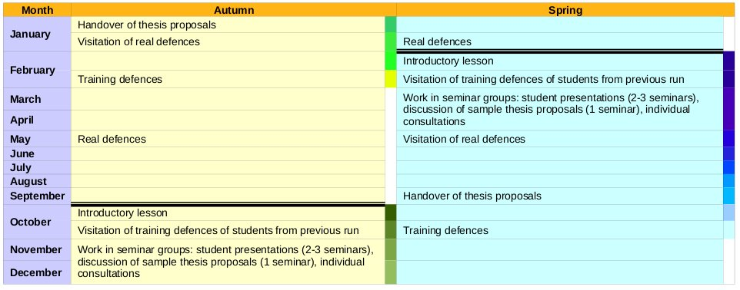

Details for semester Autumn 2013
Introductory lesson:
- 1. 10. 2013 13:00 – 14:00, B117
- prof. Kučera: introduction, motivation, DTEDI content, thesis proposal guideline, …
- Ada Nazarejová: formal requirements
- Assignment to seminar groups
- Schedule of the semester, plan of students introductory presentations

Training defenses of students from previous semester:
- 4. 11. 2013 8:30 in G107 (Šumavská)
- You are welcome to attend training defenses of your colleagues and became “member of scientific committee” for this moment.

Student presentations – 1st group
- Wed 6. 11. 2013 13:00 – 15:00, G215 (Šumavská)
- Following students will present their work (20 min. of presentation + 10 min. of discussion. The goal is to present your research area and PhD activities to the general public). The others will come, listen and discuss!
  - Kozák, Štěpán
  - Chalás, Igor
  - Byška, Jan

Student presentations – 2nd group
- Wed 13. 11. 2013 13:00 – 15:00, G215 (Šumavská)
- Following students will present their work (20 min. of presentation + 10 min. of discussion. The goal is to present your research area and PhD activities to the general public). The others will come, listen and discuss!
  - Bušta, Jan
  - Toth, Dalibor
  - Pazúriková, Jana
  - Velan, Petr

Student presentations – 3rd group
- Wed 20. 11. 2013 13:00 – 15:00, G215 (Šumavská)
- Following students will present their work (20 min. of presentation + 10 min. of discussion. The goal is to present your research area and PhD activities to the general public). The others will come, listen and discuss!
  - Jurčík, Adam
  - Ghafir, Ibrahim

Discussion of sample thesis proposals
- Wed 27. 11. 2013 13:00 – 15:00, G215 (Šumavská)

Visitation of real defenses
- 13. 1. - 17. 1. 2014 (will be specified)
- Visitation of real defenses followed by discussion.

Handover of your thesis proposal
- 21. 1. 2014

Your training defenses
- February 2014 (will be specified)

Individual consultations
- At any time
- Send e-mail to oslejsek@fi.muni.cz, xrehak@fi.muni.cz and glum@fi.muni.cz and one of us will respond and arrange an appointment.

Inovace doktorského studia na Fakultě informatiky MU (IDSnaFI)
(CZ.1.07/2.2.00/15.0196)

