COMBAT SPORTS
Generally sports in which athletes fight or combat each other, usually one-on-one. A competitive contact sport where two combatants fight against each other using certain rules of engagement. Boxing, amateur wrestling, mixed martial arts and fencing are examples of combat sports.The techniques used can be categorized into three domains: striking, grappling, and weapon usage. Some rule-sets specialize in one area, while others allow overlap.
History
Sports related to combat skills have been a part of human culture for thousands of years. The Ancient Olympic Games were largely composed of sports that tested skills related to combat, such as Boxing, Wrestling, Pankration (blend of boxing and wrestling) Chariot racing amongst others. This tradition of Combat sports was taken even further by the Romans with gladiators who would fight with weapons, often to the death.
Through the Middle ages and Renaissance the Tournament became popular, with the Joust (a sport and an entertainment for the rich and noble. It consists of martial competition between two mounted knights using a variety of weapons. While the tournament was popular amongst Aristocrats, combative sports where practiced by all levels of society. Folk wrestling exists in many forms and in most cultures.

Combat sports
Here are some examples of combative sports, and martial arts with varying degrees of sporting application.
Martial arts vary widely, and may focus on strikes, grappling, or weapons training. Some examples that focus on as specifics aspect:
Striking: Kickboxing, Taekwondo, Karate
Grappling: Jiu Jitsu, Judo, Wrestling (various types)
Weaponry: - Fencing, Kendo
Boxing is a combat sport in which two participants (generally) of similar weight fight each other with their fists. Boxing today is conducted in a regulated way, typically in a series of one to three-minute intervals called rounds. Victory is achieved if the opponent is knocked down and unable to get up before the referee counts to ten (a Knockout, or KO) or if the opponent is deemed too injured to continue (a Technical Knockout, or TKO). If there is no stoppage of the fight before an agreed number of rounds, a winner is determined either by the referee's decision or by judges' scorecards.
Although fighting with fists comes naturally to people, the ancient Greeks were the first to make a sport of it, by giving rules and staging tournaments with professionals. The birth hour of boxing as a sport may mark its allowance as an Olympic game as early as 688 BC. Modern boxing evolved in Europe, particularly Great Britain.
In some countries with their own fighting sports, the sport is referred to as "English Boxing" (e.g. in France to contrast with French boxing). There are numerous different forms of boxing practiced across the world.

Modern boxing
Early fighting had no written rules. There were no weight divisions or round limits, and no referee. The first boxing rules, called the London Prize Ring rules, were introduced by heavyweight champion Jack Broughton in 1743 to protect fighters in the ring where deaths sometimes occurred.
In 1838, the London Prize Ring rules were expanded in detail. Later revised in 1853, they stipulated the following:
Fights occurred in a 24-foot-square ring surrounded by ropes.
- If a fighter was knocked down, he had to rise within 30 seconds under his own power to be allowed to continue.
- Biting, headbutting and hitting below the belt were declared fouls.

Stance
The modern boxing stance differs substantially from the typical boxing stances of the 19th and early 20th centuries.
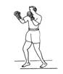  Upright stance | 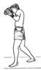  Semi-crouch | 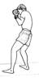  Full crouch

Punches
There are four basic punches in boxing: the jab, cross, hook and uppercut.

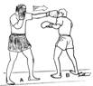  jab | 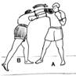  Cross (Straight right) | 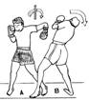  Hook | 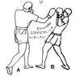  Uppercut
- Jab - A quick, straight punch thrown with the lead hand from the guard position. Cross - A powerful, straight punch thrown with the rear hand. From the guard position, the rear hand is thrown from the chin, crossing the body and traveling towards the target in a straight line.
- Hook - A semi-circular punch thrown with the lead hand to the side of the opponent's head. From the guard position, the elbow is drawn back with a horizontal fist (knuckles pointing forward) and the elbow bent.
- Uppercut - A vertical, rising punch thrown with the rear hand.
Defense
There are several basic maneuvers a boxer can use in order to evade or block punches, depicted and discussed below.
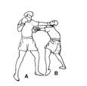  Slipping | 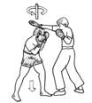  Bobbing | 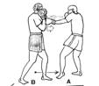  Blocking (with the arms) | 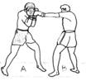  Cover-Up (with the gloves)
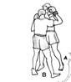  Clinching | 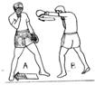  Footwork | 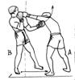  Pulling away

Guards
There are several defensive positions (guards or styles) used in boxing. Within each style, there is considerable variation among fighters, as some fighters may have their guard higher for more head protection while others have their guard lower to provide better protection against body punches. Many fighters vary their defensive style throughout a bout in order to adapt to the situation of the moment, choosing the position best suited to protect them.
Boxers who use an upright stance protect their chin with the rear hand in either the low or mixed guard styles depicted below. Crouch fighters tend to use the "peek-a-boo" style,
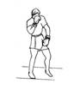  Low guard | 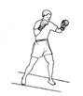  Mixed guard | 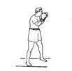  Peek-a-boo

TASK
Classify the following terms: JAB, FULL CROUCH, FOOTWORK, PEEK-A-BOO, UPPERCUT, SLIPPING, COVER-UP, CROSS, BOBBING, HOOK, CLINCHING, PULLING AWAY

into these categories:

A/ Stance:
B/ Punches:
C/ Defense:
D/ Guards:

