Physical Therapy Exercises
Exercising daily plays a main role in the process of healing and recovering from injury or disease. This is the goal of physical therapy exercises. Stretching and strengthening activities are only a few types of physical therapy exercises. Balance, joint control, and muscle re-training are other types of important physical therapy exercises.

Task 1
Fill the gaps with the correct word chosen from below.
increase joints recovery health immune regular cardiovascular

Physical exercise is the performance of some activity in order to develop or maintain physical fitness and overall _____________. Frequent and _______________exercise is an important component in the prevention of the diseases such as heart disease, cardiovascular disease, Type 2 diabetes and obesity.

Exercises are generally grouped into three types depending on the overall effect they have on the human body:
1. Flexibility exercises such as stretching improve the range of motion of muscles and
________________.
2. Aerobic exercises such as walking and running focus on increasing ________________ endurance.
3. Anaerobic exercises such as weightlifting or sprinting ______________muscle strength.

Physical exercise is important for physical fitness including healthy weight, building and maintaining healthy bones, muscles and joints; and strengthening the ____________ system.
Proper nutrition is at least as important to health as exercise. When exercising it becomes even more important to have good diet to ensure the body has the correct ratio of micro and macronutrients to help the body with the ________________ process after exercising.

Task 2 Speaking

Fitness - Exercise Myths
Although some old fitness fictions, such as “no pain, no gain” are fading fast, plenty of popular exercise misconceptions still exist. Here are some of the most common myths as well as the not-so-common facts based on current exercise research. Discuss them. Do you consider them myths? Support your arguments.

- If You’re Not Going to Work Out Hard and Often, Exercise Is a Waste of Time.

- Yoga Is a Completely Gentle and Safe Exercise.

- If You Exercise Long and Hard Enough, You Will Always Get the Results You Want.

- Exercise Is One Sure Way to Lose All the Weight You Desire.

- Overweight People Are Unlikely to Benefit Much From Exercise.

- Home Workouts Are Fine, But Going to a Gym Is the Best Way to Get Fit.
Task 3:
Read the following instructions how to perform certain exercises. The instructions are mixed up. Put them into a chronological and logical order:

1. Triceps Extension - Strengthens muscles in back of upper arm.
- Bend raised arm at elbow, bringing hand weight toward same shoulder.
- Raise one arm straight toward ceiling.
- Feet flat on floor; keep feet even with shoulders.
- Support this arm, below elbow, with other hand.
- Hold position.
- Slowly re-straighten arm toward ceiling.
- Slowly bend arm toward shoulder again
- Sit in chair, near front edge.

2. Hamstrings - Stretches muscles in back of thigh.
- Lean forward from hips (not waist) till you feel stretching in leg on bench, keeping back and shoulders straight. Hold position.
- Repeat with other leg.
- Straighten back
- Keep other leg off of bench, with foot flat on floor.
- Sit sideways on bench.
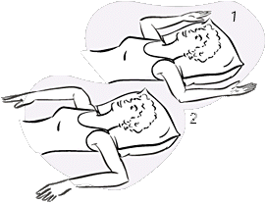
- Keep one leg stretched out on bench, straight.

3. Shoulder Rotation
- Hold position.
- Stretch arms out to side.
- Keep shoulders flat on floor.
- Bend elbows to crook lower arms downward, at right angle.
- Lie flat on floor, pillow under head.
- Bend elbows to crook lower arms upward, at right angle.
- Hold position.

Task 4: Listening – Giving instructions
Pilates Exercises – One-leg stretch
http://www.ehow.com/video_4940402_pilates-exercises-oneleg-stretch.html
Listen to a fitness trainer describing a Pilates exercise and write down as many verbs describing movement as possible.

Follow-up: Complete the gaps with parts of the body.
Rotate your____________clock-wise / anti-clock-wise
Shrug your_______________
Turn your______________from side to side
Stand with your ___________ apart/ shoulder width apart
Keep your ____________ straight
Bring/ stretch/ extend your ____________ to the side/ overhead/ straight forward
Swing ___ from side to side and around in a circle
Bend forward from your ______ and relax
Clasp your __________ behind your head
Cross ____________ over your chest
Lie on your ______, arms at the side, ___________ down/up, now bend your ___________
Hold your knee with both __________ and pull it towards your ___________
Squat on the floor with one ___________ bent up against the chest, the other leg stretched out behind
Lift up/ raise your ____________.
Task 5:
Here are some pictures of various physiotherapy exercises. First study the pictures properly, then choose an exercise and describe how to perform it.

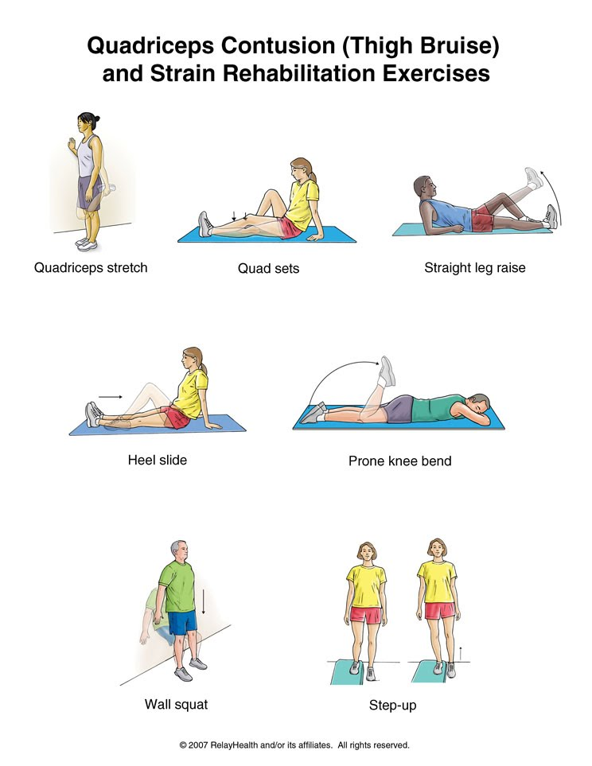

Now choose some of your classmates to perform the exercises as you describe them.

Task 6
- Prepare a set of exercises that will ensure development of all large muscle groups in the body.
- Consider a sport and develop exercises applying the overload principle that would develop all the large muscle groups used in the sport.

