JKII Session II Presenting visual information

Graphs and charts
Charts and graphs measure various statistics and are helpful when presenting large amounts of information that need to be understood quickly. This includes: facts and figures, statistical information, profit and loss, polling information, etc.
What are graphs used for in sports science? What information do we have to include when plotting a graph?

World population – describing trends
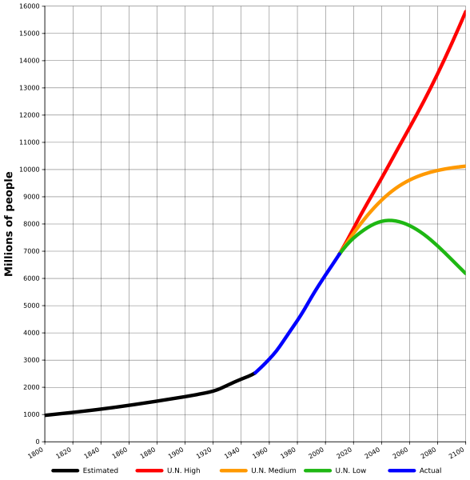
World population estimates from 1800 to 2100, based on "high", "medium" and "low" United Nations projections in 2010 (colored red, orange and green) and US Census Bureau historical estimates (in black). Actual recorded population figures are colored in blue.
  - Complete the gaps with the words below:
seen range show remain experienced stood declined increase peaked
The world population has (1) ___________ continuous growth since the end of the Great Famine and the Black Death in 1350, when it (2) ___________ at around 370 million. The highest rates of growth – global population increases above 1.8% per year – were (3) ___________briefly during the 1950s, and for a longer period during the 1960s and 1970s. The growth rate (4) ____________ at 2.2% in 1963, then (5) ____________ to below 1.1% by 2012. Total annual births were highest in the late 1980s at about 138 million, and are now expected to (6) _________ essentially constant at their 2011 level of 134 million, while deaths number 56 million per year, and are expected to (7) ___________ to 80 million per year by 2040.
Current UN projections (8) ____________ a continued increase in population in the near future (but a steady decline in the population growth rate), with the global population expected to reach between 8.3 and 10.9 billion by 2050. UN Population Division estimates for the year 2150 (9) ___________ between 3.2 and 24.8 billion; mathematical modeling supports the lower estimate. Some analysts have questioned the sustainability of further world population growth, highlighting the growing pressures on the environment, global food supplies, and energy resources.
(http://en.wikipedia.org/wiki/World_population)
  - Now fill in the missing prepositions:
To peak _____ 17%
To increase ______ 2% / to increase ________ 2%
To decline _______ below 3 billion
To range _______ 4.5 and 5.3 billion / to range ____ A to Z
  - Which of the verbs below can be used to refer to diagrams?
illustrates shows believes suggests indicates represents states demonstrates argues reflects

- Types of graphs

Match the types of graphs on the left below with their respective charts. Then complete the sentences below.

(http://office.microsoft.com/en-us/excel-help/available-chart-types-HA010342187.aspx)
1

A column chart
A line chart
A pie chart
A bar chart 2
An XY (scatter) chart
5
3
4
A stock chart
A doughnut chart
A bubble chart

8
7
6

- ________________ are often a good choice to show comparisons among data.
- ________________ are well suited to showing change over time.
- ___________ are well suited for showing parts of a whole.
- Like a pie chart, a __________ shows the relationship of parts to a whole, but it can contain more than one data series.
- You could use a ___________chart to indicate the fluctuation of daily or annual temperatures.

- Language of Graphs and Charts

(http://esl.about.com/od/businessmeetings/a/Language-Of-Graphs-And-Charts.htm)

Useful phrases used to describe common bar charts, line charts and pie charts
There are a number of specific words and phrases used to describe and discuss graphs and charts. This vocabulary is especially important when presenting to groups of people. Much of the language of graphs and charts relates to movement. In other words, the language of graphs and charts often speaks of small or large movement or differences between various data points. Refer to this language of graphs and charts to help improve your ability to speak about graphs and charts.
The following list the verb and noun used to speak about positive and negative movements, as well as predictions. Example sentences are included in each section.
Positive

to climb - a climb
to ascend - an ascent
to rise - a rise
to improve - an improvement
to recover - a recovery
to increase - an increase
Sales have climbed over the past two quarters.
We've experienced a rise in consumer demand.
Consumer confidence recovered in the second quarter.
There has been an increase of 23% since June.
Have you seen any improvement in customer satisfaction?

Negative

to fall - a fall
to decline - a decline
to plunge - a plunge
to decrease - a decrease
to worsen - a slip
to deteriorate - a dip

Research and development spending has fallen by 30% since January.
Unfortunately, we've seen a decline over the past three months.
As you can see, sales have plunged in northwest region.
Government spending has decreased by 10% over the past two years.
There's been a slip in profits this past quarter.

Predicting Future Movement

to project - a projection
to forecast - a forecast
to predict - a prediction

We project improved sales in the coming months.
As you can see from the chart, we forecast increased research and development spending next year.
We predict improving sales through June.

a) Now transform these sentences using the given word so that they mean the same:
- There's been a slight decline in sales.
Sales …………………………………….
- We made a sharp increase in investment.
Investment ………………………………
- There was an abrupt drop in sales in March.
Sales………………………………………
- Unfortunately, consumer interest suddenly decreased.
There…………………………………………
- The dramatic growth has come after we invested in a new product line.
We've …………………………………………
- Profit has been flat over the past two years.
There………………………………………..
- There has been steady improvement over the past three months.
Sales ……………………………………..

- Complete the following tables supplying the appropriate vocabulary.
VERB | NOUN
to rise
to increase
to improve
to fall
to decrease
to recover

ADJECTIVE | ADVERB | HOW MUCH CHANGE?
slight | slightly | very small
sharp
dramatic
steady

- Examining graphic material
Study the graphs below. What information does it show?
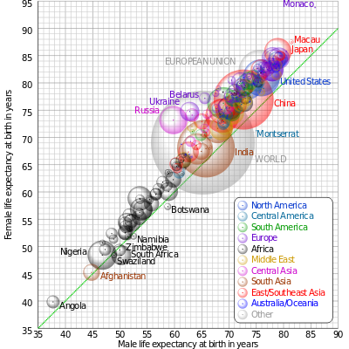
Comparison of male and female life expectancy at birth for countries and territories as defined in the 2011 CIA Factbook, with selected bubbles labelled. The dotted line corresponds to equal female and male life expectancy. The apparent 3D volumes of the bubbles are linearly proportional to their population. (wikipedia.org)

