Unit 6 ADVERTISING

Task 1 Speaking
Work with a partner. Look at the pictures – what do they represent?
Can you match them with some of the words below?
advert billboard brand logo product commercial slogan
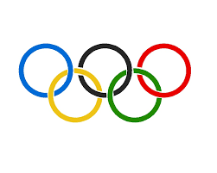
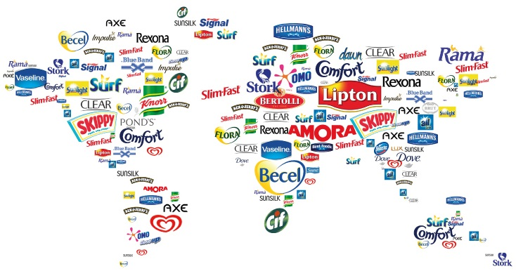

Task 2 Vocabulary
Match the adjectives below to their definitions a-f:

amusing clever confusing effective memorable persuasive

- able to make someone do something
- causing you to laugh or smile
- successfully making the effect that you want
- difficult to understand
- worth remembering or easy to remember
- showing skill or intelligence

Task 3 Listening
- Listen to three people talking about a memorable advertisement. Match speakers to points a-c.
- texting
- light
- homeless people

b) Listen again and write the number of speaker next to the statement which most closely matches what they say. There is an extra statement you do not need to use.

- People dislike being told they aren´t allowed to do something. ___
- I was really upset when I saw this advert. ____
- Adverts can make people aware of social issues. ____
- Funny adverts can be a good way to influence people. ___

c) Work with a partner. Use questions below to talk about memorable adverts/commercials you have seen.
- What was the message of the advert/commercial?
- What was it trying to persuade people to do?
- Was it effective?
- What adjectives would you use to describe it?

Task 4 Speaking – Agreeing and disagreeing
- Work with a partner. Add at least three more items to this list of things that go in and out of fashion:
clothes cars diets mobile phones

- Discuss these questions:
- Would you buy a new phone because yours felt old-fashioned? Why/Why not?
- Do you notice if people´s clothes are (un)fashionable? Does it affect your opinion on them?

- Use the phrases below to complete the table:
You might be right. Don´t you think? I was just going to say that! Rubbish!
I´m not sure about that. I couldn´t agree more. Absolutely! Would you agree?
I agree up to a point… I suppose so. Yes but I can´t help thinking… Wouldn´t you say that?

Agreeing | Disagreeing | Asking if someone agrees
- Discuss the statements below using the above phrases:

- There is no difference between expensive branded clothes and cheaper versions.
- People who follow fashion have no originality or ideas of their own.
- We have too many possessions today.

Task 5 Writing - Advantages and disadvantages essay
a) Work with a partner. What do you think fast fashion is?
b) Check your ideas in the first paragraph of the essay.

Broadly speaking, ´fast fashion´ companies make and sell the latest fashions very quickly. The clothes are heavily influenced by the international fashion shows in London, Milan, etc., and can even appear on the high street within two weeks of the show. They introduce new clothes into the shops every two or three months, not twice a year, like traditional fashion houses. The main objectives of ´fast fashion´ are to bring high- fashion clothes into the shops quickly and cheaply. However, this has both advantages and disadvantages.
One advantage is that customers can buy very up-to-date, fashionable clothes. Another major benefit is that there is a greater variety of clothes in the shops. This means that a smaller number of each item of clothing is made, so you probably won´t find other people wearing the same clothes as you.
On the other hand, there are also several drawbacks with ´fast fashion´. One disadvantage can be that the designs are not original; they are copied from the fashion shows or famous designers. Moreover, the clothes are usually made very cheaply, which can mean that the quality is poor and that the people who make the clothes are not well paid. This can give the companies a negative image.
Overall, we have seen that fast fashion can be a good or bad thing. We need to realize that we are responsible for the choices we make when we are shopping, and the difference those choices make to the world.

c) In the text above underline all useful phrases to express advantages and disadvantages.

d) Look at the essay title:
What are the advantages and disadvantages of buying the latest technology?

Work with a partner. Complete the essay plan with ideas for each paragraph.

- Introduction
- Advantages
- Disadvantages
- Conclusion
Write your essay. Then swap it with another student. Read your partner´s work and tell them about the things you like and the things they could improve (e.g. the ideas, the organisation, spelling, use of tenses).

(lesson adapted from Roberts, R. Navigate. OUP, 2015.)

