Unit 2 Sports and activities
Task 1 Speaking
Read the sentences about why sport can be positive and number them in order of importance for you. 1 = most important, 5 = least important. Think about why.
- Sport helps develop coordination and balance.
- It is very good for health to do exercise.
- Sport allows people to learn about competition in a positive way.
- Children who are less academic may find they can excel at sports.
- Sport gives people an opportunity to work off negative feelings.

Task 2
A) Read the sentences about why sport can be negative. In each sentence there are two spelling errors. Correct each error.
Sport may be beneficil for health but it also results in many people sufferring from injuries.
Competition in sport is very usefull for children who need to learn about life, but if they don´t get positive advise it can encourage them to be aggressive.
The amount of money earned by sports stars has gradualy increased and is now far too high, meaning that sport is now a business without sufficent focus on the competition itself.
Exceling at sports requires a lot of practice; if young people spend too much time on this, they may neglect school work and recieve poor grades.

B) Words commonly confused. Explain the difference between the words.

accept vs. except
affect vs. effect
lose vs. loose
stuff vs. staff
release vs. realise
chronic vs. chronicle
strength vs. strange
exercise* vs. exorcise

* note: we say “lack of exercise” when people are inactive. We use “movement” to talk about an act of moving the body, e.g. in “range of movement” or “Loose clothing gives you greater freedom of movement.”

Extra task - Online spelling quiz:
http://www.macmillandictionary.com/learn/language-quizzes/spelling-hard.html

Task 3 Finding correlations
Look at the information below about heat-related illness in sports activities and answer the questions.
The bar chart shows the number of heat-related illness suffered by high school students per 100 000 sports events in central US states. The line graph shows the average temperatures for one year in a central US state.
- Can you see any similarities in pattern?
- What kind of link between the two sets of information does this suggest?
- Are there any areas that do not link in the way you might expect?

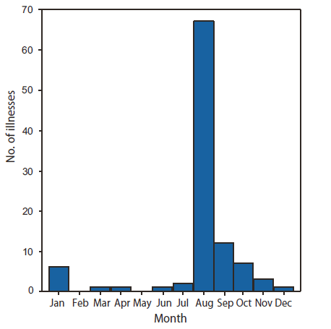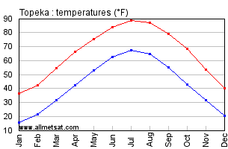
(http://www.cdc.gov/mmwr/preview/mmwrhtml/mm5932a1.htm)
(http://www.eldoradocountyweather.com/current/climate/topekaclimate.html)

Read the model answer below. How is the essay structured?
The bar chart shows the number of students from high school who were affected by heat-related illnesses in one year when participating in sports events in central US states. The line graph shows the average temperature in Fahrenheit over a year for one of those states. When considered together, the information suggests that there was a link between temperature and the number of illnesses suffered by sports participants, but this was not consistent.
The vast majority of illnesses occurred in August, reaching a peak at just under 70 incidences per 100 000 sporting events. This number was at a much higher level than at any other point in the year, almost seven times that of September, which experienced the next highest occurrence. It also correlates with a similar peak in temperature, which reached approximately 92 degrees in the same month at its highest and 69 degrees at its lowest.

However, in the winter months, the numbers of heat-related illnesses and the temperatures did not follow similar proportional trends. Temperatures dropped steadily from August to December, dipping to a minimum of 20 degrees and remaining there for January and February. However, illnesses reached their minimum of zero in February and May when the temperatures were at 25 degrees and 55 degrees respectively. There was actually a minor increase in the number of illnesses in January to roughly seven, when temperatures were at their lowest point for the whole year.
Overall the figures suggest a possible association between very high temperatures in the summer and the number of heat-related illnesses, but the correlation is not consistent at other times of the year.

Replace the underlined phrases in the model answer with the expressions a-e.
- far/significantly/substantially
- connection
- roughly/more or less
- overall/overwhelming/huge
- almost/about

Highlight phrases expressing trends, e.g. dipping, …………………………………..
………………………………………………………………………………………….

What phrases in the text above are used to show the connection between the two graphs?
………………………………………………………………………………………….

Explain the difference between these two sentences:
- There is no correlation between the two trends.
- There is a negative correlation between the two.

Task 4 Word class
Consider these sports: yoga, skateboarding, climbing, swimming. Do you associate them with younger or older people or both? Why?
Read two comments from a website. What reasons are given to support or oppose the proposal?
Proposal: There should be an age limit for the Olympics.
Yes! I think the Olympics should put a 30-year-old cap on their sports. After 30, the bones become more brittle and the body becomes less flexible. The muscles tear more easily and performance is not as good. The athlete is more likely to break something, or even have a breakdown. They are not as resilient.
NO! I do not believe so! It is true that as we get older it is harder to maintain the same athletic ability as in a person´s twenties. But with technology and our knowledge of proper nutrition, athletes are able to compete when they are older. I believe that everyone has a right to accomplish their dream no matter what age that person is! It is important that everyone has a dream.
Do you agree with the proposal? Why/not? Use the phrases below.
_ _ my opinion…
That is partly t_ _ _, but…
There is no d _ _ _ _ about it!
I couldn´t a _ _ _ _ more!

I agree _ _ to a point.
That´s not always the c _ _ _ .
I´m a _ _ _ _ _ I disagree.
We have to agree to d _ _ _ _ _ _ _ then.

Complete the table with the correct words.
Adjective | Verb | Noun
competitive
 |  | knowledge
 | X | athlete
X | maintain
 | accomplish
resilient | X
important | X
(adapted from Dimond-Bayir, S. (2014). Writing for IELTS. Macmillan.)

