Unit 5 GOOD INTENTIONS, POOR RESULTS

Task 1 Describe the graph below.
Gym membership retention
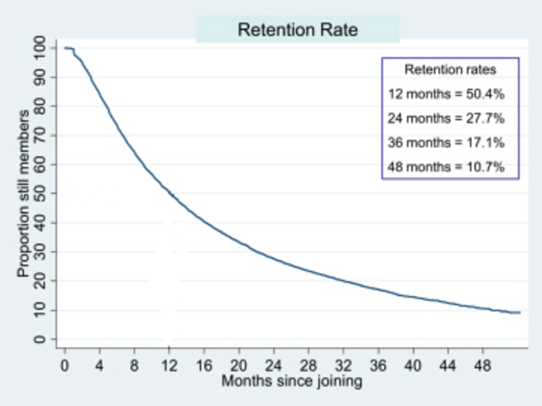
(http://www.science20.com/the_conversation/why_we_give_up_on_new_years_resolutions_online_courses_and_diets-151892)

Task 2 Speaking
Despite the medical and scientific evidence that physical activity promotes health, about 6 in 10 Americans are not regularly active, and another 1 in 4 are not active at all. So the questions are:
- Why is it so hard to adopt and maintain a physically active lifestyle?
- What are the barriers that keep so many people from being physically active?
- How can people change their behaviour to become more active?

Task 3 Vocabulary
Match the expression below with their definitions. Then use the expressions in sentences:

- willpower
- confidence
- to adhere to (exercise programme)
- resolution

- to behave according to particular rules or instructions
- the ability to control your thoughts and actions
- a firm decision to do or not to do sth.
- the feeling you can be sure about your abilities

Task 4 Reading
Common barriers to physical activity

Classify the barriers described below as personal, environmental, social or exertion barriers.

- Many people learn attitudes and habits from watching and listening to family and friends. Excessive distractions e.g. going to parties are unwanted.

- Too much time spent watching TV or surfing the Internet creates huge barriers to starting an exercise programme that takes time and effort mainly because it may not feel as good as sedentary options to people. Physical activity after longer period of inactivity subjectively feels hard, people perceive pain, achy joints, sweating, etc.

- Aging is associated with activity limitations due to deteriorating health. Also, older people may not know the benefits of being physically active. Furthermore, many older people may not view exercise as appropriate for their age.

- People who dropped out of exercise programmes reported that they failed because the exercise schedule conflicted with other commitments such as work, or because of inaccessible facilities.

- Many people lose motivation soon and give up exercising because their goals are too ambitious.

Follow-up

What tips or recommendations can you give to people to overcome the barriers described above?

Task 5 Conjunctions
Choose the correct answer:
- Although/ Despite / Due to the vast majority of Americans believe that being active is healthy for them, most remain sedentary.
- Although / Despite / Due to the medical and scientific evidence, many people do not maintain active lifestyle.
- Despite / In case / Unless you stick with this programme, you will not lose the weight.
- The injuries are largely unless/ due to / although ignorance.
- Take a granola bar in case / unless / despite your blood sugar drops.

Task 6 Phrasal verbs
- Use the following phrasal verbs in sentences:
work out
get over sth.
make sth. up
get on with sb.
run out of
take off
deal with

- Complete the sentences with suitable phrasal verbs. You may have to change the form of the verb.
burn off keep up cut down stick with
pay off give up put off drop out

- Rather than starting an exercise programme it is more difficult to ………………. it.
- Her husband finally persuaded her to …………………. smoking.
- Swimming can help you ……………. the unwanted calories.
- She was injured after the first round and had to ………………. of the race.
- I´m trying to ………………..on salt.
- You should not ………………… going to the dentist.
- The idea to exercise …………………. quickly – I look and feel much better after only a month!
- Well done! ………………. the good work!

