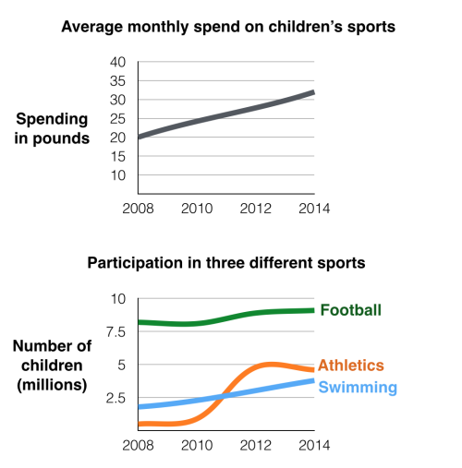

(http://ielts-simon.com/ielts-help-and-english-pr/ielts-writing-task-1/)

