**JAZYKOVÁ KOMPETENCE II**

**Seminar 2 - Thursday 19th March, 10.40 – 14.00**

**1. Aims**

Last seminar we discussed the structure and content of a presentation. Today we will move on to other factors, tips and techniques to help you deliver a more effective presentation.

Does everyone have the seminar notes for today?

**2. Homework task**

- Has everyone completed the homework task? (outline / plan of your research presentation)?

* Work in groups of 3. Share your research presentation plan with your colleagues, discuss the structure, content, how the points are broken up etc. Give each other feedback.

* Present back to the group briefly the research plan of one of the other members of your group.

**3. Planning your presentation**

**What factors do you need to consider when planning and preparing for your presentation?**

**\* Discuss with a partner, then with the class group.**

**4. What makes a good presentation**

**Ted Talks: Stacey Kramer – The Best Gift I ever Survived**

<https://www.ted.com/talks/stacey_kramer_the_best_gift_i_ever_survived?referrer=playlist-ted_in_3_minutes#t-172619>

***\* Listen to the presentation, then discuss with the group***

***\* Think about the below questions as you listen:***

a. What is the hook Stacey uses to get the audience engaged?

b. How does she share her background?

c. What are the main points of the talk?

d. What is the take-home message?

e. What other factors make this an entertaining presentation?

**5. What makes a good presenter?**

***\* Complete the principles of an effective presentation below with appropriate verbs:***

***\* Think about each statement then discuss with the class group.***

*A good presenter…*

*…. the presentation short, but complete.*

*…. a proper introduction of himself/herself and the topic of the talk.*

*…. the presentation with adequate volume, diction, and eye contact.*

*.. Doesn’t _____ on using notes.*

*…. the audience*

*…. participation and constructive comment*

*..Avoids _____ too much detail*

*…. information to make the best use of the time*

*…. the main arguments or points*

*…. an original conclusion from what he/she said*

*…the talk within the time limit*

*…questions from the audience*

**6. Jump starting your presentation**

**\* Brainstorm with a partner different ideas that may help to start your presentation effectively, engage the audience and get things off to a flying start…**

**\* Discuss your ideas with the class group.**

**6.1. What type of beginning are the following statements?**

***\* Read the statements below and discuss with the class group.***

a. Hello, I’m Steven….please feel free to have some refreshments while we are waiting for everyone to arrive and be seated…

b. Do you realize that recent studies have shown more than 60% of Americans are now considered to be overweight or obese? And this is not just happening in the US…

c. I’d like to share with you today the findings of our research, and how this may stimulate you to think completely differently about the topic of sports nutrition…

d. OK….to start with, I’d like to ask you a question. How many of you average less than 8 hours of sleep a night? And how many average 7 or less? 6?....

e. To start with today, I’d like to share with you a famous quote from the British Author, William Shakespeare…….and how does this related to today’s topic? …

f. We often talk about improving communication and the lines of communication within large organisations. But what does this mean exactly? …

g. Speaker projects the opening slide with a funny cartoon on it….the audience laughs…

**7. Using Visual Aids:**

**\* What visual aids are might you need for a presentation? Why? * Discuss with the class group.**

**\* With a partner, discuss the following statements, then discuss with the group.**

a. A picture is worth 1000 words.

b. You should include as much information on each slide as possible.

c. If the audience can’t understand me, they can always read the information.

d. The presentation hand-out should be exactly the same as the slides.

e. Everyone in the audience needs pictures because that’s how people learn best.

f. There should never be more than 6 words on a slide.

g. It’s important to have videos or clips in all presentations these days.

**7.1. Using Slides**

**\* Look at the headings below. What do you think is important when using slides in a presentation? * Discuss with the class group.**

a. Number of slides:

b. Layout and information on each slide:

c. Pictures / charts / visual aids:

d. The way the speaker refers to the slides:

e. Other comments:

**7.2. Graphs and charts**

Charts and graphs measure various statistics and are helpful when presenting large amounts of information that need to be understood quickly. This includes: facts and figures, statistical information, profit and loss, polling information, etc.

***What are graphs used for in sports science? What information do we have to include when plotting a graph? * Discuss with the class group.***

**\* Look at the graph below of world population. With a partner, discuss how you would describe the general trends in this graph to an audience.**

# World population – describing trends

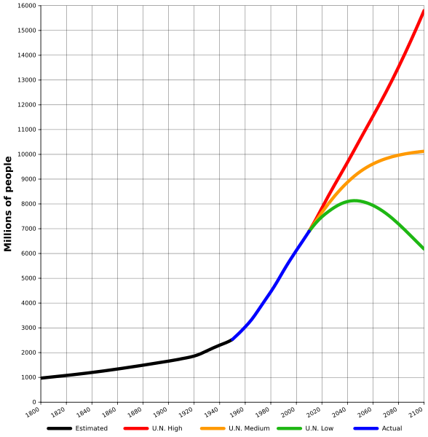

World population estimates from 1800 to 2100, based on "high", "medium" and "low" United Nations projections in 2010 (colored red, orange and green) and US Census Bureau historical estimates (in black). Actual recorded population figures are colored in blue.

**7.3. Activities - Complete the gaps in the text using the words listed below:**

***\* Read and complete with the class group:***

*seen range show remain experienced stood declined increase peaked*

The world population has (1) **___________** continuous growth since the end of the Great Famine and the Black Death in 1350, when it (2) **___________** at around 370 million. The highest rates of growth – global population increases above 1.8% per year – were (3) **___________**briefly during the 1950s, and for a longer period during the 1960s and 1970s. The growth rate (4) **____________** at 2.2% in 1963, then (5) **____________** to below 1.1% by 2012. Total annual births were highest in the late 1980s at about 138 million, and are now expected to (6) **_________** essentially constant at their 2011 level of 134 million, while deaths number 56 million per year, and are expected to (7) **___________** to 80 million per year by 2040.

Current UN projections (8) **____________** a continued increase in population in the near future (but a steady decline in the population growth rate), with the global population expected to reach between 8.3 and 10.9 billion by 2050. The UN Population Division estimates for the year 2150 a (9) __**_________** between 3.2 and 24.8 billion; while mathematical modeling supports the lower estimate. Some analysts have questioned the sustainability of further world population growth, highlighting the growing pressures on the environment, global food supplies, and energy resources.

(<http://en.wikipedia.org/wiki/World_population>)

***\* Now fill in the missing prepositions:***

To peak _____ 17%

To increase ______ 2% ______ 3%

To decline _______ below 3 billion

To range _______ 4.5 and 5.3 billion

To range ______ A to Z

**\* With a partner, discuss which of the verbs below can be used to refer to diagrams?**

illustrates shows believes suggests indicates

represents states demonstrates argues reflects

***\* Now create some example phrases which you can use to introduce a chart or graph:***

**7.4. Numbers, Trends and Pronunciation**

***\* Practice reading the following numbers aloud:***

a. 6759 b. 20.75 m c. £6.2 million d. 7.836% e. $885 f. 6 ft 2 inches

**When you don’t need to say an exact amount:**

a. *Around* 5600 people attended the event…

b. *Approximately* 89% of individuals present…

c. *Roughly* $90 million has been spent …

d. The figures *more or less* suggest that…

e. *Just over* ¾ of the subjects that we recruited were asymptomatic…

***\* Read the sentences below, then rewrite them as approximations:***

a. At the shop they produce 995 new items every day.

b. The company’s profit was reported to be $1.005 million last year.

c. The consitituents of the mixture included 49% paint and 51% water.

d. 68.9% of people mentioned that they prefer eating meat over vegetables.

e. In the UK there are 192,597 fully qualified medical professionals.

f. There are 548 rivers in the region of greater Westonia.

g. The firm has now produced 101 different items that have gone on sale.

**7.4. Describing Graphs and Trends**

***\* Work with a partner: Match the trends in the graphs with the sentences below them:***

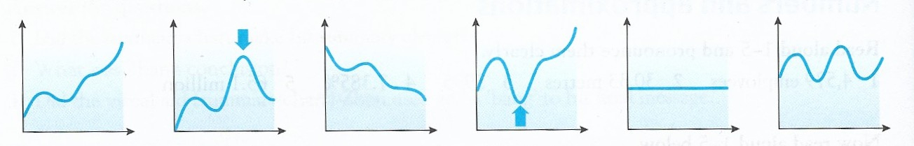

1 2 3 4 5 6

a. You can see in the graph that the figures are quite stable / consistent…

b. There is a general downward trend that can be seen, with a small rise in the early to mid portion of the time period…

c. It can clearly be seen on the graph that the numbers fluctuate throughout the testing period..

d. There is a steep rise early followed by a small decrease. However then steady growth once again can be seen with a sharp rise towards the end.

e. The arrow indicates the lowest point on the scale, however prior to and following this point, the numbers were generally much higher.

f. There is an early steep rise in the curve followed by a shallow drop. Following this the figures skyrocket to the peak, which can be seen by the arrow.

**8. Time for Questions**

A short time period set aside for questions is a common feature of academic presentations. Think about why this is the case, what are the benefits of providing this time for your presentation, and how to best prepare for this time.

***\* Discuss these ideas in groups of 3, then with the class group:***

a. Why invite questions from the audience and why do people ask questions?

b. When should you invite questions? Why or why not?

c. What are the advantages / disadvantages of allowing questions?

d. How can you best prepare for questions?

**8.1. Repeating and Paraphrasing questions**

When you receive a question from the audience, there are different methods that you can use that can both help you clarify the question for both yourself and the audience, and to give yourself a bit of extra time to respond as well as you can.

**a. Repeating the question back:** When a question is asked, it’s possible to simply repeat the question using the same words, but without raising your intonation as used for typical questions….eg.

Question: Are there any previous studies that have found different results to yours?

Response: Are there any previous studies that have had different results to ours……well….

**b. Paraphrasing:** When the question of more complicated and perhaps difficult to understand either for yourself or the audience, then it may be useful to paraphrase the question back to the person who asked it so everyone is clear on exactly what the question is. Then you can respond appropriately…

Question: You mentioned that there were some outliers in your study that may have skewed the results towards a positive finding, can you tell us why you think that occurred?

Response: OK, so am I right in saying that you are asking whether the outliers from our subject group may have skewed our results in a positive direction? Is that correct? ……OK…well……

**c. Prepared responses:** You can have some other statements ready for when you receive a question which can function similarly to the above points:

I’m sorry, can you please repeat your question….

So to clarify, you were asking about….

So you would like me to explain in more detail….

To be clear then, you are asking about….

You’ve raised two points here….the first…..

I’ll be discussing that point a little later so if its ok, we will move on for now…

I’m afraid that point moves beyond the scope of my research and this talk, however….

I didn’t catch that, can you please repeat the question?

I’m sorry, I don’t understand your question. Can you please put it another way?

So you’re asking me if I agree with previous research findings or not?

Would you mind holding on to that question for the end? We will be talking about that soon.

**Assignment and Presentation**

***Assignment:*** *Submission date 5pm* ***Thur 9th April.***

*\* Prepare a 1000 word written document on the same topic of your upcoming presentation. Use the structure used in your plan and the ideas covered during the seminars where possible.*

***Presentation:*** *All talks will be on* ***Thur 2nd April.***

*\* 10 – 15 minute presentation on your research or another topic of choice.*

*\* Be prepared with visual aids / powerpoint etc (bring on a flash drive or email to me beforehand if needed).*