COMBAT SPORTS
A competitive contact sport where two combatants fight against each other using certain rules of engagement. Boxing, amateur wrestling, mixed martial arts and fencing are examples of combat sports. The techniques used can be categorized into three domains: striking, grappling, and weapon usage.
History
Sports related to combat skills have been a part of human culture for thousands of years. The Ancient Olympic Games were largely composed of sports that tested skills related to combat, such as Boxing, Wrestling, Pankration (blend of boxing and wrestling) Chariot racing amongst others. This tradition of Combat sports was taken even further by the Romans with gladiators who would fight with weapons, often to the death.
Through the Middle ages and Renaissance the Tournament became popular. It consists of martial competition between two mounted knights using a variety of weapons. While the tournament was popular amongst Aristocrats, combative sports where practiced by all levels of society.

Combat sports
Here are some examples of combative sports, and martial arts with varying degrees of sporting application.
Martial arts vary widely, and may focus on strikes, grappling, or weapons training. Some examples that focus on as specifics aspect:
Striking: Kickboxing, Taekwondo, Karate
Grappling: Jiu Jitsu, Judo, Wrestling (various types)
Weaponry: - Fencing, Kendo
Boxing is a combat sport in which two participants (generally) of similar weight fight each other with their fists. Boxing today is conducted in a regulated way, typically in a series of one to three-minute intervals called rounds. Victory is achieved if the opponent is knocked down and unable to get up before the referee counts to ten

Modern boxing

Stance
The modern boxing stance differs substantially from the typical boxing stances of the 19th and early 20th centuries.
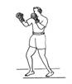  Upright stance | 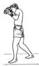  Semi-crouch | 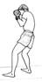  Full crouch

Punches
There are four basic punches in boxing: the jab, cross, hook and uppercut.

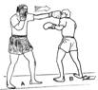  jab | 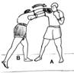  Cross (Straight right) | 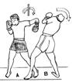  Hook | 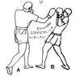  Uppercut
- Jab - A quick, straight punch thrown with the lead hand from the guard position. Cross - A powerful, straight punch thrown with the rear hand. From the guard position, the rear hand is thrown from the chin, crossing the body and traveling towards the target in a straight line.
- Hook - A semi-circular punch thrown with the lead hand to the side of the opponent's head. From the guard position, the elbow is drawn back with a horizontal fist (knuckles pointing forward) and the elbow bent.
- Uppercut - A vertical, rising punch thrown with the rear hand.
Defense
There are several basic maneuvers a boxer can use in order to evade or block punches, depicted and discussed below.
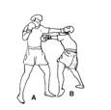  Slipping | 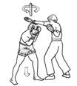  Bobbing | 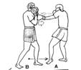  Blocking (with the arms) | 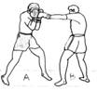  Cover-Up (with the gloves)
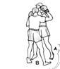  Clinching | 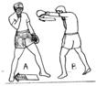  Footwork | 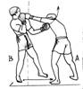  Pulling away

Guards
There are several defensive positions (guards or styles) used in boxing.
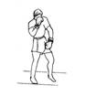  Low guard | 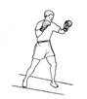  Mixed guard | 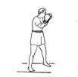  Peek-a-boo

