Strategies in sports club

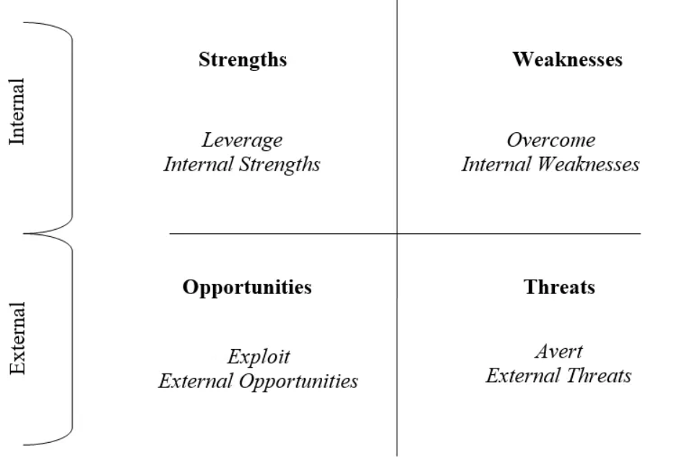

S – O (max – max) = leverage internal strengths – exploit external opportunities
S – T (max – min) = leverage internal strengths – avert external threats
W – O (min – max) = overcome internal weaknesses – exploit external opportunities
W – T (min – min) = overcome internal weaknesses – avert external threats

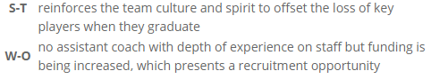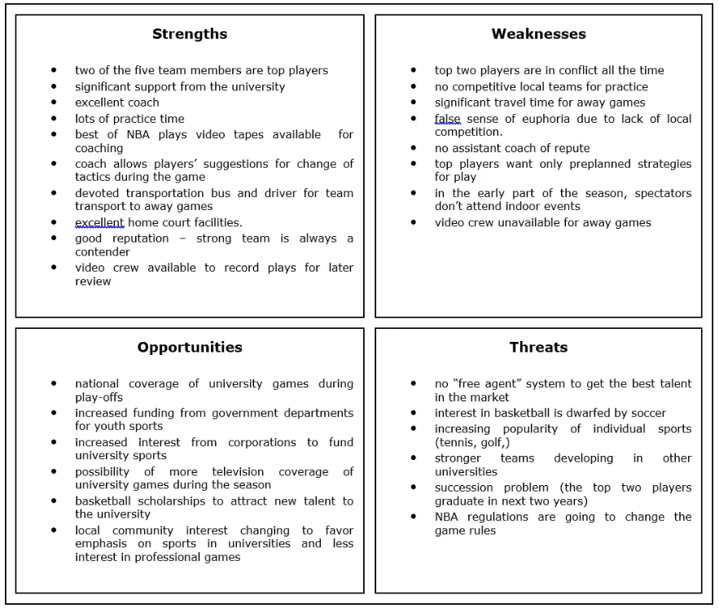
Strategic ways for sports teams on a different level

- Education for coaches
  - Self-study
  - Mentor coaching
- Improvement of facilities
  - Quality of sporting surface /equipment
  - Lighting
  - Social areas with food / drink bars
  - Clean and tidy areas
  - Spectator seating with protection from sun and rain
  - Shops
  - Car parking
- Recruitment of participants
- Organising Events
  - Assisting some organisation
  - Providing an opportunity
  - Raising the performance standards
- Nurturing of volunteers
- Openness in political and administrative structure
  - Democratic processes inside the organisation
  - Aiming fo grants
- Knowledge management
  - Coaching
  - Policies and procedures
  - Strategic plans
- Development of self-funding systems
- Athletes development programs
  - Academies
- Forming partnerships with other sports and organisations
- Internationalization

