[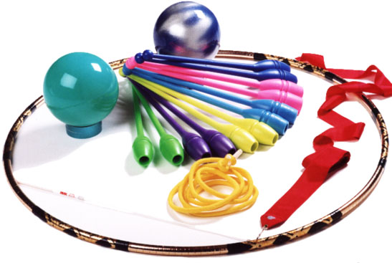](https://www.google.com/url?sa=i&source=images&cd=&cad=rja&uact=8&ved=2ahUKEwiApZLw29HhAhXv2eAKHa1oBTsQjRx6BAgBEAU&url=https%3A%2F%2Fwww.dugymrg.com%2Foutfits-apparatus.html&psig=AOvVaw32x9gcQj4dZk44kb85ZDUN&ust=1555404619333093)