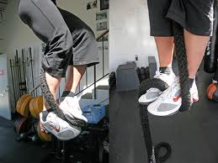

<http://coretraining.cz/2012/06/jak-se-prosplhat-k-lepsim-vysledkum/>

<https://www.youtube.com/watch?v=qUCXyVCatgI>

<https://www.youtube.com/watch?v=3l3CptBY2cs>

<https://www.youtube.com/watch?v=GUk3CZ-5rsE>

<https://www.youtube.com/watch?v=53WgYmEwGh4>

<https://www.youtube.com/watch?v=7Joj0oGYkMk>

<https://www.youtube.com/watch?v=y0wZ949J_4w>

<https://www.youtube.com/watch?v=JDCUSve-qJ4>