[](http://www.visualdictionaryonline.com/sports-games/combat-sports.php)

[](http://www.visualdictionaryonline.com/sports-games/combat-sports.php)

[](http://www.visualdictionaryonline.com/sports-games/combat-sports.php)

[](http://www.visualdictionaryonline.com/sports-games/combat-sports.php)

[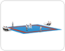](http://www.visualdictionaryonline.com/sports-games/combat-sports/jujitsu.php)

[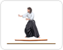](http://www.visualdictionaryonline.com/sports-games/combat-sports/aikido.php)

[](http://www.visualdictionaryonline.com/sports-games/combat-sports.php)

[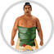](http://www.visualdictionaryonline.com/sports-games/combat-sports.php)

[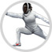](http://www.visualdictionaryonline.com/sports-games/combat-sports.php)