wrestling
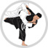
judo
karate
Kung fu
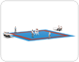
jujitsu

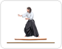
aikido

kendo
sumo
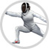
fencing

