3rd Announcement of the International Conference

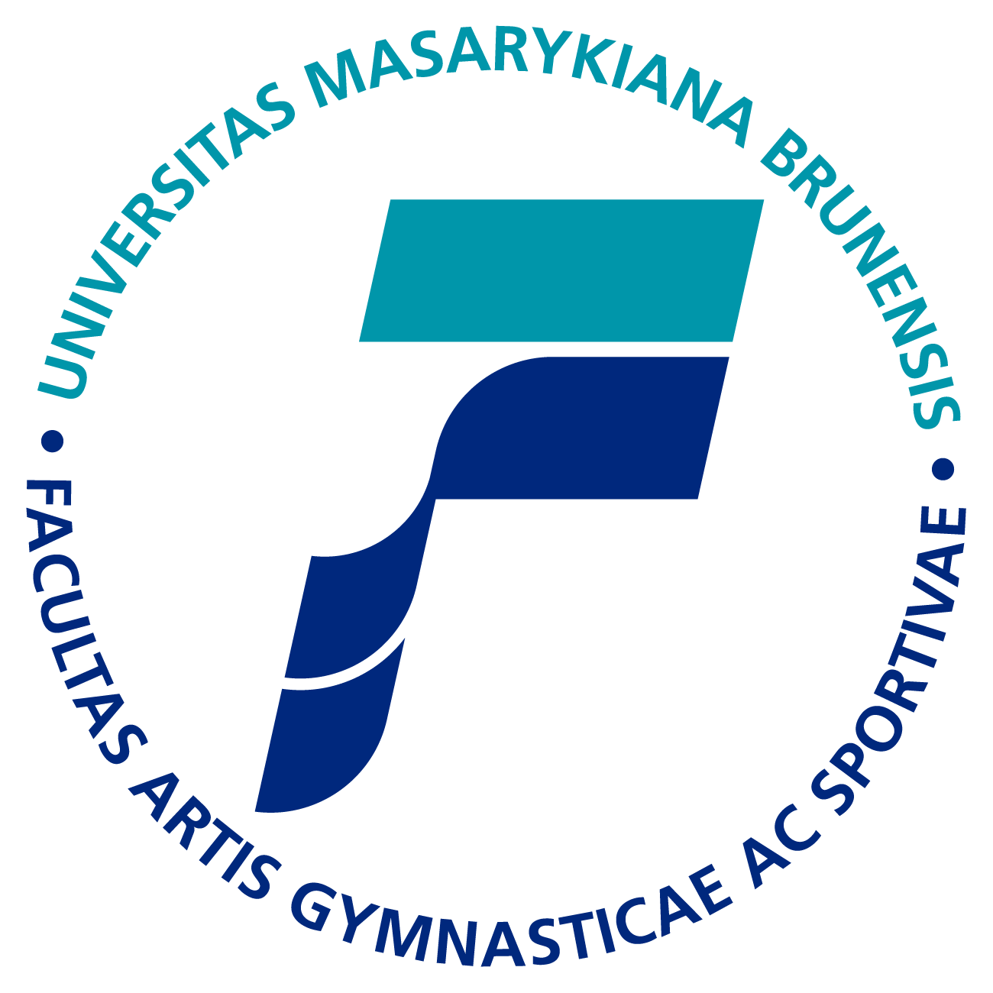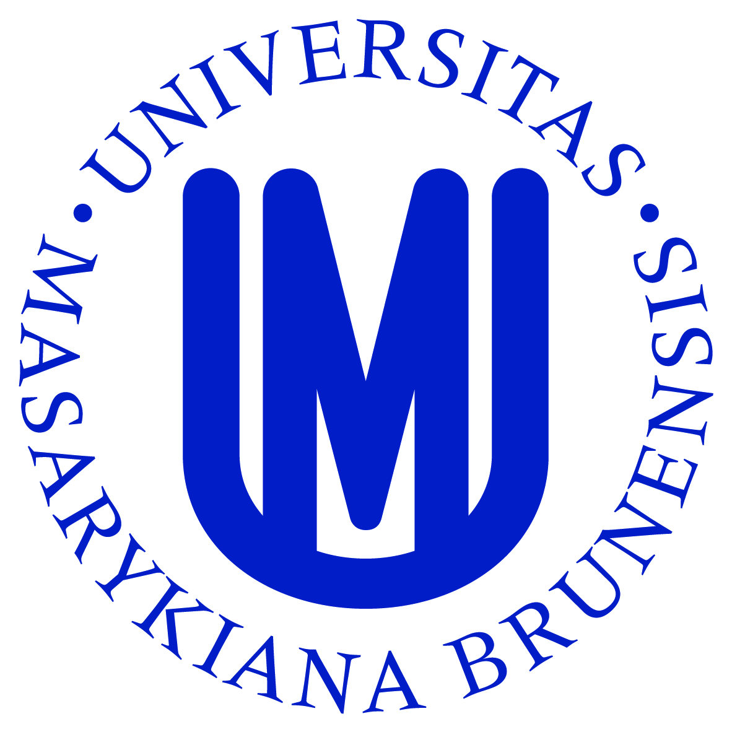

Faculty of Sports Studies, Masaryk University, Brno
in cooperation with The Czech Association of Kinantropology
Present the 7th year of the international scientific conference

SPORT AND QUALITY OF LIFE 2009
Sport and its social dimension
Under the patronage of
rector of the Masaryk University
prof. PhDr. Petr Fiala, Ph.D., LL.M.
head of the Czech Association of Kinantropology
doc. RNDr. Jan Hendl, CSc.
hejtman of the South Moravian Region
Mgr. Michal Hašek

Conference takes place during International Sports Fair SPORT Life (5. - 8. 11. 2009)

Conference date: 5. - 6. 11. 2009

Conference site: Brno Exhibition Centre, Congress centre (entrance next to the tram Nr. 1 stop “Výstaviště – hlavní vstup“)

Scientific commitee: doc. PhDr. Michal Charvát, CSc. – chairman
prof. Ing. Václav Bunc, CSc.
prof. MUDr. Hana Hrstková, CSc.
prof. PhDr. Antonín Rychtecký, DrSc.
prof. PhDr. Ján Grexa, Ph.D.
prof. PhDr. Vladimír Hellebrandt, Ph.D.
doc. PaedDr. Jitka Kopřivová, CSc.
doc. MUDr. Jan Novotný, CSc.
doc. PhDr. Josef Pavlík, CSc.
doc. PaedDr. Marie Blahutková, Ph.D.

Honorary Committee:

prof. PhDr. Petr Fiala, Ph.D.LL.M., rector of the Masaryk University
doc. PaedDr. Miroslav Holienka, Ph.D., dean of the Faculty of Physical Education and Sports, UK Bratislava
doc. PhDr. Dušan Tomajko, CSc., dean of the Faculty of Physical Education, UP Olomouc
Doc. PhDr. František Dvořák, CSc., Faculty of Physical Education and Sports, UK Praha
PhDr. Walter Bartoš, president of the Committee of Science, Education and Culture of Youth and Sports of the Parliament of the Czech Republic
MUDr. Milan Jirásek, president of the Czech Olympic Committee
PhDr. Jaroslav Nekola, president of the Anti-Doping Committee of the Czech Republic
Ing. Vladimír Srb, president of the Czech Association of Physical Education
Roman Onderka, mayor of the city of Brno

Organisation Committee:
doc. PaedDr. Marie Blahutková, Ph.D.
Ing. Jana Smítalová
Mgr. Marta Drozdková
Bc. Pavlína Vlachová, Dis.
Ing. Jiří Šišma
Mgr. Petr Zaoral

Thematic Sections: Aggressiveness in sport
Sport and health
Sport and society
Sport and leisure time
Sport of disabled
Poster section

Official languages of the conference: Czech, Slovak, English

Forms of presentations: oral presentations, video projections, posters

Deadline of registration and full version of papers: 30th September 2009.

You can REGISTER here http://www.fsps.muni.cz/konference2009/en_prihlaska.php

To send ABSTRACT use this form http://www.fsps.muni.cz/konference2009/en_prihlaska.php

FULL VERSION OF YOUR PAPER is to be sent to the official email address of the conference konference2009@fsps.muni.cz, in *.doc or *.pdf format, maximum 20 pages, including attachments and literature list.

Should your paper be of another form, i.e. video, etc., please contact Mrs. Drozdková: drozdkova@fsps.muni.cz

Accepted size of posters is 120 x 90 cm

Fees::

Students | till 30.9.2009 | 30 EUR
All participants | till 30.9.2009 | 80 EUR
All participants | from 1.10.2009 | 90 EUR
Passive attendance |  | 60 EUR
Cancellation charge |  | 30 EUR

After receiving your registration form we shall immediately send an invoice to your home institution. The invoice includes conference fee covering the entrance to all sections of the conference, refreshment during the conference, collection of abstracts and papers, free entry to the SPORT Life Fair and sports gala including banquet.

Conference fee has to be paid till 24th October 2009 otherwise the presentation can not be put into the memorial volume.

Accommodation: Hotel, double room, 490,- CZK/bed/night including breakfast (980, - CZK/whole room). The accommodation will be paid individually by each participant.

Board: Breakfast – individual

Lunch – individual in the area of Brno Exhibition Centre

Dinner – after evening sports gala “90 years in movement”

Social evening: On Thursday evening 5. 11. 2009 at 19,30 the sports gala “90 years in movement” is going to take place at new sports hall of Faculty of Sports Studies at University Campus Bohunice. The gala is part of the celebrations of the 90th anniversary of Masaryk University.

After performance there will be a banquet.

All conference participants are kindly invited.

Secretariat of the conference:
Masaryk University
Faculty of Sports Studies
Kamenice 5, 625 00 Brno
+420 549 49 2006, + 420 549 49 8666
konference2009@fsps.muni.cz

Preliminary program of the conference Sport and Quality of life 2009

Thursday 5th November 2009 Friday 6th November 2009
9:00 – 10:00 Arrival and registration 9:00 – 10:30 Conference in sections
10:00 Official opening of the conference 10:30 – 11:00 Coffee Break
10:30 – 12:30 Conference in the plenum 11:00 – 12:30 Conference in sections
12:30 – 14:00 Lunch
13:15 – 14:00 Posters section
14:00 – 15:30 Conference in sections
15:30 – 16:00 Coffee break
16:30 – 18:00 Conference in sections
Sports gala “90 years in movement“

You are heartily invited by: doc. PhDr. Michal Charvát, CSc. doc. PaedDr. Marie Blahutková Ph.D.

scientific committee organization committee

