Physiotherapy of Sports Injuries

Discussion:
Have you ever suffered any injuries due to sports? If so, which ones? How did it happened?
What kind of therapy did you undergo?

Types of sports injury
Sport injuries can be acute or chronic.
- Acute sports injuries occur as a result of a sudden impact/hit or bad movement. Examples include a cut to the skin or a sprained ankle.
- Chronic sports injuries develop over time, often because of continual use of the same joints or muscle groups.
TASK:
Match the following common sports injuries on the left with their definitions on the right:
sprain, an inflammation of a tendon ...
strain a trauma to the head
bruise a small pocket of fluid within the upper layers of the skin
cut an injury to a muscle or tendon in which the muscle fibers tear as a result of overstretching. Also colloquially known as pulled muscles.
bone fractures wounds caused by sharp objects, such as knives or glass
tendonitis an injury to ligaments that is caused by being stretched beyond their normal capacity and possibility
blister a common skin injury that results in a discoloration of the skin visible as black and blue mark.
head injury. a medical condition in which there is a break in the continuity of the bone.

Reading
The following English words are written in Czech in the text. Can you match each Englis word with a corresponding Czech equivalent according to the context?
Here is the list of the words: staff(s),connective, major, challenge, brace, twisting, healing, relief, dressing, damage, settle, swelling, range.

When players have sports injuries, they turn to physiotherapy for rehabilitation. Physiotherapy, also called physical therapy, can help to correct the poškození .
One example of the many sports injuries is an anterior cruciate ligament (ACL) injury.

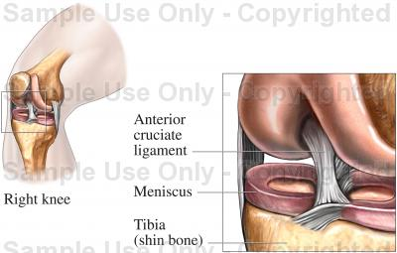

This is an injury to the knee. It is one of the common sports injuries in people who play sports that namáhají their knees, such as hockey, skating, skiing, basketball, and of course, football. It can limit the rozsah of a player's motion in that leg, and make the leg weak.
Surgery is sometimes done for these sports injuries, but physiotherapy is always a part of the treatment. The three hlavní exercises done to start the hojivý process of ACL are heel slides, quad sets, and straight leg raises.

http://www.youtube.com/watch?v=2pdWi8srqFc = heel slides
http://www.youtube.com/watch?v=-iMemFCxYAI = quad sests
http://www.youtube.com/watch?v=OmB1ck20IfA = straight leg raises
Heel slides are exercises for ACL sports injuries that are easy to understand, but may be painful to do at first. One simply lies on the bed or floor with the foot down. Then, one slides the foot slowly towards the buttocks until it hurts a little, and slides it back. This and the other exercises help prepare the knee for surgery or to heal without it.
Another of the sports injuries that physiotherapy is used for is tennis elbow.

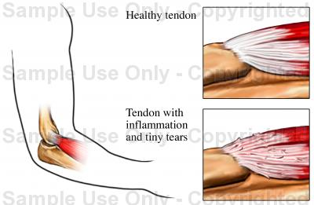

One might get tennis elbow from playing tennis, certainly, but it can also come about from any activity that involves otáčení the wrist.
Sports injuries like tennis elbow are treated with a comprehensive plan of physiotherapy. A common procedure for sports injuries is the use of ultrasound. Ultrasound is a way of applying heat deep into the muscle for pain úleva.
Electrical stimulation can be used not to feel pain through the nervous system. It is used for tennis elbow and many other sports injuries. Massage and manual therapy can also be used for physiotherapy.
Massage is one of the forms of soft tissue manipulation. However, soft tissue manipulation is to muscles what chiropractic is to bones. It deals not only with muscle, but with tendons and pojivová tissue as well.

Another example of a common sports injury is a sprained ankle.

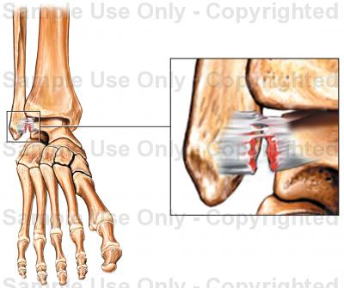

Physiotherapy treatment starts with PRICE, which stands for protection, rest, ice, compression and elevation. Protection involves using a ortéza to prevent abnormal movement of the joint and further damage. Rest is important for damaged structures and allows the part to srovnat se without stress. Cryotherapy or cold/ice treatment is useful to reduce pain and otok.
A compression obvaz reduces or prevents swelling.
Elevation--Raising your ankle to or above the level of your heart will help prevent the swelling from getting worse and will help reduce bruising. Try to keep your ankle elevated for about 2 to 3 hours a day if possible.

Physiotherapy is useful in the healing of many sports injuries. Many professional sports teams have physiotherapists on their personál.

TASK
You will watch a short presentation about problems with Achilles tendon:

http://www.youtube.com/watch?v=vrdUUJks2QI&feature=more_related

Listening preparation: vocabulary: can you guess the meaning of the following words from the meaning of their antonyms (=words having an opposite meaning) ?
The word: opposite meaning:
descend x go up
susceptible x immune

How would you describe a “pop” sound?
Which defect is typically accompanied by the pop sound?

Listen and answer the questions:

- Choose the right alternative:
Your doctor has recommended that you undergo surgery to repair your: a) posture of Achilles tendon
b) rupture of Achilles tendon
c) torture of Achilles tendon

2. Which of the following qualities of Achilles Tendon are mentioned – it is the a) shortest
b) greatest
c) largest
d) weakest
e) strongest
f) longest
g) thickest
h) widest
i) thinnest

- Fill in the missing words:
Achilles tendon is extremely susceptible to _________________ and _________________ __________________

