Food Pyramid

Vocabulary

carbohydrates
Definition: Any of a large group of compounds that contain carbon, hydrogen, and oxygen found in food that give energy
Context: Carbohydrates are an important source of energy for your body.
diet
Definition: The foods that a person, animal, or community usually eats
Context: Your diet should include healthful foods in the recommended daily amounts.
energy
Definition: The strength and vitality needed to stay active
Context: Eat well to gain energy to grow, think and study, and walk and run and play.
nutrients
Definition: A substance essential for life and growth
Context: Food provides the nutrients people need to function and live healthfully.
protein
Definition: Any of a group of organic compounds forming part of body tissues and making up and important part of the diet
Context: Foods from the meat group provide protein.
serving
Definition: A quantity of food suitable for one person
Context: One slice of bread is a serving.

Video

http://www.youtube.com/watch?v=8zt-KYP_4vg&feature=related

Watch the video and fill in the table:
(food group, products, nutrients)
Grains

Vegetables

Fruit

Milk, yogurt and cheese

Meat, Poultry, Fish, Dried Beans, Eggs and Nuts

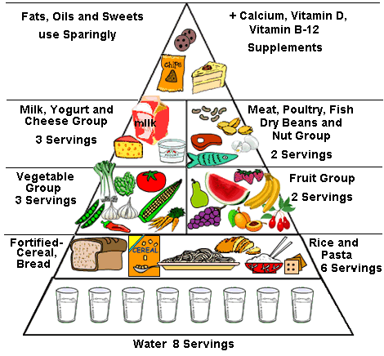

Text
Before reading:
Find words which mean the following in the text:
foodstuff used in baking
uncooked
meat of chickens, ducks or geese
possible to see
carefully

Bread, Grain, Cereal and Pasta
At the base of the food pyramid, you will see the group that contains breads, grains, cereals and pastas. These foods provide complex carbohydrates, which are an important source of energy, especially for a low-fat meal plan. You can make many low-fat choices from foods in this group. You will need 6 to 11 servings of these foods in a day. One serving of this group can be:
• 1 slice of bread
• 1/2 cup of rice, cooked cereal or pasta
• 1 cup of ready-to-eat cereal

Try to eat whole-grain breads, cereal and pasta for most of your servings from this group. Whole-grain foods (which are made with whole wheat flour) are less processed and contain more valuable vitamins, minerals and fiber than foods made with white flour.
Fruits and Vegetables
Fruits and vegetables are rich in nutrients. Many are excellent sources of vitamin A, vitamin C, folate or potassium. They are low in fat and sodium and high in fiber. The Food Pyramid suggests 3 to 5 servings of vegetables each day. One serving of vegetables can be:
• 1 cup of raw leafy vegetables
• 1/2 cup of other vegetables, cooked or raw
• 3/4 cup of vegetable juice
The Food Pyramid suggests 2 to 4 servings of fruit each day. One serving of fruit can be:
• One medium apple, orange or banana
• 1/2 cup of chopped, cooked or canned fruit
• 3/4 cup of fruit juice
Beans, Eggs, Lean Meat and Fish
Meat, poultry and fish supply protein, iron and zinc. Non-meat foods such as dried peas and beans also provide many of these nutrients. The Food Pyramid suggests 2 to 3 servings of cooked meat, fish or poultry. Each serving should be between 2 and 3 ounces. The following foods count as one ounce of meat:
• One egg
• 2 tablespoons of peanut butter
• 1/2 cup cooked dry beans
• 1/3 cup of nuts
Remove skin from poultry and visible fat on meat. Avoid frying these foods.

Dairy Products
Products made with milk provide protein and vitamins and minerals, especially calcium. The Food Pyramid suggests 2 to 3 servings each day. If you are breastfeeding, pregnant, a teenager or a young adult age 24 or under, try to have 3 servings. Most other people should have 2 servings daily. Interestingly, cottage cheese is lower in calcium that most other cheeses - one cup counts as only 1/2 serving of milk. Go easy on high-fat cheese and ice cream. Choose non-fat milk and yogurt and cheeses made from skim milk because they are lowest in fat.

Fats and Sweets
A food pyramid's tip is the smallest part, so the fats and sweets in the top of the Food Pyramid should comprise the smallest percentage of your daily diet. The foods at the top of the food pyramid should be eaten sparingly as they provide calories but not much in the way of nutrition. These foods include salad dressings, oils, cream, butter, margarine, sugars, soft drinks, candies and sweet desserts.

True or false:
- Whole-grain foods are less processed and more healthy.
- Fruits and vegetables are high in fat and low in fiber.
- Meat and fish should always be fried.
- Fats and sweets should be the biggest percentage of your daily diet.
Find the following in the text:
- 4 dairy products
- 3 names of fruits
- 3 types of fat

