Physiotherapy: Procedures and Equipment

Vocabulary

The words below are names of common types of physiotherapy. Fill in the missing letters.

m…ss…g…

h…dr…th…rapy

l…s…r ther…py

…ryot…erapy

i…fr…red rays

…on…r…st b…th

Match the words from the left to the words from the right. You will get names of equipment used in physiotherapy. Can you explain where it is applied?

Hot weight

Exercise band

Elastic gel

Ultrasound ball

Hydro pack

Read the explanation and name the type of physiotherapy treatment.

In (………………….), exercises are done under water in a tub or canal. The movement can be performed more easily under water than air because the buoyancy in water eliminates gravity.

(…………..) is one of the oldest of the Health sciences and has been used for curative purposes since time immemorial. It uses "TOUCH" to apply pressure to the body's skin, muscles, tendons, ligaments.

This kind of physiotherapy treatment involves use of low frequency current. (……………………………………..) is used to activate and train a muscle, which has lost its action or in training a muscle which has lost or 'forgotten' its action after an injury / surgery.

A (……………………….), also called hot/cold immersion therapy, is a method of treating soreness, swelling, and inflammation in a person’s joints or muscles. It increases muscle blood flow without expending energy in order to facilitate the flushing of metabolic waste.

Which type of treatment would you advise in case of…and why?

- muscular pain _______________
- insomnia _________________
- stroke________________
- nerve injury __________________

Reading

Equipment Used in Physical Therapy

Physiotherapists use a wide range of physiotherapy equipment to reduce and relieve pain, repair the joints and muscles, and to make the patient more comfortable during his or her visit.

A physiotherapy chair, bed, couch, or table is among the various types of physiotherapy equipment. This is generally a flat cushioned bench with cushioned head support and two to seven sections. The PT uses this to keep the patient comfortable while examining and diagnosing. It is also used while the patient performs specific exercises, or for massage therapy.

For exercise a physical therapist might bring in hand and leg weights, elastic bands, and exercise balls as part of their physiotherapy equipment. A balance ball chair is a large air filled ball securely attached to a small stool set on rollers with back support. The client may use this type of equipment for exercises that require support for less strain on the spine and back.

To relieve pain physiotherapy equipment such as a TENS, or Transcutaneous Electrical Nerve Stimulation, system may be used. A TENS unit provides the patient with temporary pain relief without the added use of drugs, narcotics, or painful shots. The attachments are set on the skin over the affected area where the machine sends tiny electrical currents, or pulses to the nerves.

Often included in a physical therapist's equipment are items used in electrotherapy and ultrasound. Ultrasound devices generally consist of a round handheld wand, or probe. This probe is placed on the patient's skin with the use of ultrasound gel to transmit ultrasonic waves through the skin.

Each physical therapist has her or his own method of treatment. These examples are just some of a long list of physiotherapy equipment used to treat patients.

http://relieve-backpain.com/physiotherapy/permalink.php?article=Physiotherapy+Equipment.txt

Tasks:

Find the following in the text:

- equipment used to make the patient feel comfortable while he is examined
- equipment sending ultrasonic waves through the skin
- equipment used to lessen the strain on the spine and back during exercises requiring support
- equipment temporarily easing the pain

True or false:

- The PT uses the PT chair to make the patient more comfortable while examining him.
- A ball chair may be used for articles which require support.
3. TENS stand for Transcutaneous Electrical Nerve Simulation.
4. Ultrasound devices are used to relieve the patent’s pain.
5. The ultrasound probe is placed under the patient’s skin.
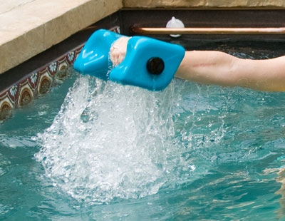

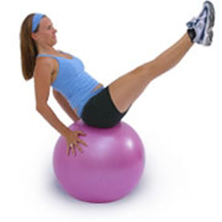
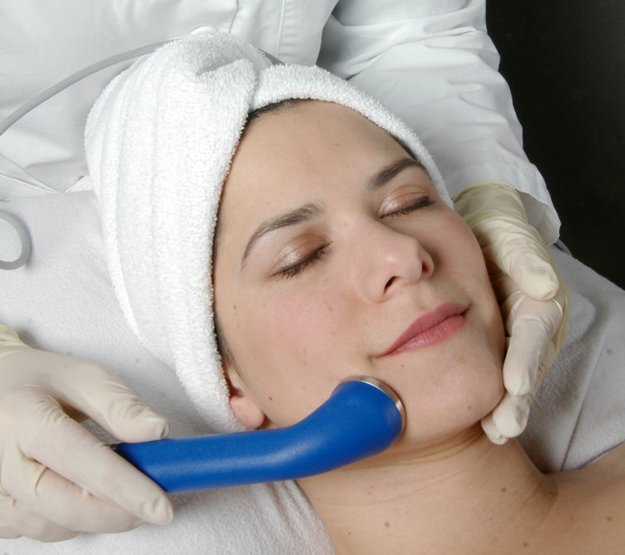

Name the types of physiotherapy equipment

1.

2.

3.

Listening:

Watch the video “Stretch out Strap DVD” and answer the following questions.

One of the most overlooked aspects of physical fitness at any level is…

- flexibility
- stretching
- strength

Flexibility and mobility are essential to our daily….

- hassles
- fitness
- health

Watch again and fill in the blanks:

It will help keep you fit, improve your _________, prevent __________

Working on your flexibility will ___________ your ____________ in any activity or in any sport.

The stretch-out strap allows you to _____________ a level of flexibility that is not ____________ alone.

