Pediatric Physiotherapy

Vocabulary Quiz: Body Parts

- When this is full, you need to find a toilet:
a) the heart
b) the bladder
c) the pancreas

- The back of the neck:
- the nostrils
- the nape
- the calf

- They stop dust getting into your eyes
- the hips
- the eyelashes
- the nostrils

- You move this when you eat:
- the ankle
- the jaw
- the calf

- The back of the lower part of your leg:
- the calf
- the knee
- the elbow

- This organ breaks down toxins which enter the body, including alcohol:
- the lungs
- the liver
- the heart

- The top part of your leg:
- the calf
- the thigh
- the knee

- The organ which cleans your blood:
- the kidneys
- the lungs
- the uterus

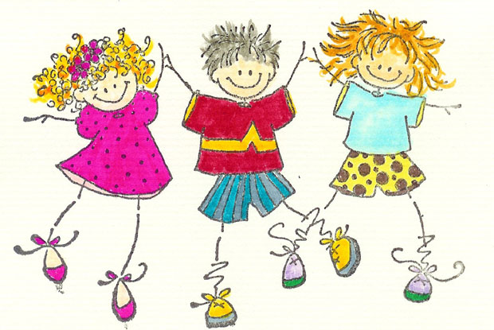
Pediatric Disorders and Physiotherapy to Help Them

Discussion point:

In your opinion, what are the difficulties a pediatric physiotherapist may have?
What is important to remember when working with children?

Vocabulary

Match the words with their synonyms:

occur renovate
severe defeat
curvature illness
revive happen
overcome bend (n)
disorder serious
Use these adjectives to make verbs:

strong
straight

Most of us find illness and injuries to children very distressing. We instinctively seek to protect children from harm and suffering. But we have to accept the reality that many pediatric disorders do occur. Fortunately, physiotherapy can often help.

Among the many pediatric disorders, a few common examples are: scoliosis, torticollis, sports and traumatic injuries, developmental disorders, cerebral palsy, and genetic disorders.

Physiotherapy for scoliosis - a curvature of the spine - consists of exercises to strengthen the back. Electrical stimulation is used for this type of pediatric disorders. The stimulation goes directly to the skeletal muscles. Chiropractic is also used in an effort to straighten the spine.

Torticollis is a type of pediatric disorder of the neck. There is a problem with one of the muscles of the neck so that the child is not able to hold his head up straight. Physiotherapy can stretch this muscle so that the child can hold his head more normally.

Spinal cord injuries as pediatric disorders are difficult to treat. Children often do not want to do the work that is required for this condition. Physiotherapy personnel are challenged to keep the child's spirits up as they teach them how to exercise with and without special equipment.

Brain injuries, including cerebral palsy and strokes are pediatric disorders that must be managed delicately. The neurological system is often not as sturdy as the skeletal or muscular systems. However, brain injuries also involve these other systems as well.

A new treatment for these pediatric disorders like brain injuries is using hyperbaric oxygen therapy (HBOT). In an atmosphere of high pressure oxygen, certain dysfunctional areas of the brain may sometimes be revived.

Pediatric disorders such as sports injuries and traumatic injuries require different types of physiotherapy based upon the location and severity of the injury. If a child has repeatedly sprained the same ankle, therapy will necessarily focus on that ankle, as well as any body part that supports or counterbalances that ankle. Overall strength is important.

Traumatic injuries require a certain amount of psychological training, as the subject of the accident or other ordeal may bring on such distress that the child does not want to work. A good physiotherapist will be able to work with such a child. Traumatic injuries can also be severe enough that the physiotherapist plans a lengthy course of therapy to overcome them. Pediatric disorders like this require patience from everyone involved.

http://thephysiosite.com/pediatric-disorders-and-physiotherapy-to-help-them.php

Find in the text:

- 3 types of physiotherapy
- 2 types of brain injuries
- 1 new treatment for pediatric disorders
Which are the most common pediatric disorders treated by physiotherapists?
What is the best treatment for scoliosis?
Why are spinal chord injuries difficult to treat?
What is HBOT?
Why do traumatic injuries require a certain amount of psychological treatment?

True or false:

- Electrical stimulation is recommended for children with scoliosis.
- Torticollis is a type of pediatric disorder of the spine.
- Brain disorders are illnesses which should be treated carefully.
- Traumatic injuries can be treated without psychological training.

