Physical Therapy Exercises
Exercising daily plays a main role in the process of healing and recovering from injury or disease. This is the goal of physical therapy exercises. Stretching and strengthening activities are only a few types of physical therapy exercises. Balance, joint control, and muscle re-training are other types of important physical therapy exercises.

TASK:
Read the following instructions how to perform certain exercises. The instructions are mixed up. Put them into a chronological and logical order:
Triceps Extension
Strengthens muscles in back of upper arm.
Summary:
- Bend raised arm at elbow, bringing hand weight toward same shoulder.
- Raise one arm straight toward ceiling.
- Feet flat on floor; keep feet even with shoulders.
- Support this arm, below elbow, with other hand.
- Hold position.
- Slowly re-straighten arm toward ceiling.
- Slowly bend arm toward shoulder again
- Sit in chair, near front edge.
Hamstrings
Stretches muscles in back of thigh.
Summary:
- Lean forward from hips (not waist) till you feel stretching in leg on bench, keeping back and shoulders straight. Hold position.
- Repeat with other leg.
- Straighten back
- Keep other leg off of bench, with foot flat on floor.
- Sit sideways on bench.
- Keep one leg stretched out on bench, straight.

Shoulder Rotation
Summary:
- Hold position.
- Stretch arms out to side.
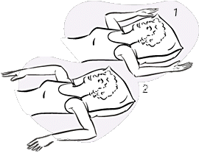
- Keep shoulders flat on floor.
- Bend elbows to crook lower arms downward, at right angle.
- Lie flat on floor, pillow under head.
- Bend elbows to crook lower arms upward, at right angle.
- Hold position.
TASK:Look at the pictures and find Czech equivalents to the described movements:

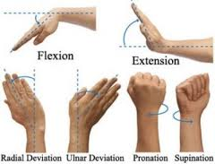

TASK:
Here are some pictures of various physiotherapy exercises. First study the pictures properly, then choose 4 pictures and describe how to perform the exercises:
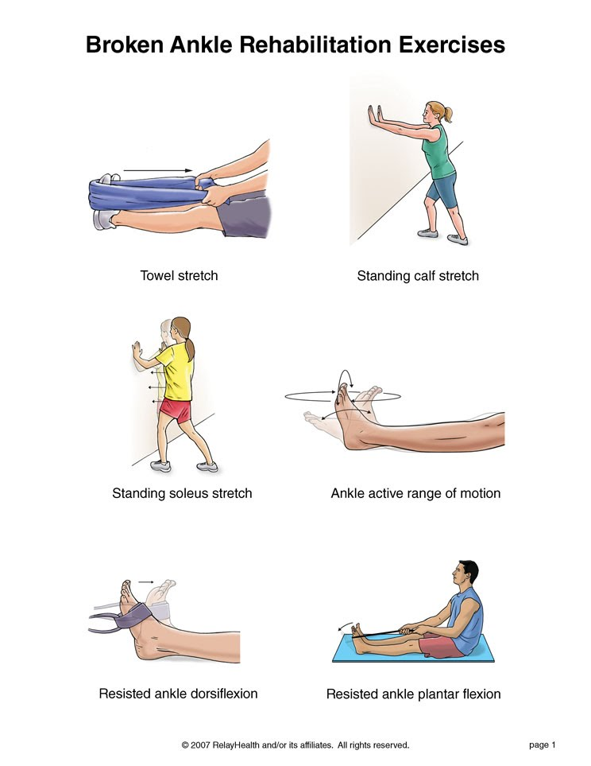
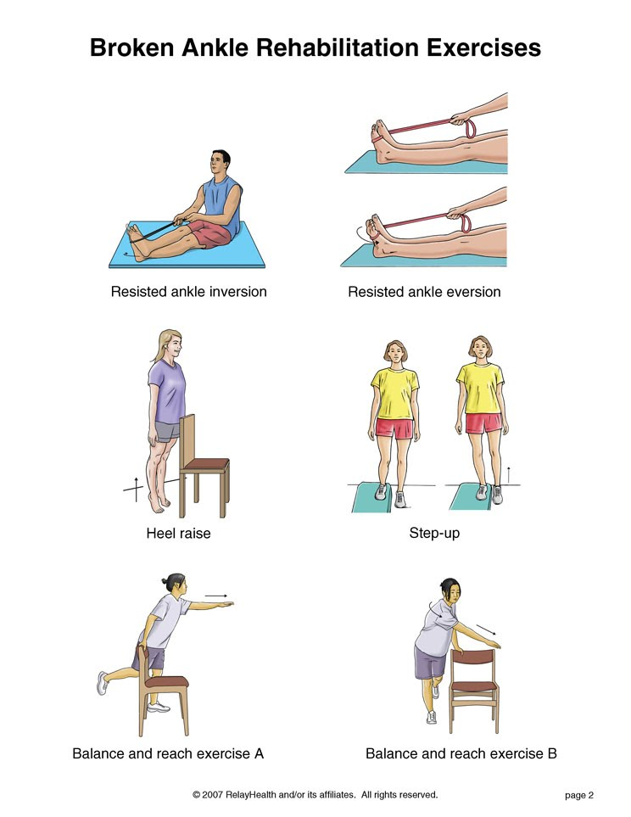
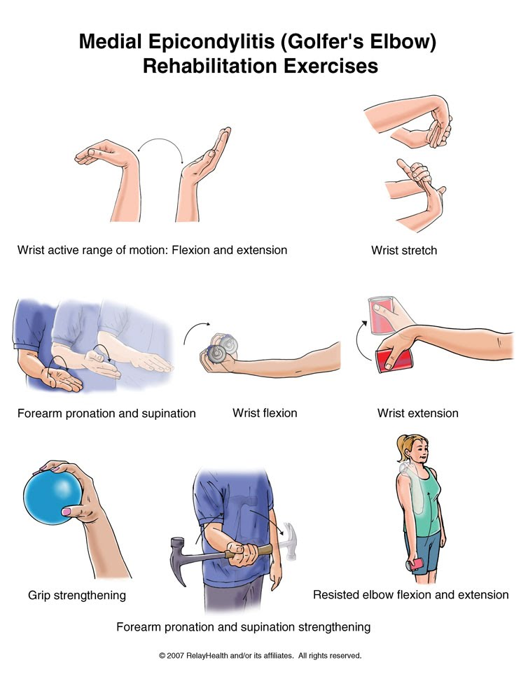

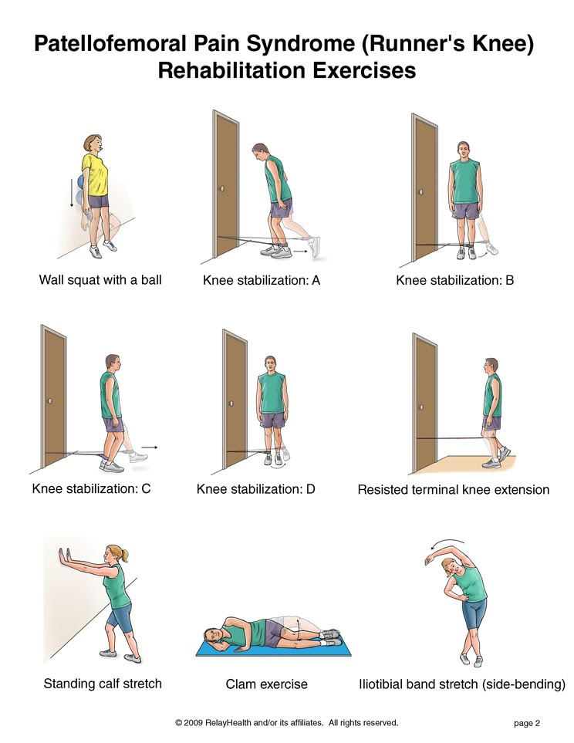
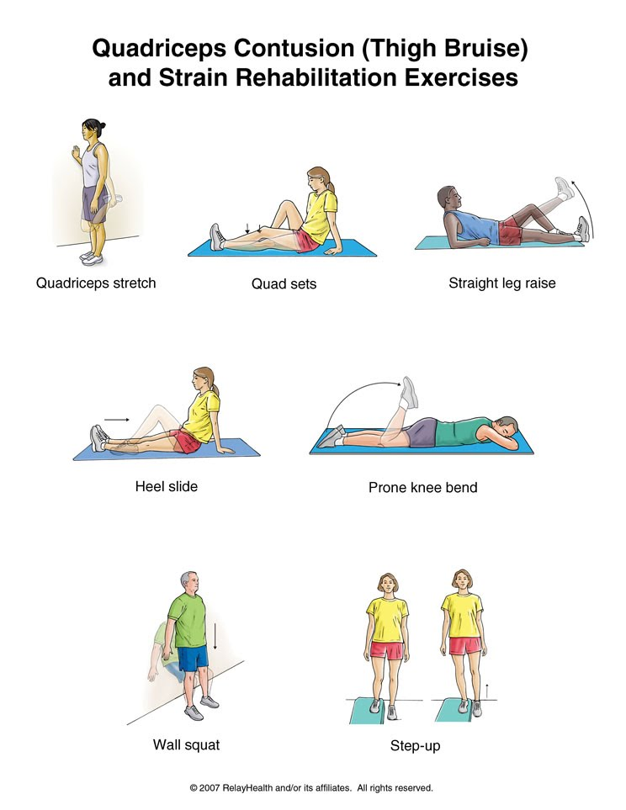

TASK: Choose some of your classmates to perform the exercises as you describe them.

TASK: Here is a list of exercises. Classify them into two groups:
moderate (=using lower degree of energy) and vigorous (=full of energy)
- Swimming
- Hiking
- Digging holes
- Cross-country skiing
- Gardening
- Walking quickly on a level surface
- Mopping floor
- Cycling on a stationary bicycle
- Swimming laps
- Fast bicycling up hills
- Dancing
- Downhill skiing
- Volleyball
- Rowing
- Jogging
- Climbing stairs or hills
- Bicycling
Adapted from:
http://www.orthohyd.com/exercises-yoga
http://physicaltherapy.about.com
http://physicaltherapy.about.com/gi/o.htm?zi=1/XJ&zTi=1&sdn=physicaltherapy&cdn=health&tm=20&gps=255_334_1276_882&f=11&tt=14&bt=0&bts=0&zu=http%3A//weboflife.ksc.nasa.gov/exerciseandaging/chapter4_balance.html

