Eating and drinking habits
„On the continent people have good food; in England people have good table manners“. George Mikes.
PART A
Food and drinks in Britain.

1. What British people eat.
A “fry-up” is a phrase used for several items fried together. The most common items are eggs, bacon, sausages, tomatoes, mushrooms, and even bread. Bread is most commonly eaten with butter and anything else. Eggs are a basic part of most people´s diet. They are either fried, soft-boiled and eaten out of an “egg cup”, hard boiled or poached (steamed). It is quite common for a family meal to finish with a prepared sweet dish. This is called either “pudding”, “sweet” or “dessert”. Some sweet dishes are served hot – e.g. a pie. The British are the world´s biggest consumers of sugar. They love sweets which means both all kinds of chocolate and also what the Americans call “candy”.

2. When people eat meals.
Breakfast is usually a packeted cereal (e.g. cornflakes) and/or toast and marmalade. “Elevenses” is a cup of tea or coffee and some biscuits at around eleven o´clock. Lunch is typically at one o´clock. But it is often a bit earlier for schoolchildren and those who start work at 8. For the working class and people in Scotland and Ireland tea is the evening meal, eaten as soon as people get home from work (around 6 o´clock). Supper is the usual word for the evening meal among most people who do not call it tea. Dinner is also sometimes used for the evening meal. It suggests something rather grander and eaten late (around 8 o´clock). It is also sometimes used to refer to the midday meal in schools.

3. What people drink.
People drink large amounts of hot drinks such as tea, coffee and cocoa. They also drink squash (fruit concentrate that has to be diluted with water) and water straight from the tap. Wine has increased in popularity, but beer is still the most popular alcoholic drink. The most popular pub beer is “bitter”, which is draught (i.e. from the barrel). It is drunk at room temperature. Several kinds of bottled beer, usually known as “ales” are also available. Beer with gas and closer to continental varieties is known as “lager” In some pubs, cider is available on draught. Shandy is half beer and half fizzy lemonade.
For each sentence choose T – true, F – false or 0 – doesn´t say:

1. People in Britain only eat fried bread.

2. Hard boiled eggs are called poached.

3. The British eat a sweet dish after every meal.

4. Pudding is served hot.

5. Americans call all sweets candy.

6. The British still eat their traditional breakfast.

7. Lunch is the main dish of the day.

8. The meal eaten at noon at schools is called dinner.

9. People who start work at 8 have lunch at one o ´clock.

11. Supper is eaten earlier than dinner.

12 Many people in Britain drink whisky.

13. Beer has been the most popular alcoholic drink in Britain.

14. Lager is quite similar to beer drunk in the rest of Europe.

15. If you drink shandy you will not get drunk so fast.

PART B exercises:

Complete each sentence with a suitable word from the list:
Add, bake, sprinkle, boil, chop, fry, grate, mix, peel, roast, squeeze /check with your dictionary where necessary/

- John decided to ......................... the beef in the oven for two hours.
- Put all the ingredients in a bowl and ....................... them together well.
- First .................... the onions into small pieces.
- I wanted to ....................... some cakes this morning, but I did not have time.
- Taste the soup, and .................. salt and pepper if necessary.
- .......................... the potatoes, and then cut them into large pieces.
- These vegetables taste great if you ............................ them for a minute in hot oil.
- .......................... some cheese, and sprinkle it over the spaghetti.
- ................................... a lemon and sprinkle the juice over a salad.
- ............................. the rice in salted water for ten minutes.

Complete each phrase with a suitable word from the list:
Bacon, biscuits, butter, chips, fork, salt saucer, vinegar
- pepper and ..........................
- knife and ............................
- egg and ...............................
- bread and ............................
- fish and ...............................
- oil and ................................
- cup and ..............................
- tea and ...............................

TASKS:
Compare eating habits in Britain to those in this country.
Why are the following components a necessary part of our nutrition? What do they provide us with? Can you add anything else to the list? CARBOHYDRATES, FATS,PROTEIN & AMINO ACIDS, FLUIDS
look at the food pyramid
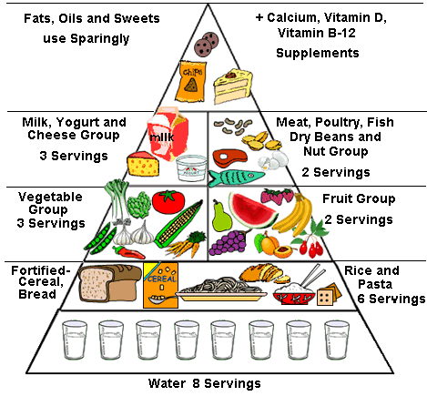
How would you explain the term proper diet?
What should a proper diet consist of?
Explain your eating habits and how much you care for a proper diet.
Do you eat at fast food places? Why, why not, how often?
How often do you eat out?

How many servings of the following food should we eat per day? Click the right choice:
 | 1 | 2 | 3 |  | 4 | 5 | 6 |  | 7 |  | 8
dessert
eggplant

macaroni
meat

oil
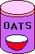
oatmeal
pie
pretzel
tuna
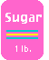sugar
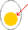 yolk
milk
water

