SEMINAR 5 TEACHING PE, LISTENING

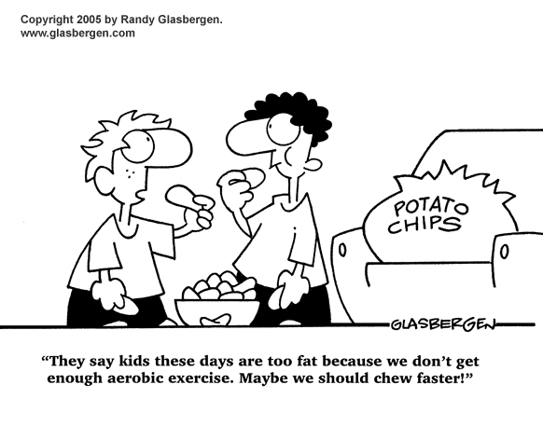
Teaching Physical Education
Questions for reflection:

- Think back to your experiences in physical education classes. Recall the things that your teachers may have done that were probably unpleasant or even harmful to the poorly skilled or unfit children in your classes. Why do you think the teachers weren’t sensitive to these children?

- Reflect on your own teaching. Do you tend to favor any certain group of children – high- or low-skilled? Attractive or unattractive children? Boys or girls? What do you do, as you teach, to be sensitive to your tendency to favor a certain group?

- As physical education teachers we tend to have many friends who are also highly skilled. Think about your friends and acquaintances who have been turned off to physical activity. Do you know why this is so? Why do they find it so hard to exercise regularly? Can any of these feelings be traced back to their experiences in physical education classes?

- When testing in physical education, it is difficult to make the testing a very private affair. Describe some of the ways that teachers might test in physical education to help ensure the relative privacy of the test. Do you think children can test one another? Why or why not?

- Children and adults do not have the same feelings or ability to understand. Recall several examples of these differences and explain the implications for teaching physical education.

- What would you say is the main goal of physical educators?
BUILDING POSITIVE FEELINGS

- feelings about one’s self
- feelings about others
- feelings of joy
- feelings of satisfaction
- feelings of pleasure
- feelings of self-accomplishment

TEACHER ACTION
Teachers have developed a number of ways to help every child, not just the highly skilled, to enjoy physical activity.

- Mistakes-OK-Here Zone
One of the ways to help children feel good about themselves is to assist them to realize that learning inevitably involves mistakes. Teachers can do this by declaring the playground or gym a “mistakes-OK-here zone“. It is expected that everyone, including the teacher, will make mistakes from time to time.
- Provide alternatives
When children are asked to play in a game that singles them out, any feelings of inadequacy and incompetence are reinforced. Caring teachers create environments in which children are not embarrassed in front of the class.
- Audiotaping
Another technique that a teacher can use is to audiotape a class. When you listen to the tape after the lesson, try to hear what you communicate to the children. For example:
- Do you sound supportive? Encouraging? Understanding?
- Do you sound too demanding or critical?
- Do you communicate a tone of warmth and caring to the children?
Questions and tasks:
- Talk to your partner. Which of the methods above do you consider effective?
- Briefly summarize the above techniques.
- Are there any activities that you think should be avoided in the class not to embarrass any of the children?

(Adapted from: Graham G. Teaching Children Physical Education. Human Kinetics.)
Physical Education LISTENING
Task 1 Answer the following questions about the interview.

1) Monica thinks kids spend too much time _________.
a) on the computer b) watching TV
2) In New Zealand, P.E. is taught _________.
a) with health b) twice a week
3) The Prime Minister wants to increase _________.
a) the number of PE classes b) out-of-school activities
4) Monica thinks they should increase _________ .
a) the number of PE classes b) out-of-school activities
5) Todd says the counter argument is that _________ .
a) some kids will not exercise b) the clubs cost extra money

Task 2 Listen again and find the English equivalent of the following expressions.
často slyšíme - ..................................................................
ve skutečnosti - .................................................................
důraz musí být kladen na - ...............................................
abych byl upřímný - ..........................................................
protiargument - ..................................................................
Adapted from: http://www.elllo.org/english/1001/1005-PE.htm

Task 3 Grammar – Focus on so, such, and such a. Remember that so is followed by an adjective. We use such + noun when the noun is uncountable or plural, and such + a/an + noun when the noun is countable:

1 That was really an outstanding performance. __________ great musicians are hard to find.
2 It was a super concert. We had __________ good time that we will always remember it.
3 I didn’t enjoy the music. The singers were __________ loud and shrill.
4 The lyrics were __________ difficult to understand; I really couldn’t catch even a single word.
5 We can’t decide which performance to attend; it’s __________ dilemma.
6 It was __________ difficult music, that we had a hard time appreciating it.
7 He is __________ good composer that he gained worldwide recognition.
8 The open-air concert was excellent but it was _________ bad weather that we left before it ended.

Task 4 Grammar – Focus on few(almost none) and a few (some); little (almost none) and a little(some). Remember that few/a few follows countable nouns. There are few/a few boys left in the class. Little/a little is used with uncountable nouns, I have little/a little money.

1 __________ of the band members gathered for a jam session last night.
2 There was very __________ applause after the embarrassingly bad performance.
3 Very __________ people came to the concert, as it was not very well promoted.
4 Could you turn up the volume __________?
5 There was __________ attention paid to the event in the media, therefore almost nobody came.
6 I was really lucky to get the tickets, because there were only __________ left.
7 Just _________ people can read music these days.
8 I listen to this kind of music just ____________ bit.

