Unit 3
Ice Hockey – General Background
Present Perfect Simple and Continuous (Murphy - English Grammar in Use: Unit 7 – 10)
Ice Hockey – one of the fastest sports, “game of speed and strength”, in which two opposing teams of skaters use long, curved sticks to try to drive a hard rubber disc into each other’s goal. It is especially popular in Canada, where it developed.

A/ Work in pairs. Write as many information as you can.

- Team

- Play

- Penalties

- Ice hockey skills

- Equipment

- Referees
B/ Describe the rink

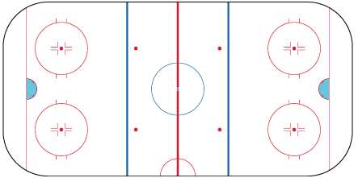

C/ Ice Hockey Quiz – Choose one correct answer:

- Where is the International Ice Hockey Federation (IIHF) based?
- Montreal, Canada
- Zurich, Switzerland
- New York, USA

- Which of these shirt numbers did Wayne Gretzky wear when he played for Sault Ste Marie Greyhounds?
- 9
- 19
- 29

- In which year was the first HHL All-Star Game played?
- 1933-34
- 1935-36
- 1937-38

- Why was not there and an NHL All-Star Game in 1995? Because of…
- a blizzard
- a player strike
- a TV boycott

- Where was Wayne Gretzky born?
- Ontario, Canada
- Kladno, the Czech Republic
- Pskov, Russia

- When did Czechoslovakia first appear in the World Championships?
- 1920
- 1922
- 1924

- In 1933, the World Championships were held in which Czechoslovakian city?
- Bratislava
- Prague
- Vsetin

- In 1947-48 Czechoslovakia won silver medals in the Olympics and World Championship. What was the colour of their European Championship medal that season?
- gold
- silver
- bronze

- Which team won the Czech Republic Championship in 1999-00?
- HC Olomouc
- HC Petra Vsetin
- HC Sparta Prague

- Which team won the Slovakia Championship in 1999-00?
- Dukla Trencin
- HC Kosice
- Slovan Bratislava

