Unit 5
Human body

Task 1 Human Body
ankle  arm  navel  chest  chin |  | ear  elbow  eye  fingers  foot | hand  head  heel  hip  knee | leg  mouth  nose  neck  shin | shoulder  thigh  toes  waist  wrist
 | Label the human body diagram using the word list above.

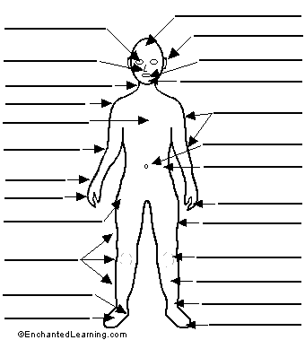

Task 2 Basic anatomy
Match the description with one of the systems. What organs do you associate with each of them?

skeletal digestive lymphatic integumentary respiratory nervous reproductive urinary muscular circulatory endocrine

1. The ____________ system supports and protects, regulates body temperature, makes chemicals and hormones, and acts as a sense organ.
2. The _____________ system supports and protects, makes movement easier (with joints), stores minerals, and makes blood cells.
3. The __________ system brings about body movement, maintains posture, and produces heat.
4. The ________________ system allows a person to communicate with the environment and integrates and controls the body.
5. The _____________ system secretes hormones into the blood that serve to communicate with, integrate, and control mechanisms.
6. The ____________system transports substances through the body and establishes immunity.
7. The _____________ system is a subdivision of the circulatory system. It does not contain blood, but rather lymph, which is formed from the fluid surrounding body cells and diffused into lymph vessels. The major functions of this system are the movement of fluid and its critical role in the defense mechanism of the body against disease.
8. The __________system exchanges oxygen from the air for the waste product carbon dioxide, which is eliminated from the body.
9. The ____________ system breaks down food, absorbs nutrients, and excretes solid waste.
10. The _________ system cleans waste products from blood in the form of urine and maintains electrolyte balance, water balance, and acid-base balance.
11. The ___________ system produces sex cells, allows transfer of sex cells and fertilization to occur, permits development and birth of offspring, nourishes offspring, and produces sex hormones.

Task 3
Fill the gaps with the correct word chosen from below.
increase joints recovery health immune regular cardiovascular

Physical exercise is the performance of some activity in order to develop or maintain physical fitness and overall _____________. Frequent and _______________exercise is an important component in the prevention of the diseases such as heart disease, cardiovascular disease, Type 2 diabetes and obesity.

Exercises are generally grouped into three types depending on the overall effect they have on the human body:
1. Flexibility exercises such as stretching improve the range of motion of muscles and
________________.
2. Aerobic exercises such as walking and running focus on increasing ________________ endurance.
3. Anaerobic exercises such as weightlifting or sprinting ______________muscle strength.

Physical exercise is important for physical fitness including healthy weight, building and maintaining healthy bones, muscles and joints; and strengthening the ____________ system.
Proper nutrition is at least as important to health as exercise. When exercising it becomes even more important to have good diet to ensure the body has the correct ratio of micro and macronutrients to help the body with the ________________ process after exercising.

Task 6 Listening
Fun science: The human body
(http://www.videojug.com/interview/fun-science-the-human-body#what-is-my-body-made-of)

Listen and answer the questions:

- What´s my body made of?
- Why do we get “goose bumps”?
- Why do I get “brain freeze” when I eat ice cream?
- Why does my skin look like a wrinkled prune after I take a bath?
- Why do I sweat?
- How do my eyes see colour?
- What happens to food when I eat it?
- Why do I need food?

