Clasify the pictures below to the following headings:
Chin-up, Deadlift, Push-up, Split squad

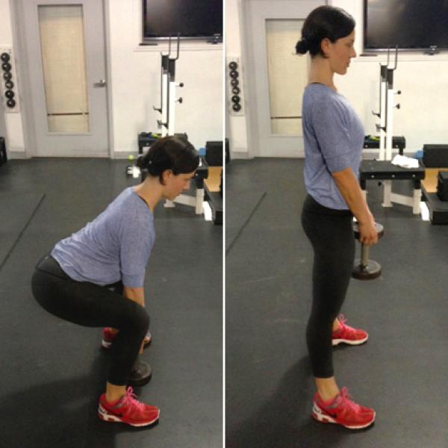

Chin-up, Deadlift, Push-up, Split squad

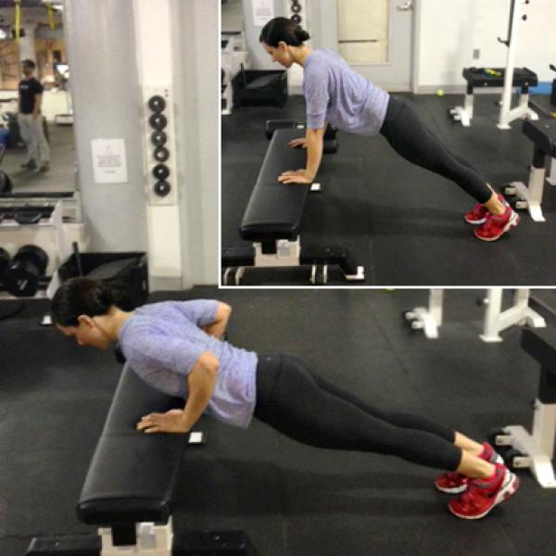

Chin-up, Deadlift, Push-up, Split squad

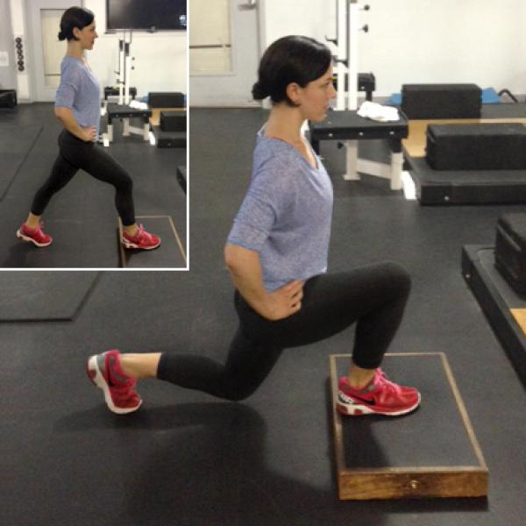

Chin-up, Deadlift, Push-up, Split squad

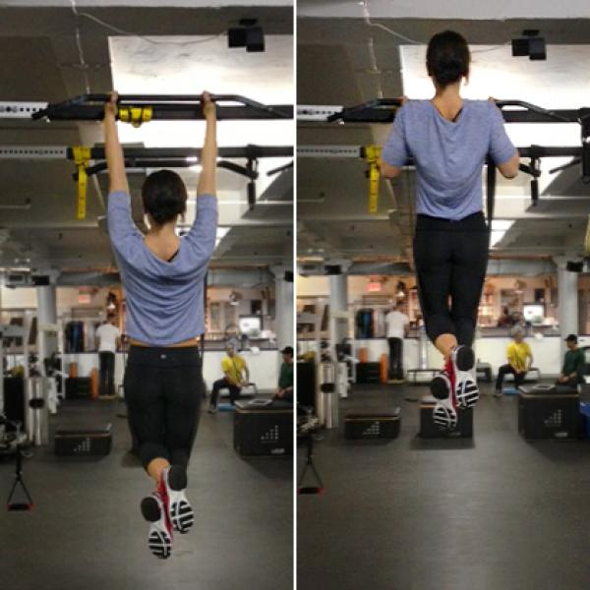

Describe how to perform each exercise.
Adapted from: http://www.shape.com/fitness/workouts/only-5-exercises-you-really-need/slide/

